An Empirical Analysis of Stochastic Volatility Models in Commodity Markets under Negative Rates

Luca Somigli

Department of Economics, Mathematics and Statistics

Birkbeck, University of London

Monday the 20th of September 2021

Student Number: 13197480

Words count: 7993

Dissertation submitted in partial fulfillment of the requirements for the degree of

**Master of Science in Mathematical Finance**

***Abstract* -** The quantitative finance world has developed rapidly over the last decades. Since the discoveries of Black in the seventies, research has contributed to building models to more accurately identify the behavior of prices in financial markets. With the development of equity skews and smiles following the 1987 market crash, and more recently with the presence of negative interest rates, research has tried to produce models that could define changes in expected volatility.

This research paper compares trends in modelling volatility smiles on commodity markets, starting with Dupire’s local volatility model, which treats volatility as a function of time and asset prices; the Heston model, treating volatility as a stochastic process with a mean reverting structure; Hagan’s SABR model, presenting a complex structure based on the CEV stochastic process; more recent SABR variants to price derivatives under negative interest rates such as the shifted, free boundary and mixture SABR models. Follows an empirical analysis using the $QuantLib$ library for quantitative finance. Efficiency of models in identifying volatility smiles are compared on the basis of the following criteria: fit to market data, computational complexity, technical implementation and computation time.

TABLE OF CONTENTS

1 INTRODUCTION 5

2 MATHEMATICAL DEFINITIONS 6

2.1 General Assumptions 6

2.2 Ito’s Calculus 6

2.3 Pricing under the risk-neutral measure 7

3 THEORY AND LITERATURE REVIEW 8

3.1 The Black-Scholes Option Pricing Model 8

3.1.1 The Normal Model 8

3.1.2 The Black Model 9

3.2 Implied Volatility 9

3.2.1 Implied volatility under the Black-Scholes model 9

3.2.2 Flaws with the Black Model 10

3.2.3 Volatility Smiles and Skews 10

3.2.4 Volatility Surfaces 10

3.3 Dupire’s Local Volatility Model 11

3.4 Stochastic Volatility and the Heston Model 12

3.5 SABR Models 13

3.5.1 The Constant Elasticity of Variance Process (CEV) 13

3.5.2 Classical SABR Models 14

3.5.3 SABR Extensions for Negative Rates 17

4 ANALYSIS AND COMPARISON 24

4.1 Data and Methodology 24

4.2 Analysis 25

4.2.1 Black Volatility Surface 25

4.2.2 Local Volatility Model 26

4.2.3 Heston Model 26

4.2.4 SABR Model 30

4.2.5 Shifted SABR Model 34

4.2.6 Free-Boundary SABR Model 35

4.2.7 Mixture SABR Model 39

4.3 Comparison 41

4.3.1 Comparison of SABR, Heston and Black Volatility models 41

4.3.2 Computational Complexity and Technical Implementation 43

4.3.3 Computation time 44

5 CONCLUSION 44

6 APPENDIX 47

6.1 LVM 47

6.1.1 Local Volatility Model on gold 47

6.1.2 Local Volatility Model on silver 48

6.1.3 Local Volatility Model on coffee 48

6.2 Heston 49

6.2.1 Heston Model on gold 49

6.2.2 Heston Model on silver 51

6.2.3 Heston Model on coffee 54

6.3 SABR 57

6.3.1 SABR Model on gold 57

6.3.2 SABR Model on silver 58

6.3.3 SABR Model on coffee 59

6.4 Shifted SABR 60

6.4.1 Shifted SABR Comparison on gold 60

6.4.2 Shifted SABR Comparison on silver 63

6.4.3 Shifted SABR Comparison on coffee 66

6.5 Free Boundary SABR 69

6.5.1 Free-Boundary SABR on gold 69

6.5.2 Free-Boundary SABR on silver 70

6.5.3 Free-Boundary SABR on coffee 71

6.6 Mixed SABR 72

6.6.1 Mixture SABR on gold 72

6.6.2 Mixture SABR on silver 73

6.6.3 Mixture SABR on coffee 75

6.7 Comparison Tables 76

6.8 Python Code and Full Data 77

7 ACKNOWLEDGEMENT 87

8 REFERENCES 87

# INTRODUCTION

“Il secolo breve”, or the ‘short century’ is often the expression to which Italians appoint to the 20th century to indicate the fast development that the world experienced over the period. The fields of finance and mathematics, experienced an incredibly fast-changing environment. In 1900 Louis Bachelier made a grounding discovery by using Brownian motion to explain movements of stock prices. Several decades later, the development of the Black model, which is still to this day thought of as a milestone in finance history, provided a simple solution to price derivatives under constant volatility assumptions.

With the market crash of 1987 the financial world experienced a drastic change in the behavior of volatility for options, for the first time showing smiles or skews. In the last decade, we have seen central banks setting negative interest rates and just recently oil prices dropping below zero for the first time during the pandemic. Over the last decades a number of models were proposed to take into account of changes in the market, namely Dupire’s local volatility model [Dupire, 1994], which treated $σ$ as a function of stock price and time, the Heston model [Heston, 1993], which was the first to identify volatility as a stochastic process, and more recently Hagan’s SABR model [Hagan, 2002], which is an advancement in the CEV process and defines a modern way to price derivatives.

The main goal of this paper is to investigate properties of modern option pricing models and their reliability in explaining current volatility smiles of commodities using vanilla options data. The main research question is the following:

*How efficient are modern volatility models in explaining volatility smiles for commodities under negative rates? Can new variants to SABR explain market volatility better than traditional models?*

In particular, the research is aimed at assessing efficiency with respect to the following criteria:

* *Fit to market data.* What is the size of the error with respect to market volatility? This is explained using the RMSE.
* *Computational complexity.* How complex is the algorithm for calibrating parameters and how does changing initial conditions affect final result?
* *Technical implementation.* How easy is to write the model in computer code, using QuantLib?
* *Computational time.* How much time does the calibration take to find solutions?

Our paper is divided in chapters to best describe the research. This chapter described general topics covered in the paper and the overall structure. The second chapter covers the mathematical framework. The third chapter goes through a theoretical and historical explanation of models with related literature review. Chapter four goes first trough data, sources and methodology, then moves onto analysis and results. The fifth chapter reviews obtained results and concludes on findings.

# MATHEMATICAL DEFINITIONS

In this chapter we will be going through the main mathematical framework around our study, starting with general theory assumptions, Brownian motion processes, Ito’s calculus and pricing under a risk-neutral framework.

## General Assumptions

For the purpose of the research study, we assume the following:

* Markets are complete.
* Markets are efficient. All information is available to investors.
* No transaction fees, taxes, inflation and no restrictions to short sell.
* The risk-free rate exists and is non-negative.
* It is possible to buy and sell securities at the same time and at any time.
* Securities are infinitesimally divisible.
* Securities do not pay dividends.

## Ito’s Calculus

A Brownian motion is a stochastic process having the following properties.

$W_{0}=0$

* $W_{t}$ is continuous almost surely and not differentiable

$W_{t_{1}}-W_{t_{0}} \sim N\left(0, t_{1}-t_{0}\right) for t_{1}≥ t_{0}≥0$

Given the probability measure $P$ and the filtered probability space $F_{t}$ which denotes the information available at time $t$, we define a martingale $X_{t}$, with $t≥0$, to be a stochastic process such that $E_{P}\left(X_{t+h}\right|F_{t} )$. That is the conditional expectation of any given next value of the process $X_{t+h}$ at time $t+h$ is equivalent to the present value of the same process at time $t$.

An SDE, stochastic differential equation, is presented below in its general form.

|  |  |
| --- | --- |
| $$dX_{t}=μ\left(X_{t}, t\right)dt+σ\left(X_{t},t\right)dW_{t}$$ | (2.1) |

where $μ\left(X_{t}, t\right)dt$ is the drift component, with $μ\left(X_{t}, t\right)$ being an integrable function, and $σ\left(X_{t},t\right)dW_{t}$ being a random component, following a stochastic process and differentiable using Ito’s rules.

An Ito process is an adapted stochastic process that can be expressed as the sum of two integrals, with respect to a Brownian motion and with respect to time. Generally, the solution to a stochastic differential equation is an Ito process, which is shown below.

|  |  |
| --- | --- |
| $$X_{t}= X_{0}+\int_{0}^{t}{σ_{s}} {dW}_{s}+\int_{0}^{t}{μ_{s}} ds$$ | (2.2) |

Ito’s lemma states that for a given univariate drift-diffusion stochastic process, and an at least twice differentiable function $Y_{t}=f\left(X_{t},t\right)$, for $X_{t}$ being a stochastic process and $t∈R$, we have the infinitesimal increment in $Y_{t}$.

|  |  |
| --- | --- |
| $$dY_{t}=\left(\frac{∂f}{∂t}+\frac{∂f}{∂x}+\frac{1}{2}\frac{∂^{2}f}{∂x^{2}}\right)dt+\frac{∂f}{∂x}dW_{t}$$ | (2.3) |

As an example, we consider the process $dX_{t}=μ\left(X_{t}, t\right)dt+σ\left(X_{t},t\right)dW_{t}$, then the process satisfies the following stochastic equation:

|  |  |
| --- | --- |
| $$df\left(X_{t},t\right)=\left(\frac{∂f\left(X_{t},t\right)}{∂t}+\frac{∂f\left(X_{t},t\right)}{∂x}μ\left(X_{t}, t\right)+\frac{1}{2}\frac{∂^{2}f\left(X_{t},t\right)}{∂x^{2}σ^{2}\left(X_{t}, t\right)}\right)dt+\frac{∂f\left(X_{t},t\right)}{∂x}σ\left(X_{t}, t\right)dW_{t}$$ | (2.4) |

Hence, we can use the relationship to find a solution to the stochastic process on $dX_{t}$, with initial condition $X_{0}=x_{0}$.

|  |  |
| --- | --- |
| $$X_{t}=x_{0}e^{\left(μ-\frac{1}{2}σ^{2}\right)t+σW_{t}}$$ | (2.5) |

## Pricing under the risk-neutral measure

If a probability measure $Q$ is said to be risk-neutral, then the discounted price of the derivative process is a martingale. With constant interest rates $r$, we have that the value of an option is equivalent to the expected value of its time discounted payoff at a given maturity conditional on the information set available today $F_{0}$ under the risk-free probability measure .

|  |  |
| --- | --- |
|  | (2.6) |

It is important to distinguish the probability measure $Q$, which is a measure of convenience with respect to using the risk-neutral pricing, from the probability measure $P$, which is the true probability measure in the real world. In our research we are assuming probability under the risk-free measure $Q$.

# THEORY AND LITERATURE REVIEW

## The Black-Scholes Option Pricing Model

### The Normal Model

The Normal model for pricing options was originally developed in 1900 by Louis Bachelier [Bachelier, 1900]. In the normal model, the price of the stock $S_{t}$ does not pay dividends, it is assumed to be normally distributed and follows an Ornstein-Uhlenbeck process.

|  |  |
| --- | --- |
| $${dS}_{t}={μS}_{t}dt+σ_{N}{dW}_{t,}$$ $$S_{T}=S_{t}e^{r\left(T-t\right)}+σ_{N}\int_{t}^{T}{e^{r\left(T-s\right)}}dW_{s}.$$ | (3.1) |

where $r$ is the constant risk-free rate, $S_{t}$ is the stock price, $T-t$ is the time to maturity, $σ_{N}$ is the constant normal volatility and $W_{t}$ is a standard Brownian motion.

We now consider a European call option with payoff $\max\left(0,S_{T}-K\right)≡{\left(S_{T}-K\right)}^{+}$, where $S_{t}$ is the asset price and $K$ the strike price. The closed-formula for the option price using the Bachelier model is derived under probability measure .

|  |  |
| --- | --- |
|  | (3.2) |

where $Φ\left(z\right)$ and $ϕ\left(z\right)$ is the standard normal CDF and PDF respectively, $F_{t}$ is the set of information available at time $t$.

### The Black Model

At the core of the model is the Black-Scholes [Black and Scholes, 1973] partial differential equation, with $r$, $σ$ treated as constants and $V$ being the price of the option as a function of $S$ and $t$.

|  |  |
| --- | --- |
| $$\frac{∂V}{∂t}+\frac{1}{2}σ^{2}S^{2}\frac{∂^{2}V}{∂S^{2}}+rS\frac{∂V}{∂S}-rV=0$$ | (3.3) |

From this, the premium for a call option with maturity $T$ evaluated at time $t$ is given by the following relationship.

|  |  |
| --- | --- |
| $$C\left(S_{t},K, T, t\right)=S_{t}Φ\left(d_{1}\right)-{Ke}^{-r\left(T-t\right)}Φ\left(d_{2}\right),$$ $$d_{1}=\frac{\ln{\frac{S_{t}}{K}}+\left(r+\frac{1}{2}σ^{2}\right)\left(T-t\right)}{σ\sqrt{T-t}}, \\ d_{2}=d_{1}-σ\sqrt{T-t}$$ | (3.4) |

The model assumes that changes in the underlying asset prices satisfy the following stochastic process.

|  |  |
| --- | --- |
| $${dS}_{t}={rS}_{t}dt+σ{S_{t}dW}_{t},$$ $$S_{t}=S_{0}e^{\left(μ-\frac{1}{2}σ^{2}\right)t+σW_{t}}$$ | (3.5) |

Hence, the value of the option priced under probability measure $Q$ yields the following.

|  |  |
| --- | --- |
|  | (3.6) |

## Implied Volatility

### Implied volatility under the Black-Scholes model

Following the assumptions in the Black model, asset price returns - meaning $\log\left(S_{t+h}/S_{t}\right)$- follow a lognormal distribution with no fat nor heavy tails. We can retrieve the value of the standard deviation of asset returns by simply reversing the equation and solving for $σ_{BS}$.

|  |  |
| --- | --- |
| $$C_{BS}\left(S_{t},K, T, t\right)=C_{BS}\left(S_{t},K, T, t\right)=S_{t}Φ\left(d_{1}\right)-Ke^{-r\left(T-t\right)}Φ\left(d_{2}\right),$$ $$σ_{BS}\left(S_{t}, K, T, t, C_{t\left(S_{t}, K, T, t\right)}\right)$$ | (3.7) |

### Flaws with the Black Model

Historically, credit to the model was mainly given to its simplicity and how market volatilities were moving during that time. The most profound flaw with respect to identifying volatility is treating $σ$ as a constant. Where, for options on the same underlying and with a given maturity, $σ$ should be a constant no matter how in or out of the money the price is trading at, this is not true when dealing with the idea that stock returns following fat tailed distributions as in real world scenarios. In essence, the risk of the underlying moving more than average is much higher than what the Black-Scholes model expected the market to do and Black implied volatility smiles resulted to be imprecise.

### Volatility Smiles and Skews

The put-call parity formula implies that the volatility of calls and puts does not differ when the Black-Scholes option price is matched to the market, that is when $C_{BS}\left(S_{t},K,T,t,r,σ_{BS}\right)=C_{mkt}$. Because we generally are used to see out-of-money and in-the-money options trading substantially above at-the-money options, implied volatility for such options is higher. This behavior, called volatility smile, started occurring after the famous Black Monday market crash in the October of 1987.

In recent times, OTM (out-the-money) and ITM (in-the-money) options tended to have unequal levels of implied volatilities, with OTM fluctuating more than ITM option prices. This feature is commonly referred to as “implied volatility skew” and is what commonly we see in markets today, especially with equities. Supposedly, the reason behind this being the increasing number of portfolio managers purchasing more OTM options than ITM for hedging purposes, thus resulting in raising prices and volumes of these options.

### Volatility Surfaces

Together with volatility smiles, the term structure of implied volatility is also incredibly useful for assessing overall stability of the option. Whereas volatility smiles are showing the variability in volatility with respect to different strikes on options with same tenor, term structures assess the future expectations of $σ$ with respect to different maturities.

A volatility surface puts both these two sets of information together – volatility term structures and smiles - in a tridimensional chart where the x-axis is the moneyness of the option, the y-axis is the maturity, and the z-axis is implied volatility.

For a given underlying asset, we can define a $KxT$ volatility matrix $Σ$, where T is the number of tenors and K the total number of strikes for each expiry.

|  |  |
| --- | --- |
| $$Σ=\left(\begin{matrix}σ_{1,1} & σ_{2,1} & ⋯ & σ_{i,1} \\ σ_{1,2} & σ_{2,2} & ⋯ & σ_{i,2} \\ σ_{1,3} & σ_{2,3} & ⋯ & σ_{i,3} \\ ⋮ & ⋮ & ⋱ & ⋮ \\ σ_{1,j} & σ_{2,j} & ⋯ & σ_{i,j}\end{matrix}\right)$$ | (3.8) |

where $i$ is the time to time to expiry and $j$ is referring to the option strike price. We then have that $σ_{i,j}$ is the implied volatility for the option with strike $K_{i}$ expiring at time $T_{i}$. This definition is extremely useful when working with $QuantLib$ modules on $ql.Matrix$ which are necessary for building volatility surfaces.

## Dupire’s Local Volatility Model

In 1994 Dupire brought in the field a real first step forward towards the analysis of modern volatility patterns [Dupire, 1994]. Assuming only minimal changes to the original model, he proposed a replacement of the constant $σ$ with a deterministic function of time and stock price $σ\left(S_{t}, t\right).$ We have that the stock price follows a diffusion process.

|  |  |
| --- | --- |
| $${dS}_{t}={μ_{t}S}_{t}dt+σ\left(S_{t}, t\right)S_{t}{dW}_{t},$$ $$S_{0}=0, μ_{t}=\left(r_{t}-d_{t}\right)$$ | (3.9) |

$r_{t}$ is the instantaneous risk-free rate at time $t$ and $d_{t}$ is the time dependent continuous dividend yield, which in our case we can set up to zero. Hence $d_{t}=0$ and $μ_{t}=r_{t}$ as our initial assumptions imply stocks do not pay dividends. We then have that the forward price of a call option is given by the following.

|  |  |
| --- | --- |
| $$C_{0}\left(K, T\right)=e^{-rT}C\left(K,T\right)=E_{Q}\left[\left(S_{T}-K\right)\right]=\int_{K}^{∞}{\left(x-K\right)ϕ\left(x,T\right)dx}, \\ \frac{∂C}{∂K}\left(K,T\right)=\int_{K}^{∞}{-ϕ\left(x,T\right)dx,} \\ \frac{∂^{2}C}{∂K^{2}}\left(K,T\right)=ϕ\left(K,T\right), \\ \frac{∂C}{∂T}\left(K,T\right)=\frac{σ^{2}K^{2}}{2} ϕ\left(x, T\right)+\int_{K}^{∞}{rxϕ\left(x,T\right)dx}$$ | (3.10) |

In this case $ϕ$ satisfies the Fokker-Planck equation. The mathematics above are more thoroughly explained in Dupire’s original paper. From the above relationships, we find Dupire’s equation.

|  |  |
| --- | --- |
| $$\frac{∂C}{∂T}-\frac{1}{2}σ^{2}\left(K,T;S_{0}\right)K^{2}\frac{∂^{2}C}{∂K^{2}}+rK\frac{∂C}{∂K}+rC=0, \\ C\left(K,T\right)={\left(S_{0}-K\right)}^{+}$$ | (3.11) |

From the Dupire equation we solve for $σ_{local}^{2}$.

|  |  |
| --- | --- |
| $$σ_{local}^{2}\left(S_{t},K,T,t, C, r \right)=\frac{\frac{∂C}{∂t}+rK\frac{∂C}{∂K}-dC}{\frac{1}{2}K^{2}\frac{∂^{2}C}{∂K^{2}}}$$ | (3.12) |

The first real concern with the original Dupire resolution was to identify if there exists a single equation $σ\left(S_{t}, t\right)$ that matches implied Black volatility at each smile. The answer was found by Derman and Kani shortly after the release of the first paper by Dupire [Derman and Kani, 1994]. The solution consisted in using an implied binomial tree, where the local volatility is calculated at each node and calibrated across strikes and expirations along with market data. Furthermore, the local volatility surface can be extrapolated along with respective gradients w.r.t. prices and strikes. The results are then used to calibrate $σ$ on the Dupire equation as we have seen above.

Whereas for short term calibration smiles are registered fine by the model, with longer maturities the smile effect continues, which is highly unrealistic in a real-world situation. Longer maturities tend to have a flatter skew, which goes against what the model outputs. As stated by Hagan a few years later, due to this contradiction between model and market, Delta and Vega hedges derived from the local volatility model can be unstable and may perform worse than naive Black-Scholes’ hedges [Hagan, 2002].

## Stochastic Volatility and the Heston Model

With the rising concern of proving a good statistical match with volatility surfaces in option prices, in 1993 Heston contributed to the field with a model that for the first time treated volatility as a stochastic process, in contrast with the previous deterministic (Dupire) and constant (Black Scholes) predecessors. Still being heavily used to this day for pricing options, the Heston stochastic volatility model is an extended version of Black-Scholes, with volatility following a CIR (Cox–Ingersoll–Ross) process [Rasmus, 2008]. The asset price now obeys a diffusion process.

|  |  |
| --- | --- |
| $$dS_{t}=μS_{t}dt+\sqrt{v_{t}}S_{t}dW_{1t},$$ $$dv_{t}=κ\left(θ-ν_{t}\right)dt+ξ\sqrt{v_{t}}dW_{2t}, \\ dW_{1t}dW_{2t}=ρdt$$ | (3.13) |

where $μ$ is the instantaneous expected rate of return, $ξ$ is the volatility of variance $v_{t}$, $θ>0$ is the long term mean of the variance, $κ$ is a positive constant indicating speed of mean reversion (how fast is variance approaching its mean value) and $dW_{1t}$ and $dW_{2t}$ are Brownian motions with $-1<ρ<1$ being their correlation, typically negative, which is often referred to as ‘leverage effect’. In addition, since volatility follows a CIR process, we need the Feller condition $2κθ≥ξ^{2}$ [Cox–Ingersoll–Ross 1985, Feller 1951].

The reason why the Heston model gained so much popularity among professionals is the existence of a closed-form solution that quickly obtains prices with any given parameter set $\left(μ, v, κ, ξ,θ\right)$. The closed-form solution is presented.

|  |  |
| --- | --- |
| $$C\left(S_{t},V_{t},τ\right)=S_{t}P_{1}-Ke^{-rτ}P_{2}$$ | (3.14) |

$P_{1}$ and $P_{2}$ are probability-related quantities that are obtained using Fourier transforms as shown below.

|  |  |
| --- | --- |
| $$P_{j}=\frac{1}{2}+\frac{1}{π}\int_{0}^{∞}{Re\left(\frac{e^{-iϕ\ln\left(K\right)}f_{j}\left(x,v, τ,ϕ\right)}{iϕ}\right)dϕ}, \\ x=\ln{〖{(S〗}_{t})}, f_{j}\left(x,v, T,ϕ\right)=e^{C\left(T-t,ϕ\right)+D\left(T-t,ϕ\right)v+iϕx}, \\ C\left(τ,ϕ\right)=μϕτ+\frac{α}{σ^{2}}\left[\left(b_{j}-ρσϕi+d\right)τ-2\ln\left(\frac{1-ge^{dτ}}{1-g}\right)\right],$$ $$D\left(τ,ϕ\right)=\frac{\left(b_{j}-ρσϕi+d\right)}{\left(b_{j}-ρσϕi-d\right)} \left(\frac{1-e^{dτ}}{1-ge^{dτ}}\right), \\ g=\frac{b_{j}-ρσϕi+d}{b_{j}-ρσϕi-d}, d=\sqrt{{\left(ρσϕi-b_{j}\right)}^{2}-σ^{2}\left(2u_{j}ϕ-ϕ^{2}\right)}, \\ for j=1,2 where \\ u_{1}=\frac{1}{2}, u_{2}=-\frac{1}{2}, α=κθ, b_{1}=κ+λ-ρσ, b_{2}=κ+λ$$ | (3.15) |

The full derivation to this closed-form is shown in Heston’s paper [Heston, 1993]. The calibration process under the Heston model proceeds to minimize the difference between market prices and model prediction prices. We have a total of five parameters to estimate $\left(v, κ,θ, ρ,σ\right)$ which respectively are initial value of the option, speed of the reversion process, long-run mean, volatility of variance (which measures steepness of smiles), correlation between $W_{1t}$ and $W_{2t}$. We want to choose the best fit that consistently replicates market prices.

|  |  |
| --- | --- |
| $$\left(\hat{v},\hat{ κ},\hat{θ},\hat{ ρ},\hat{σ}\right)=argmin_{v, κ,θ, ρ,σ}\sum_{i}^{n}{{\left({C_{i}}^{mkt}-C_{i}^{Heston}\left(S_{i}, K_{i}, T,t; v, κ,θ, ρ,σ\right)\right)}^{2}}$$ | (3.16) |

The calibration process is somewhat cumbersome as the objective function presents multiple local minimas, hence the entire process is highly dependent on the choice of the initial parameters [Bin, 2007]. Mrázek and Pospíšil have run calibrations using different procedures and concluded that even though the initial guess is critical, it might not be converging to a good fit [Mrázek and Pospíšil, 2017]. In order to work through the problem, a possible solution is to run the calibration multiple times with different initial guesses, until the best parameter set is found. This works but under the drawbacks of higher computational times and, even then, sometimes the best fit does not return a satisfiable result.

## SABR Models

### The Constant Elasticity of Variance Process (CEV)

The SABR model is built on top of the constant elasticity of variance process, or CEV. The dynamics of a CEV process were originally presented by Cox [Cox, 1975] and Ross [Cox and Ross, 1976]. The main motivation was to create a model that does not assume stock prices to be lognormally distributed, as was empirically noted by Black [Black, 1976] and others [Blatterberg and Gonedes, 1974; Macbeth and Merville, 1979]. The diffusion process takes the following form.

|  |  |
| --- | --- |
| $$dS_{t}=μS_{t}dt+σ{S_{t}}^{β} {dW}_{t}$$ | (3.17) |

It is common to generally assume $0<β<1$. In fact, when $β>1$ volatility and stock price are moving in the same direction, which is highly unlikely. Instead, when $β=1$ the process resolves to the Black model, whereas with $β=0$ it conforms to the Normal model. In the more realistic case, volatility decreases as stock prices increase ($β<1$), and this is observed empirically.

### Classical SABR Models

#### SABR, stochastic alpha, beta, rho

The SABR model was first introduced by Hagan as an extension of the CEV (constant elasticity of variance) and the Black model [Hagan, 2002]. It is a stochastic volatility model but, unlike the Heston model, it does not produce option prices directly. The main purpose behind SABR was to provide a solution for matching volatility smiles over longer maturities, where other models had failed to do so.

|  |  |
| --- | --- |
| $${dF}_{t}=σ_{t}{\left(F_{t}\right)}^{β} {dW}_{1t},$$ $$dσ_{t}=ασ_{t}^{ }{dW}_{2t},$$ $${dW}_{1t} {dW}_{2t}=ρ dt$$ | (3.18) |

where $F_{t}$ is the forward price under the risk neutral measure at time t, $W_{1t}$ and $W_{2t}$ are Brownian motions with correlation $ρ∈\left[-1, 1\right]$, $β$, which explains volatility skew curvature, and $α$, which is the volatility of volatility, follow conditions $0≤β≤1, α≥0$.

The SABR model was originally intended to work with forward rates $F_{t}$, whereas the Heston and previous models work with asset prices $S_{t}$ by definition. For equity options, we recall the relationship $F_{t}=S_{0}e^{\int{r\left(t\right)dt}}$, where $F_{t}$ is the compounded present value of the asset under stochastic interest rates.

As it can be seen, the drift component is now missing from the forward stochastic equation. The variance of forward prices is now stochastic and does not have a mean reverting process. Since variance is now a function of both strike and time to maturity, we are expecting to have a more realistic fit to market data with regards to smiles with long-term maturities.

Since we are dealing with vanilla options, we can construct the SABR variant based on asset prices $S_{t}$ [Vlaming, 2011]. The model will now show a drift term.

|  |  |
| --- | --- |
| $${dS}_{t}={rS}_{t}dt+e^{-rT\left(1-β\right)}σ_{t}{\left(S_{t}\right)}^{β} {dW}_{1t},$$ $$dσ_{t}=ασ_{t}^{ }{dW}_{2t}, {dW}_{1t} {dW}_{2t}=ρ dt$$ | (3.19) |

Again, unlike in the Dupire or Black model, volatility is now a function of time. This means, just as with the Heston model, that SABR will not only capture the smiles behavior across moneyness, but also changes in volatility across longer maturities with greater accuracy. Hagan’s formula for $σ\left(f,K\right)$, originally shown in his paper follows.

|  |  |
| --- | --- |
| $$σ_{B}\left(f, K\right)=\frac{α}{{\left(fK\right)}^{\frac{1-β}{2}}\left(1+\frac{{\left(1-β\right)}^{2}}{24}\log^{2}\left(\frac{f}{K}\right)+\frac{{\left(1-β\right)}^{4}}{1920}\log^{4}\left(\frac{f}{K}\right)+…\right)}∙ \left(\frac{z}{χ\left(z\right)}\right)∙ \\ ∙\left(1+\left(\frac{{\left(1-β\right)}^{2}}{24}×\frac{α^{2}}{{\left(fK\right)}^{1-β}}+\frac{1}{4}\frac{ρβνα}{{\left(fK\right)}^{\frac{1-β}{2}}}+\frac{2-3ρ^{2}}{24}ν^{2}\right)T+…\right), \\ where$$ $$z=\frac{ν}{α}{\left(fK\right)}^{\frac{1-β}{2}}log\left(\frac{f}{K}\right), χ\left(z\right)=\log\left(\frac{\sqrt{1-2ρz+z^{2}+z-ρ}}{1-ρ}\right)$$ | (3.20) |

With f being the current forward price $f=S_{0}e^{-rT}$ and K being the strike price of the option.

We then find the optimal values for the parameters $α, β, ρ, ν$– $β$ being arbitrarily chosen – and plug the volatility back into the Black-Scholes formula to get the price.

|  |  |
| --- | --- |
| $$C_{t}={Call}_{BS}\left(K,T,f,σ_{B}\left(f,K\right)\right)$$ | (3.21) |

By collecting volatility for each strike for options with same tenor and different strike, we end up with the volatility smile. We can then substitute the obtained SABR volatility in the Black-Scholes model and solve. Overall, the SABR model successfully produces a result that explains the behavior of real world assets as the smile is generally pronounced for short-dated options and flattened for longer maturities.

#### Backbone in SABR models

When introducing the SABR model, a backbone was identified in the effects of changing the forward price $f$ in the calibration and resulting smiles. The inner behavior of the backbone seems to be solely dependent on the value of $β$. With $β=0$, as the value of $f$ decreases, volatility smiles move along the backbone curve to the upper left side of the plot. Instead, with $β=1$ and the price of $f$ decreasing, the backbone line seems to flatten as smiles move to the left and along the x-axis. See below for a graphical reconstruction of this response.

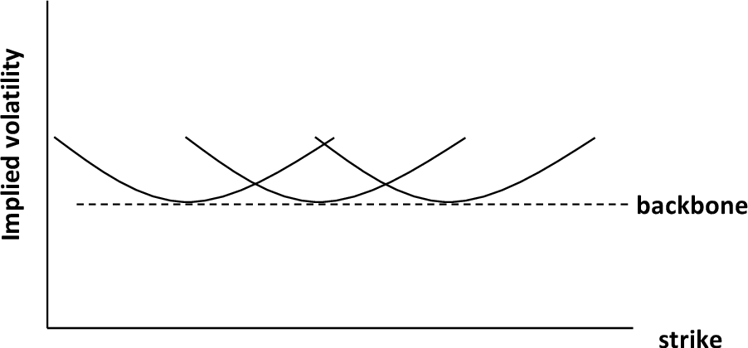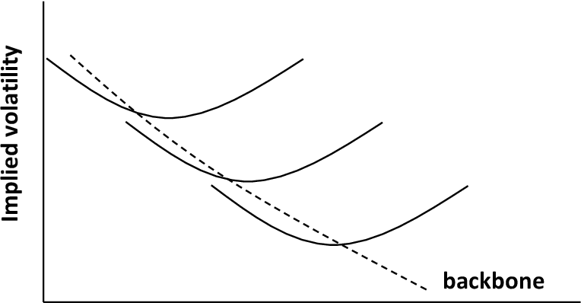

Fig. 2 - Backbone on volatility smiles when $β=1$

Fig. 1 – Backbone on volatility smiles when $β=0$

Whenever the price of the forward $f$ changes, the implied volatility curve shifts in the same direction. This is extremely useful and is one of the major advantages of the SABR model.

#### SABR calibration

As a first step, $β$ is set arbitrarily to match with the condition $0≤β≤1$. Now, it is common practice to set either $β=1$ or $β=0$ depending on the asset class and general matching priorities.

When $β=0$, the movement of $F_{t}$ becomes independent of the price itself. Given that a Brownian motion follows a normal distribution $W_{t}∼N\left(0, t\right)$, then the forward price will be normally distributed with stochastic variance. In this case, the model takes the name of Normal SABR, as the assumptions match with the Normal model we have seen previously.

When $β=1$, $F_{t}$ follows a lognormal distribution, which is more in line with the CEV model. In our case we will be looking also at $β=0.5$, which produces a CIR model. In this case, the current level of the price is under a square root, preventing the forward price to be negative. After having chosen a value for $β$, the following calibration methods are used.

* First method: estimate $α$, $ρ$ and $ν$ directly when minimizing the sum of squared errors with market volatilities.
* Second method: calibrate $ρ$ and $ν$ directly, then find $α$ from $ρ$, $ν$ and ATM volatility $σ_{ATM}$.

For the purpose of this research, we will be using the first method only, as the differences in outputs are very small and not noticeable [Ivarsson, 2020]. After having specified $β$ arbitrarily, we want to minimize the sum of squared errors between the market volatilities and the SABR calibrated $σ_{SABR}\left(f_{i}, K_{i}, T, t,α, β, ρ,ν\right)$ where $f_{i}$ and $K_{i}$ are the forward price and the strike price for a given option at a specified maturity. Therefore, we need to minimize the sum of squared errors between market and SABR implied volatility for each smile.

|  |  |
| --- | --- |
| $$\left(\hat{α}, \hat{ρ},\hat{ ν}\right)=argmin_{α, ρ, ν}\sum_{i}^{n}{{\left({σ_{i}}^{mkt}-σ_{SABR}\left(f_{i}, K_{i}, T; α,β, ρ,ν\right)\right)}^{2}}$$ | (3.22) |

where $σ_{i }^{mkt}$ is the volatility in the market for strike $K_{i}$. The formula above works for a given smile. In order to construct a volatility surface, we would need to do the same for each maturity and return parameters for each smile. Finally, we use the generated parameters $\hat{α}, \hat{ρ},\hat{ ν}$ to obtain $σ$, which we then plug into the Black-Scholes formula to get the option price.

As for the second method, the procedure for minimizing the objective function is the same, with the only difference that $α$, which is now a function of $ν$ and $ρ$, is found in using ATM volatility after calibrating $ρ$ and $ν$. The following third order polynomial is solved with respect to $α$, the solution takes the minimum value of the roots:

|  |  |
| --- | --- |
| $$\frac{β\left(β-2\right)T}{24F^{\left(2-2β\right)}}α^{3}+\frac{ρβνT}{4F^{\left(1-β\right)}}α^{2}+\left(1+\frac{2-3ρ^{2}}{24}ν^{2}T\right)α-σ_{ATM}F^{-β}=0$$ | (3.23) |

Following, the same objective function of the first method is minimized, with the only difference that now $α$ is a function of $ν$ and $ρ$.

|  |  |
| --- | --- |
| $$\left(\hat{α}, \hat{ρ},\hat{ ν}\right)=argmin_{α, ρ, ν}\sum_{i}^{n}{{\left({σ_{i}}^{mkt}-σ_{SABR}\left(f_{i}, K_{i}, T; α\left(ρ, ν, σ_{ATM}\right), β, ρ,ν\right)\right)}^{2}}$$ | (3.24) |

#### Pitfalls in SABR Models

Some implementations were added to the classical SABR model, including the ones by Paulot [Paulot, 2009] and Obloj [Obloj, 2007]. Most importantly, Obloj provided with a refinement to the original model that captured the flaws of incorrectly pricing options with low strikes and long maturities. In modern times, this is widely applied to SABR models and is known as the Obloj’s refinement which was tested to be an effective improvement to the model.

At a wider level, the main issue with Hagan’s proposed SABR model is generally reduced to its utilization in modern negative rates environments. Wu performed an in-depth analysis of SABR models and Obloj’s refinement using interest rate caps and found that resulting smiles were fitting market implied volatility well enough [Wu, 2008]. Nevertheless, this study did not include the Normal model, the shifted SABR and used only positive rates.

### SABR Extensions for Negative Rates

#### Normal SABR

For the Normal SABR model, we set $β=0$, which simplifies the equations as follows.

|  |  |
| --- | --- |
| $$dF_{t}=σ_{t} dW_{1t},$$ $$dσ_{t}=ασ_{t}^{ }dW_{2t},$$ $$dW_{1t} dW_{2t}=ρ dt$$ | (3.25) |

If we solve the above process above, we get $F_{t}=F_{0}+σ_{t}W_{t}$ which means that the model follows a normal distribution and can be used for modelling options in a negative rates environment.

As seen, the infinitesimally difference in forward prices in the first equation does not depend anymore on $β$ increments, which follows that the distribution is not symmetric anymore. In this case, the original Hagan’s formula can be approximated further and so is the formula for ATM volatility. We can proceed the same way we would in the standard SABR model and minimize the sum of squared errors with the approximated formula for volatility.

|  |  |
| --- | --- |
| $$σ_{N}\left( K\right)=α \left(\frac{z}{χ\left(z\right)}\right)\left(1+\frac{ν^{2}\left(2-3ρ^{2}\right)}{24}T\right),$$ $$z=\frac{ν}{α}log\left(\frac{f}{K}\right),$$ $$χ(z)=log⁡(\left(\frac{\sqrt{1-2ρz+z^{2}+z-ρ}}{1-ρ}\right),$$ $$σ_{ATM}\left(K\right)=α\left(1+\frac{2-3ρ^{2}}{24}ν^{2}T\right),$$ $$\left(\hat{α}, \hat{ρ},\hat{ ν}\right)=argmin_{α, ρ, ν}\sum_{i}^{n}{{\left({σ_{i}}^{mkt}-σ_{N}\left(f_{i}, K_{i}, T; α, ρ,ν\right)\right)}^{2}}$$ | (3.26) |

#### Shifted SABR

Working with the SABR model allowed to work with more realistic volatility curves, which better resembles real world scenarios. In modern times, the need of pricing under negative interest rates started to be a relevant issue. The Shifted SABR answers this needs effectively by shifting values of the forward and strike prices by $s$ so to have enough range in the outputs to return a positive distribution of prices. The model is shown below.

|  |  |
| --- | --- |
| $$dF_{t}=σ_{t}{\left(F_{t}+s\right)}^{β} dW_{1t},$$ $$dσ_{t}=ασ_{t}^{ }dW_{2t},$$ $$dW_{1t} dW_{2t}=ρ dt$$ | (3.27) |

We now have that the original forward price is shifted by $s$ with $s>0$. The value of $s$ can be either calibrated as an additional parameter in the SABR model or fixed prior to calibration. Since the model only depends on the initial difference of the strike with the forward price, and because this does not affect the formulas from the original SABR model whatsoever, the shift will not be changing option prices.

The only drawback is that when pricing with the shift, this does lightly influence the value of implied volatility. Hence, the model needs to be handled with care and shifts cannot be extreme. The objective function remains the same, with the only difference of using the new shifted parameters.

|  |  |
| --- | --- |
| $$\left(\hat{α}, \hat{ρ},\hat{ ν}\right)=argmin_{α, ρ, ν}\sum_{i}^{n}{{\left({σ_{i}}^{mkt}-σ_{shifted-SABR}\left(f_{i}+s, K_{i}+s, T; α, β, ρ,ν\right)\right)}^{2}}$$ | (3.28) |

Benefits of the shifted variant of the SABR model are that the computation is rather quick, and the model follows the same exact structure as with the classical SABR model. The results are excellent at fitting the data since it inherits the structure from the classical SABR model. The ending computation is the same, with the only difference of adding the shift to prices and strikes. Because of this feature, the shifted SABR model can be used effectively with negative rates environments.

#### Free Boundary SABR

In 2015 Antonov proposed a new solution to the SABR stochastic differential equation [Antonov, 2015], which is based on the discretization of the probability density function of forward rates which are assumed to follow a free-CEV process [Brecher and Lindsay, 2010]. The arbitrage-free condition follows by construction and allows pricing with low and negative interest rates by setting .

|  |  |
| --- | --- |
|  | (3.29) |

What follows is a simplified summary of the free boundary model formulation and derivation. Readers can refer to the original paper by Hagan et al. or Floch-Kennedy [Le Floch et al. 2015] for a more in-depth explanation.

The logic is to keep the CEV process for positive forward prices and modify the boundary conditions to go negative whilst keeping norm and martingality conserved. The PDF is based on the forward Kolmogorov equation with boundary arbitrage-free conditions. There exist two solutions, absorbing and resolving at the boundary.

|  |  |
| --- | --- |
| $$p_{t}-\frac{1}{2}{\left(f^{2β}p\right)}_{ff}=0 \\ p_{A}=f^{1-2β}, p_{R}=f^{-2β}$$ | (3.30) |

where $p_{A}$ is the absorbing and $p_{R}$ is the resolving solution. Using the free-CEV process from before we have the corresponding forward $f$ Kolmogorov solution with the initial condition $p\left(0,f\right)=δ\left(f-F_{0}\right)$.

|  |  |
| --- | --- |
| $$∂_{t}p\left(t,f\right)=\frac{1}{2}{\left(f^{2β}p\left(t,f\right)\right)}_{ff}, \\ p\left(t,f\right)=\frac{1}{2}\left(p_{R}\right)+sign\left(f\right)p_{A}$$ | (3.31) |

We can now exactly solve the zero-correlation free SABR using the Kolmogorov density formula and use the relationship below.

|  |  |
| --- | --- |
| $$O_{F}^{SABR}\left(T,K\right)=E\left[{\left(F_{T}-K\right)}^{+}\right]-{\left(F_{0}-K\right)}^{+}$$ | (3.32) |

In this case, we can compute the one-dimensional integral over the function $G\left(t,s\right)$ that can be approximated with a high degree of accuracy. $G\left(t,s\right)$ follows from the McKean heat kernel function on hyperbolic space $H^{2}$ [Antonov et al., 2013].

|  |  |
| --- | --- |
| $$G\left(t,s\right)=\frac{2\sqrt{2}e^{-\frac{t}{8}}}{t\sqrt{2πt}}\int_{s}^{∞}{ ue^{-\frac{u^{2}}{2t}}\sqrt{\cosh\left(u\right)-\cosh\left(s\right)}du}$$ | (3.33) |

The final exact price of the zero-correlation SABR on a European option can be computed as follows.

|  |  |
| --- | --- |
|  | (3.34) |

Antonov proposed the following parametrization with respect to parameters $ϕ$ and .

|  |  |
| --- | --- |
|  | (3.35) |

For the general correlation case, we set up a ‘mimicking’ model based on the zero-correlation SABR we have just seen. We then replace the option price with the result of the mimicking model calculated with the effective coefficients.

|  |  |
| --- | --- |
|  | (3.36) |

Antonov proposes that the effective coefficients can be parametrized based on the following approximations.

|  |  |
| --- | --- |
| $$\hat{β}=β, \\ {\hat{γ}}^{2}=γ^{2}-\frac{3}{2}\left\{γ^{2}ρ^{2}+αγρ\left(1-β\right)F_{0}^{β-1}\right\}$$ | (3.37) |

Assuming $E\left[{\left(F_{T}-K\right)}^{+}\right]≅ E\left[{\left({\hat{F}}_{T}-K\right)}^{+}\right]$, we approximate the real option time-value $O_{F}$ with the zero-correlation case constructed on the efficient parameters from before.

|  |  |
| --- | --- |
| $${\tilde{O}}_{F}\left(T,K;v, β,ρ, γ\right)≡O_{F}\left(T,K;\hat{v}, β,0,\hat{γ}\right)$$ | (3.38) |

In the normal free SABR ($β=0$) we have that the forward $F_{t}$ follows the Normal model.

|  |  |
| --- | --- |
| $$dF_{t}=v_{t} dW_{1t,}$$ $$dv_{t}=γv_{t}^{ }dW_{2t},$$ $$dW_{1t} dW_{2t}=ρdt, \\ E\left[dW_{1t}dW_{2t}\right]=ρdt$$ | (3.39) |

When imposing the free boundary conditions, we have an exact solution for the option price at any correlation.

|  |  |
| --- | --- |
| $$O_{Normal Free SABR}\left(T,K\right)=\frac{v}{π}\int_{s_{0}}^{∞}{\frac{G\left(Tγ^{2},s\right)}{\sinh\left(s\right)}\sqrt{\sinh^{2}\left(s\right)-{\left(k-ρ\cosh\left(s\right)\right)}^{2}}ds}, \\ where \\ \cosh{s_{0}}=\frac{-ρk+\sqrt{k^{2}+1-ρ^{2}}}{1-ρ^{2}}, k=\frac{γ\left(K-F_{0}\right)}{v}+ρ$$ | (3.40) |

In 2015 Le Floch et al. published a paper [Le Floch et al. 2015] where they acknowledged major flaws around the discretization process of the PDF function for both the arbitrage-free and free boundary SABR. Instead, they proposed a set of methods of which TR-BDF2 and Lawson-Swayne stand out in terms of speed and stability [Lawson and Swayne, 1976]. Both the use of TR-BDF2 and the Lawson-Swayne solutions proposed very similar results.

#### Mixture SABR

The forward rate $F_{t}$ is expressed as the weighted sum of a free boundary SABR with a normal SABR. The formula was first introduced by Antonov et al. [Antonov et al. 2015], with the goals of approximating a solution between the two models.

|  |  |
| --- | --- |
| $$F_{t}=χF_{t}^{FB}+\left(1-χ\right)F_{t}^{N}, \\ χ=\left\{\begin{aligned}1, p \\ 0, 1-p \end{aligned}\right\}$$ | (3.41) |

$where$:

* $F_{t}^{FB}$ is a zero-correlation free boundary SABR model with parameters

|  |  |
| --- | --- |
|  | (3.42) |

* $F_{t}^{N}$ is a nonzero correlation Normal SABR model with parameters $\left(σ_{t}^{N},β^{N}=0,ρ^{N},ν^{N}\right)$

|  |  |
| --- | --- |
| $$dF_{t}^{N}=σ_{t}^{N} dW_{1t}^{N},$$ $$dσ_{t}^{FB}={ν^{N}σ_{t}^{N }dW}_{2t}^{N},$$ $$dW_{1t}^{N} {dW}_{2t}^{N}=ρ^{N}dt$$ | (3.43) |

* $χ$ is a random variable, independent of $F_{t}^{FB}$ and $F_{t}^{N}$, taking value of $χ=1$ with probability $p$ and $χ=0$ with probability $1-p$.
* $F_{t}=\ln\left(S_{t}\right)$ is the relationship with stock prices

Due to the linear combination of the free boundary zero-correlation SABR and the nonzero correlation Normal SABR, the structure of the mixture SABR allows for negative rates and has closed-form solution. Seven parameters are estimated and calibrated, $\left(σ_{t}^{FB}, σ_{t}^{N},β^{FB},ρ^{N},ν^{FB},ν^{N}, p\right)$. Correlation in the FB model is set to $ρ^{FB}=0$ and $β^{N}=0$, which is an inner characteristic for both cases.

When dealing with at-the-money volatilities we want to use the following relationship on initial stochastic volatility.

|  |  |
| --- | --- |
| $$σ_{0}=σ^{FB}F_{0}^{β^{FB}}=σ^{N}$$ | (3.44) |

The probability parameter $p$, which really defines the balance between the two models, can either be arbitrarily set $p∈\left(0,1\right)$ or implied by the following relationship with the auxiliary parameter .

|  |  |
| --- | --- |
|  | (3.45) |

When $ρ^{N}=0$, model reduces to a free boundary SABR, else when $β^{FB}=0$ it reduces to a Normal SABR. An important proposition was to set parameters to small values in order to reduce singularity in the free boundary model, namely omitting .

|  |  |
| --- | --- |
|  | (3.46) |

The value of the approximated normal volatility under the mixture SABR model is given by the following.

|  |  |
| --- | --- |
| $$σ_{mixtureSABR}^{N}=\sqrt{p^{2}σ_{FB}^{2}+{\left(1-p\right)}^{2}σ_{N}^{2}}$$ | (3.47) |

Consequently, due to the restrictions fit, we successfully reduced the number of parameters for the calibration procedure $\left(σ_{t}^{FB}, σ_{t}^{N},β^{FB},ρ^{N},ν^{FB},ν^{N}, p\right)→\left(σ_{t}^{FB},β^{FB},ρ^{N},ν^{FB}\right)$. For that purpose, we have the same setup as with the standard SABR model, minimizing the sum of squared errors from the market data. We set $β^{FB}$ arbitrarily, as done before.

|  |  |
| --- | --- |
| $$\left(\hat{σ_{t}^{FB}},\hat{β^{FB}},\hat{ρ^{N}},\hat{ν^{FB}}\right)=argmin_{σ_{t}^{FB},β^{FB},ρ^{N},ν^{FB}}\sum_{i}^{n}{{\left({σ_{i}}^{mkt}-σ_{i}^{mixtureSABR}\left(f_{i}, K_{i}, T, t; σ_{t}^{FB},β^{FB},ρ^{N},ν^{FB}\right)\right)}^{2}}$$ | (3.48) |

The model provides a closed-form solution and a valid method for combining two models. There are some major drawbacks mainly due to the weighting approach. The mixture SABR is a very complex model, practically difficult to grasp in its essence due to the weighted probabilistic solution. Moreover, despite a formula for the probability $p$ being proposed by Antonov, there is no real answer to how to calibrate it and why a mixture model would be more beneficial than individual models. Due to the weighted approach, it might cause jumps when simulating stock prices with Monte Carlo. A few more general issues with regards to mixture models are discussed in Piterbarg [2003].

# ANALYSIS AND COMPARISON

## Data and Methodology

The following chapters will go through the analysis of models explained in the first part of the paper with a focus on how well they fit to the market volatility. We shall be going through the analysis of each group independently and finally compare models together to discuss efficiency in explaining implied volatility.

Spot rates used for discounting in the models are the Eonia rates yield term structures recorded on the 30th of August 2021 provided by the European Central Bank. The full-term structure can be seen below.

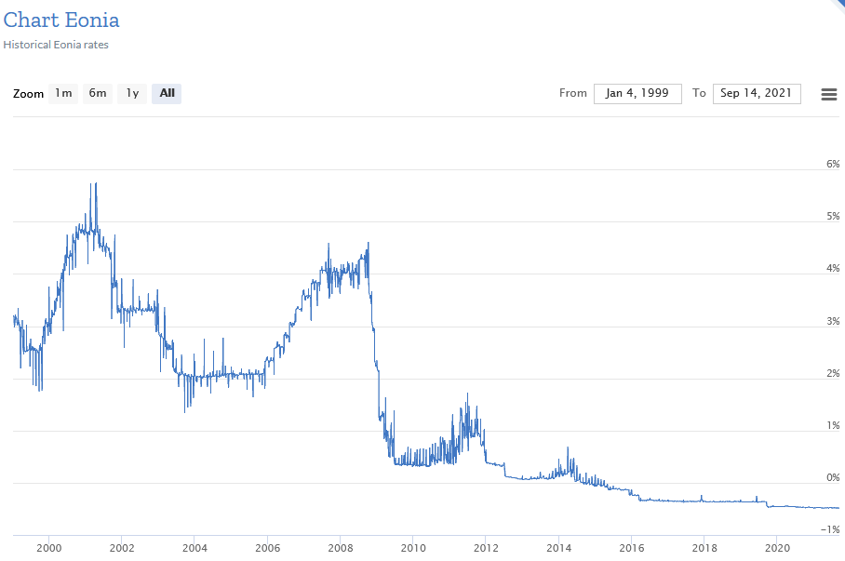

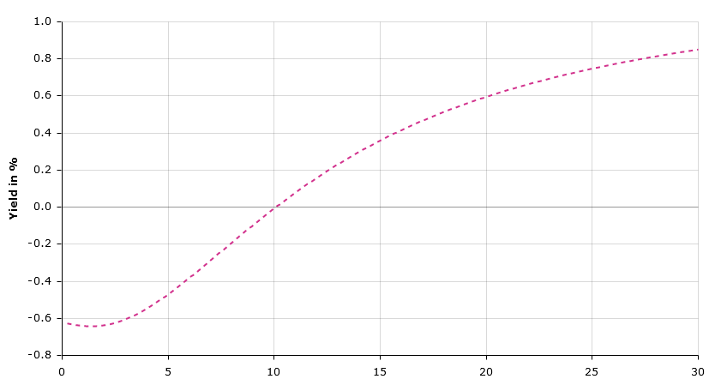

Fig. 2 – Eonia Rates Term Structure on 30th of August, 2021, European Central Bank

Fig. 1 – Eonia Spot Rates, Historical, European Central Bank

Call options chains data has been collected from barchart.com on the 30th of August 2021 on gold, silver and coffee. Data consists of options with 17 different strike prices and 12 tenors - up to 25/08/2022 - for a total of 204 options on gold, 18 strikes and 10 tenors up to 22/11/2022 for a total of 180 options on silver, and finally 20 strikes, 7 tenors, up to 12/08/2022 for options on coffee for a total of 140. Upon collection, data was checked for stability in the following days and assessed with stated ATM prices. The full dataset comprehends a wider range of strike prices, but so to have valid inputs for calculations on $QuanLib$ only options on strikes with market volatility data available on each tenor were selected.

All models have been calibrated using Python and $QuantLib$, an open-source library for quantitative finance. The full notebook can be viewed and downloaded on GitHub at <https://github.com/lucasomigli/SABR-volatility-models>. More regarding the $QuantLib$ port for python and its full documentation can be found on the developers’ GitHub page <https://github.com/lballabio/quantlib> or on <https://www.quantlib.org/>. SABR models are parametrized using $scipy.optimize$ and charts are plotted using $matplotlib$. Python code is available in the Appendix section. The machine on which models are run is a Ryzen 5 1600 6-Core processor with 16 Gb of RAM.

## Analysis

### Black Volatility Surface

We start by introducing the implied volatility smiles for a range of tenors. These are directly built from market data and are used together to construct the volatility matrix. In $QuantLib$ this is done by using a $ql.Matrix$ object which is passed to the $ql.BlackVarianceSurface$ method together with the calculation date and the day count convention to $ql.Actual365Fixed$. This method constructs a surface using linear interpolation (although other ways are possible, such as $LogLinearInterpolation, BicubicSpline$ or $KernelInterpolation$ and more).

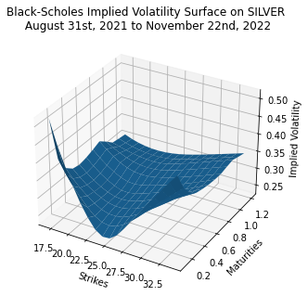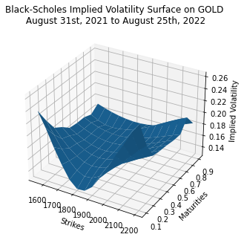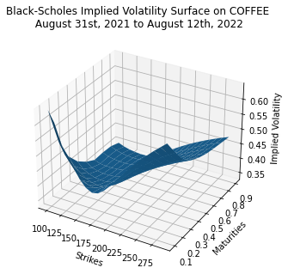

Fig. 3

Fig. 4

Fig. 5

### Local Volatility Model

As explained previously, the Local Volatility model builds by solving Dupire’s equation using implied volatility and market data. In $QuantLib$, this is done by using the process $ql.LocalVolSurface$ and plugging as arguments the yield term structure, the dividend term structure and the spot rate.

While we know that LVM has problems as with being a generally unstable model, there are a few issues with the Dupire calibration function inherently in $Quantlib$. The library currently does not support a constant calibration as the process requires the second derivative w.r.t the strike $\frac{∂^{2}K}{∂K^{2}}$, which is a problem to compute with discrete data. To get as accurate as possible, we need to use cubic spline interpolation. By doing so the calibration error increases and the algorithm returns an error as it does not find values allowing for a smooth calibration, meaning that the algorithm returns negative local volatility values. To cope with this, we use the alternative method $ql.NoExceptLocalVolSurface$ which allows less rigidity and gives more space for errors with the cost of a non-linear interpolation and an unrealistic surface.

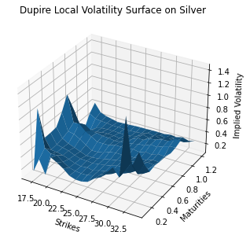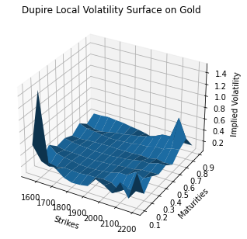

Fig. 6

Fig. 7

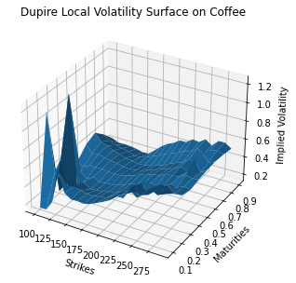

Fig. 8

For a clear view of smiles fit to market volatility please see the Appendix section. Surprisingly, the model does a sufficient job at fitting the data, but this comes at a cost. Spikes are present on the entire fit and the ‘smile’ output is completely unrealistic, leaving us with a model that cannot be used for any serious setting.

### Heston Model

We setup the initial conditions and run the calibration using $ql.HestonModel\left(process\right).calibrate$ and use the Levenberg-Marquardt algorithm for minimizing the objective function. Since this is generally advised by professionals for more accurate calculations [Cui, Rollin, Germano, 2016], $QuantLib$ uses this method by default in $ql.HestonProcess$. The process consists in minimizing the difference between model and market prices. To assess how initial parameters affect outputs, we run two scenarios on different initial conditions.

|  |  |  |  |  |  |
| --- | --- | --- | --- | --- | --- |
| **Heston Model Initial Conditions** | | | | | |
|  | **theta** | **kappa** | **sigma** | **rho** | **v0** |
| **Gold Model 1** | 0.03 | 0.30 | 0.50 | 0.30 | 0.04 |
| **Gold Model 2** | 0.01 | 0.50 | 0.50 | 0.10 | 0.03 |
| **Silver Model 1** | 0.01 | 0.50 | 0.50 | 0.10 | 0.03 |
| **Silver Model 2** | 0.50 | 0.50 | 1.25 | 0.30 | 0.00 |
| **Coffee Model 1** | 0.01 | 0.10 | 0.30 | 0.10 | 0.02 |
| **Coffee Model 2** | 0.20 | 0.90 | 0.90 | 0.90 | -0.19 |

Table 1

| **Heston Model on Silver, parameters output** | | |
| --- | --- | --- |
|  | **Model 1** | **Model 2** |
| **v0** | 0.473522 | 1.498890 |
| **kappa** | 0.468403 | 0.000000 |
| **theta** | 1.267293 | 26.829691 |
| **sigma** | 0.303634 | 0.268779 |
| **rho** | 0.000000 | 2.496803 |
| **avgError** | 2.393818 | 11.366665 |

Table 2

| **Heston Model on Coffee, parameters output** | | |
| --- | --- | --- |
|  | **Model 1** | **Model 2** |
| **v0** | 1.230783 | 0.939937 |
| **kappa** | 0.000000 | 0.000000 |
| **theta** | 0.623021 | 0.623019 |
| **sigma** | 0.618250 | 0.618249 |
| **rho** | 0.162907 | 0.162907 |
| **avgError** | 0.693019 | 0.692994 |

Table 3

| **Heston Model on Gold, parameters output** | | |
| --- | --- | --- |
|  | **Model 1** | **Model 2** |
| **v0** | 0.252117 | 0.461423 |
| **kappa** | 0.000000 | 0.453074 |
| **theta** | 0.172547 | 0.986932 |
| **sigma** | 0.334091 | -0.282696 |
| **rho** | 0.027691 | 0.000000 |
| **avgError** | 0.269509 | 128.010183 |

Table 4

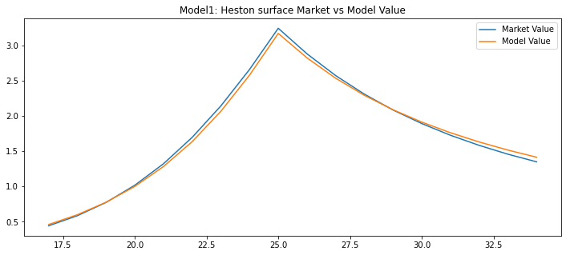

Fig. 9

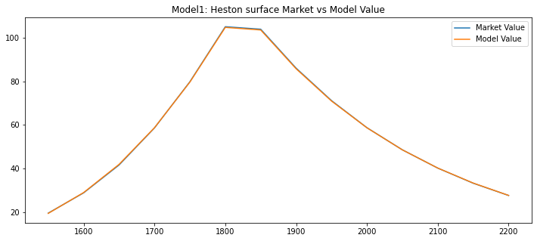

Fig. 10

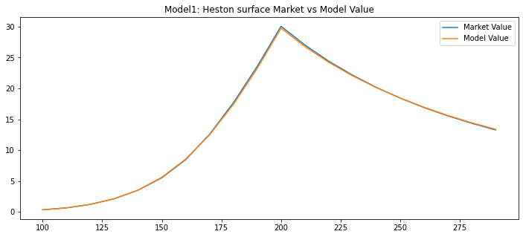

Fig. 11

Clearly, the first model is more accurate as the relative error is smaller. In particular, the first model fits best especially with longer tenors. We have tried calibrating with different parameters multiple times on coffee, with the output only changing slightly, which means there are fewer solutions and any initial condition will lead to a similar result. The relative errors plot show that where Model 1 is bound near zero, Model 2 presents more errors the larger the distance from ATM prices.

This is best explained by the average error which totals $avgError_{model1}=2.39$ and $avgError_{model2}=11.37$ for silver, $avgError_{model1}=0.54$ and $avgError_{model2}=180$ for gold and $avgError_{model1}=0.693$ and $avgError_{model2}=0.692$ for coffee. See the Appendix section for more tables and data.

Of course, the selection process for the initial conditions can be automated by running an additional optimization process using $scipy.optimize$, at the cost of higher computational times. We run a series of Heston calibrations starting with different initial conditions and find the results returning the lowest error.

The Heston proves to be generally an accurate model, especially for pricing options with mid to long term maturities. Nevertheless, tests confirm that sufficiently successful results are very much dependent on initial parameters set and time for calibration can be excessively long depending on data. Using the newly obtained parameters $\left(v, κ, θ, ρ, σ\right)$ we can compute smiles for each period volatility surfaces. Since the first Heston model has noticeably performed better, we shall use it for final comparisons at the end of the chapter.

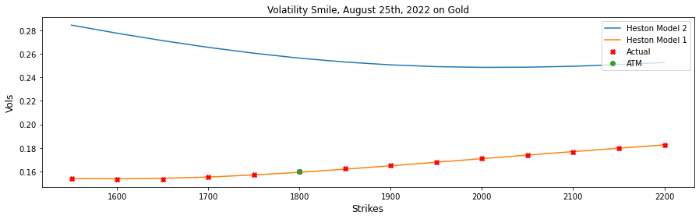

Fig. 12

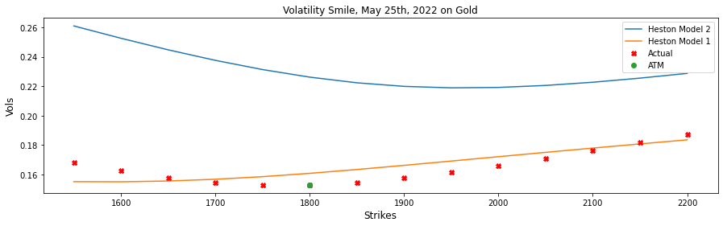

Fig. 13

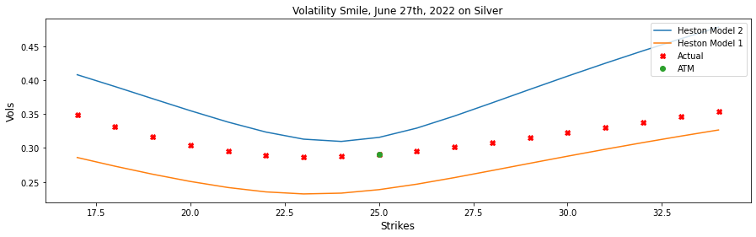

Fig. 14

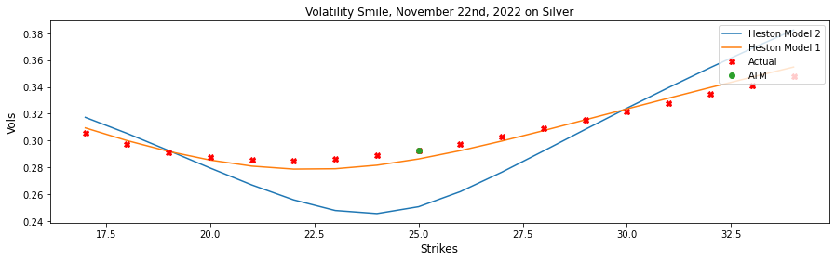

Fig. 15

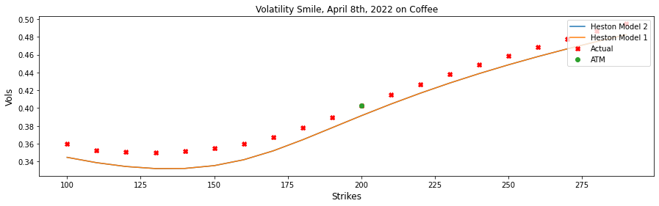

Fig. 16

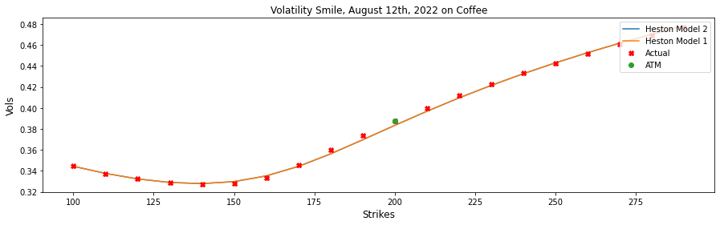

Fig. 17

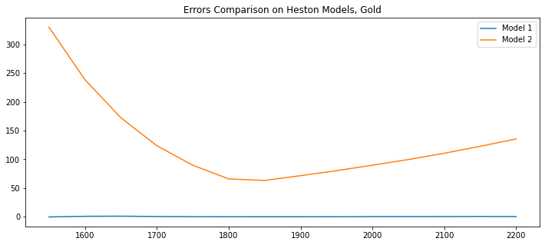

Fig. 18

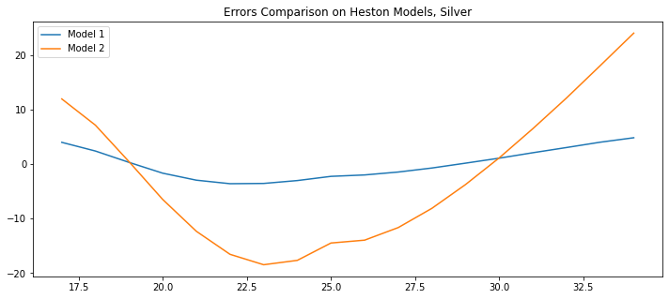

Fig. 19

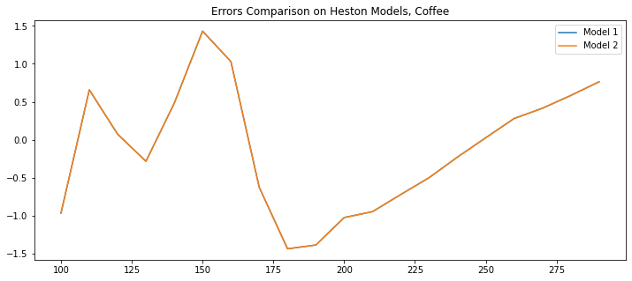

Fig. 20

### SABR Model

We use $scipy.minimize$ to calibrate the RMSE as shown before. For each smile, we use the fitting parameters into Hagan’s formula and solve using $ql.sabrVolatility$. After having parametrized all the smiles, we compute the volatility matrix and plug it into $ql.BlackVarianceSurface$ to construct the SABR volatility surface.

Again, as $β=0$ the model becomes a normal SABR and asset prices are assumed to follow a Gaussian distribution. The results are shown in the table below. A graph also shows how parameters change across tenors and by changing the value of $β$.

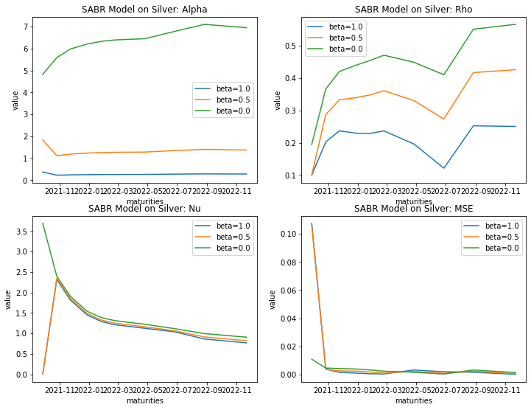

Fig. 21

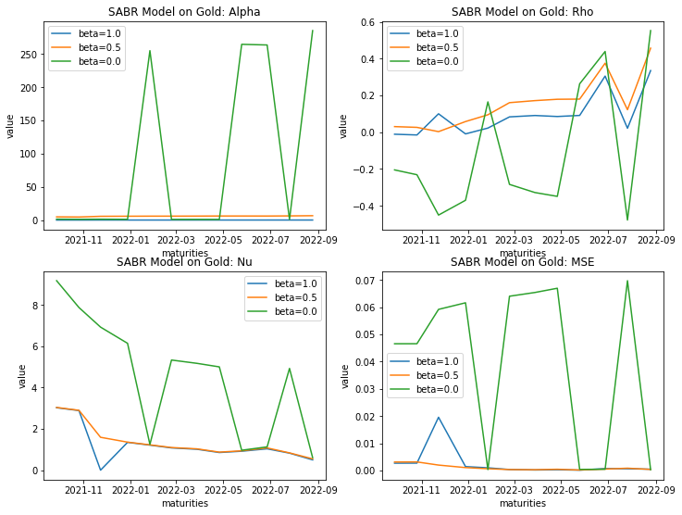

Fig. 22

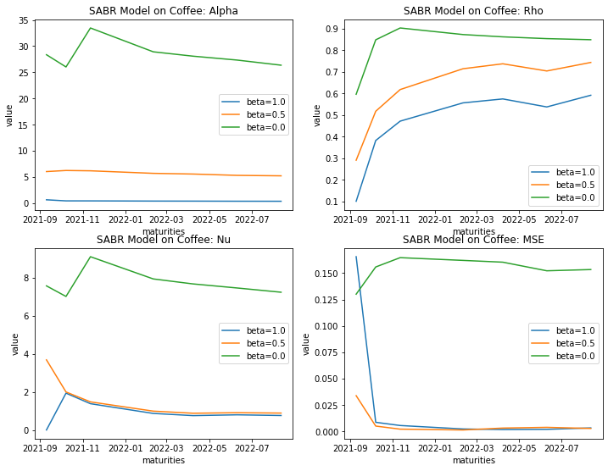

Fig. 23

Interestingly, parameters behave similarly over time across datasets with same $β$. In fact, the resulting graph for $α$ looks generally flat, $ρ$ seems to be increasing with time on average, $ν$ seems to be decreasing over time. The biggest exception comes with coffee data, where parameters behave in a drastically different way than with the other models, resulting in a constant underperformance across the entire set of tenors. An important consideration is that when $β=1$, $α$ tends to stay close to zero with small to no variability, whereas with $β=0$ the calibration results in higher values and variability with the parameter hitting more than 250 on gold data. The parameters calibration on $ν$ for the Normal SABR on coffee would imply a sharper smile on each tenor and a higher slope on each smile, which in essence results in a bad model. Similarly, spikes on $ν$ for gold would indicate sharp smiles on some (not all) tenors. Just by looking at the errors plot, it seems that the model which underperforms the most is with $β=0$, especially on coffee and gold.

Volatility surfaces are constructed by plugging the obtained matrix into $ql.BlackVarianceSurface$ (see the Appendix section for plots and the code). Below are volatility smiles for a basket of tenors.

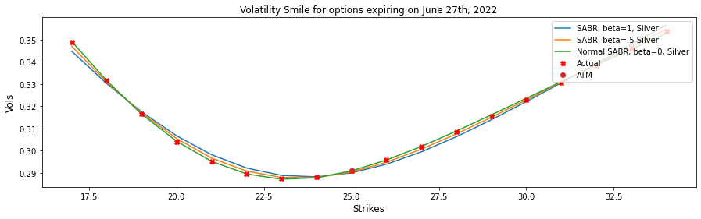

Fig. 24

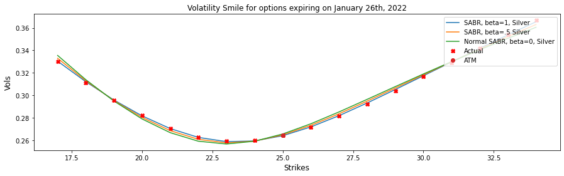

Fig. 25

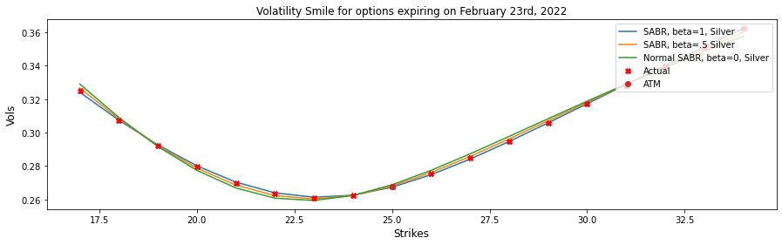

Fig. 26

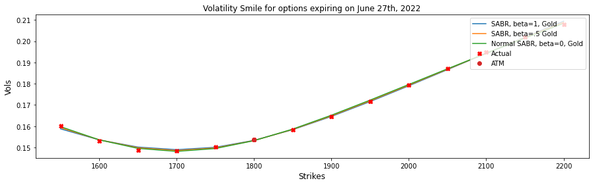

Fig. 27

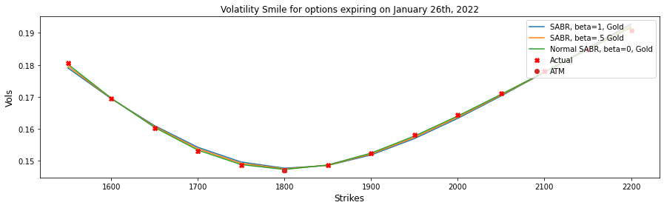

Fig. 28

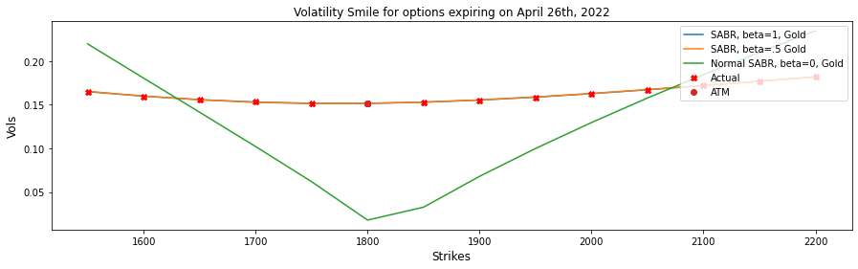

Fig. 29

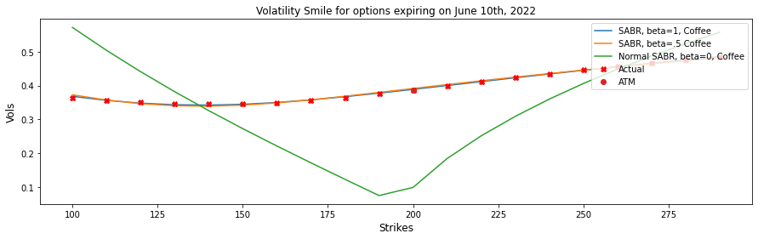

Fig. 30

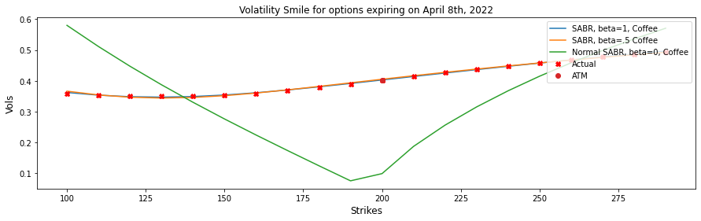

Fig. 31

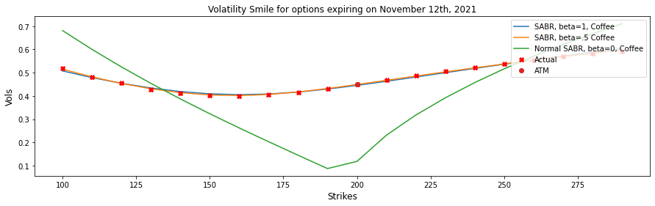

Fig. 32

As expected, SABR models with $β∈\left(.5, 1\right)$ are more accurate and behave similarly. The sharpness of smiles is the effect to why the Normal model performs badly on both coffee and gold. In particular, the surface on coffee returns with a v-shape across the entire plot which underperforms the most around ATM prices. This might be related to a calibration error and need some more research.

### Shifted SABR Model

For the shifted SABR model we run the calibration choosing a value for our shift $s$. In our case we used a shift of 50% of original prices. The calibration process runs the same way aside from this difference.

All the parameters result in a shift to the output function over time, while keeping the original model behavior. The errors plot show that that there is no large difference between the two shifted and classical SABR models. In particular, the largest differences in behavior of smiles are shown in the Normal SABR model. In this case, smiles seem to perform with the usual “V shape” for some tenors, but change to a better fit on other tenors, leading to a significantly different surface. See the full tables output and surfaces in the Appendix section for more details.

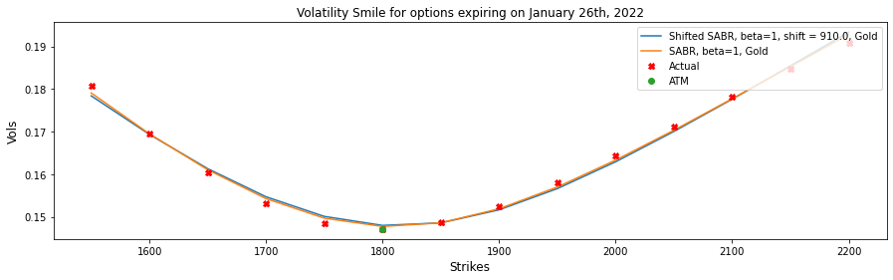

Fig. 33

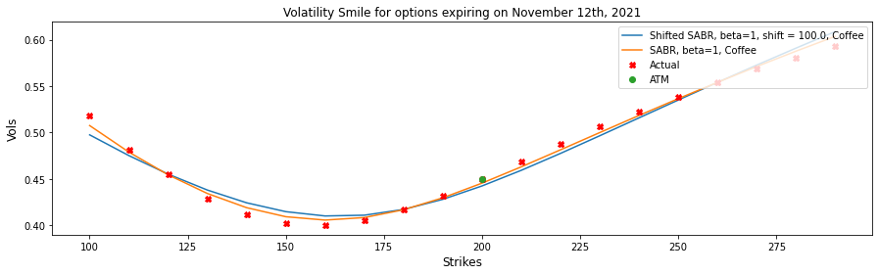

Fig. 34

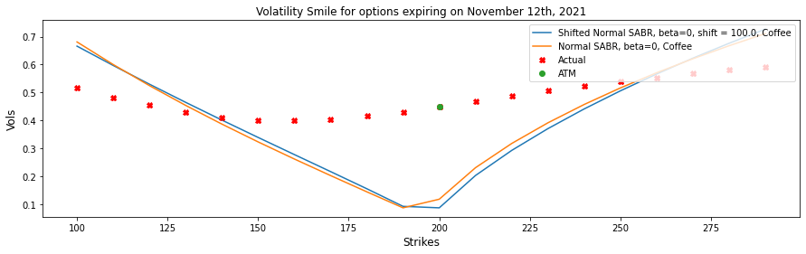

Fig. 35

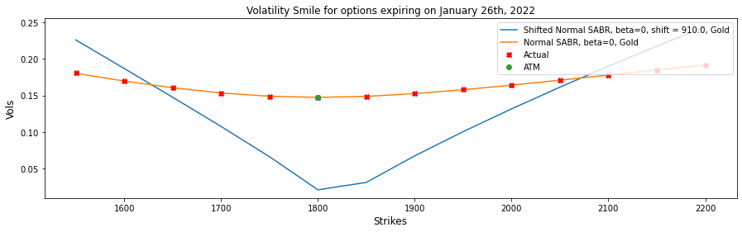

Fig. 36

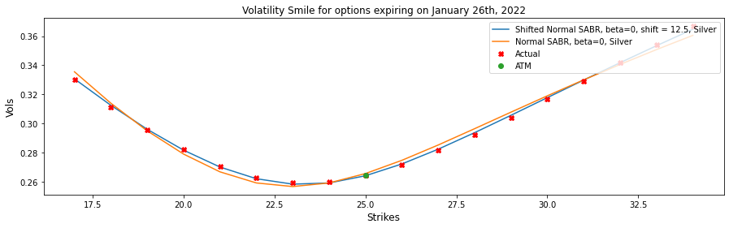

Fig. 37

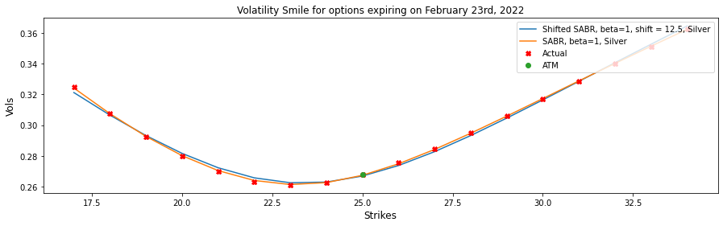

Fig. 38

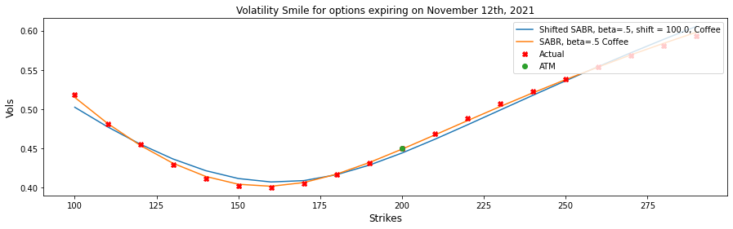

Fig. 39

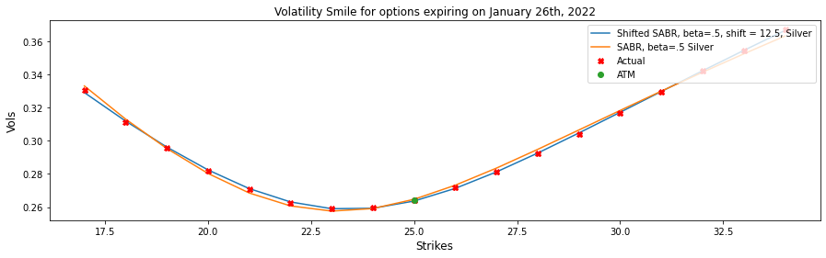

Fig. 40

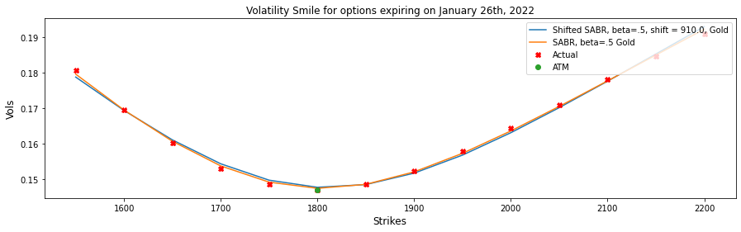

Fig. 41

### Free-Boundary SABR Model

The free boundary conditions are set up automatically using the method $ql.sabrFlochKennedyVolatility$ which relies on the TR-BDF2 algorithm for calibration which has been presented in the previous chapter. We setup the model as before, with the difference of minimizing the objective function using the Floch-Kennedy approach. Results are shown below with tables and graphs.

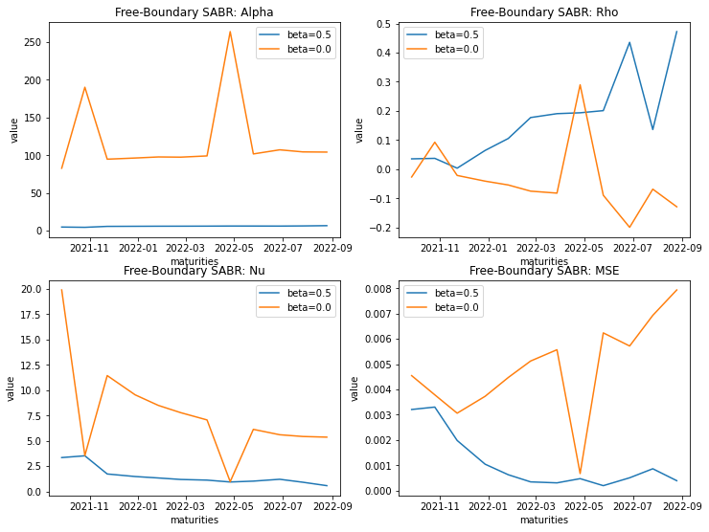

Fig. 42 - Free Boundary SABR output on gold

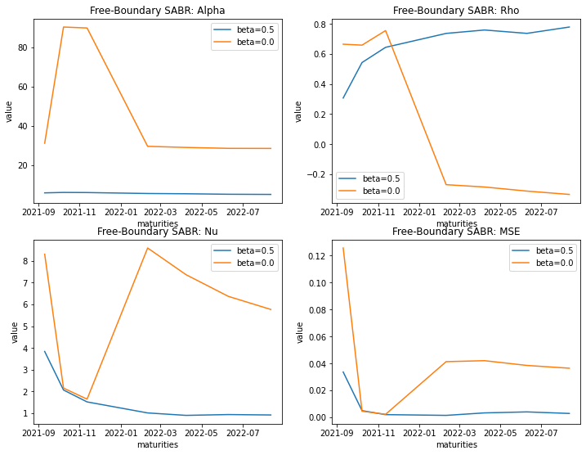

Fig. 43 – Free Boundary SABR output on coffee

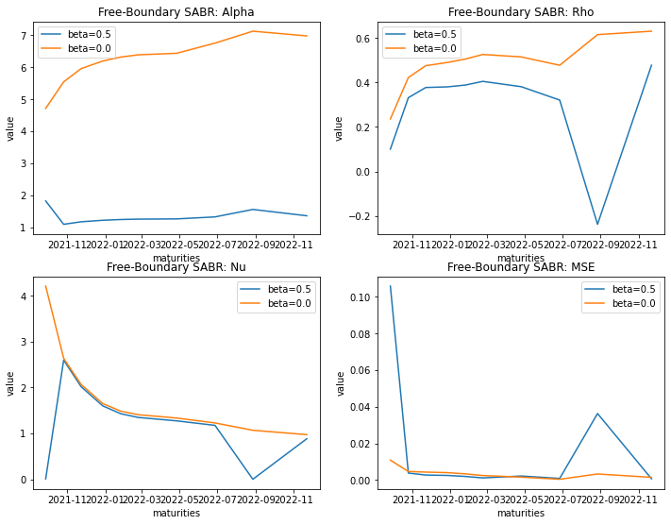

Fig. 44 - Free Boundary SABR output on silver

We can see from the results that the normal Free-Boundary SABR presents generally more spikes and a higher range of the output for all parameters, especially with $α$ where on gold data where it bounces from around 100 to 150 in value. The relative errors graph shows that the Normal model with $β=0$ underperforms in most cases and tenors.

We construct volatility surfaces for both models by inserting the volatility matrix obtained into .

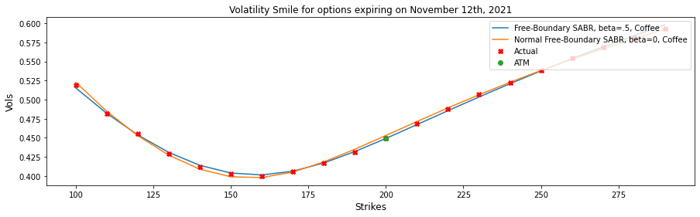

Fig. 45

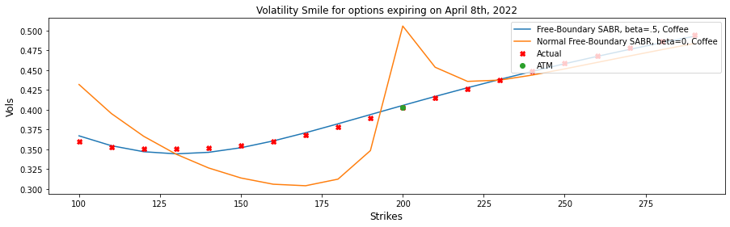

Fig. 46

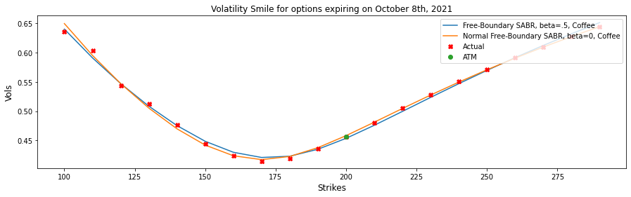

Fig. 47

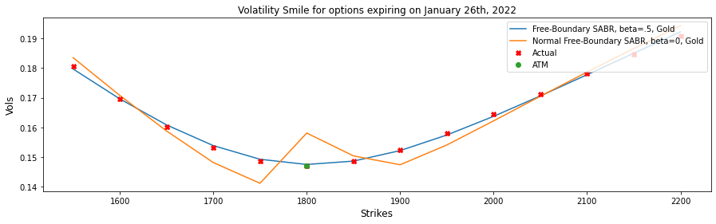

Fig. 48

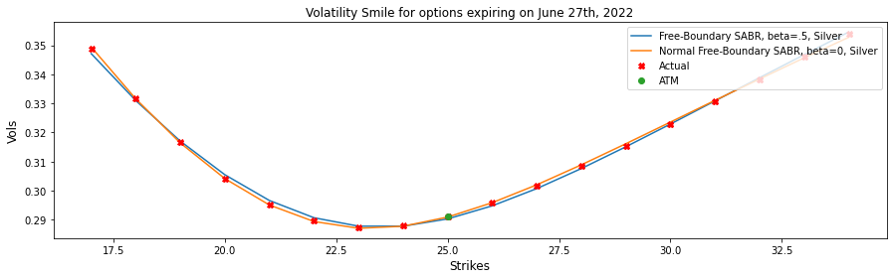

Fig. 49

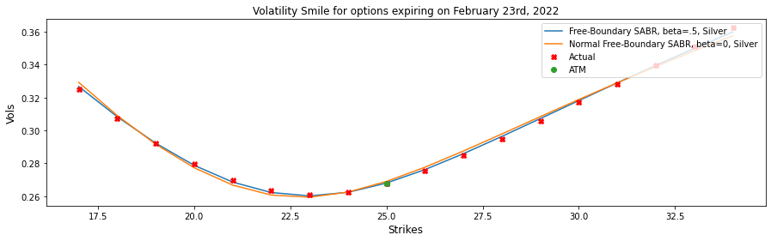

Fig. 50

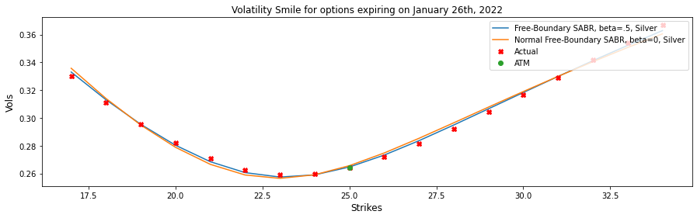

Fig. 51

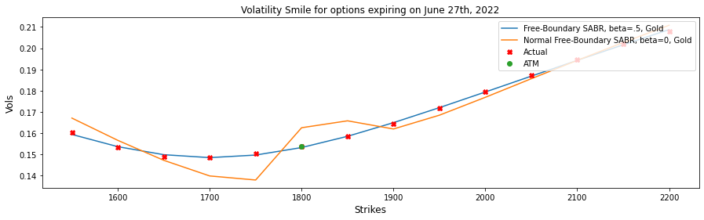

Fig. 52

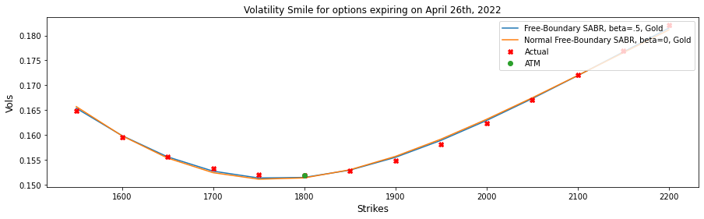

Fig. 53

As confirmed by the volatility smiles chart comparison, the normal case performs badly with short term tenors. The biggest difference relies in the small “bump” in the surface for the Normal Free-Boundary model with mid to long term maturities, when the calibration does not perform well. An exception is with data on silver options, where the two model behave similarly and fit well for all tenors to implied volatility smiles. Find the volatility surfaces for each model in the Appendix section.

### Mixture SABR Model

In the previous chapter, we have shown the process under which the mixture SABR model is calibrated, following the formula for the implied volatility of an option at a given expiry $σ_{mixtureSABR}^{N}=\sqrt{p^{2}σ_{FB}^{2}+{\left(1-p\right)}^{2}σ_{N}^{2}}$. We first calibrate the Free-Boundary SABR model, set initial conditions, then minimize the objective function for each maturity set under the constrains explained in the previous chapter and finally choose the best fitting curves.

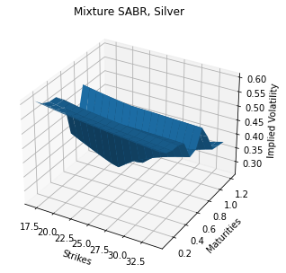

Fig. 54

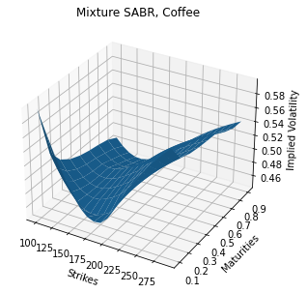

Fig. 55

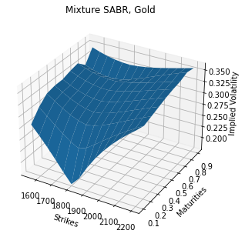

Fig. 56

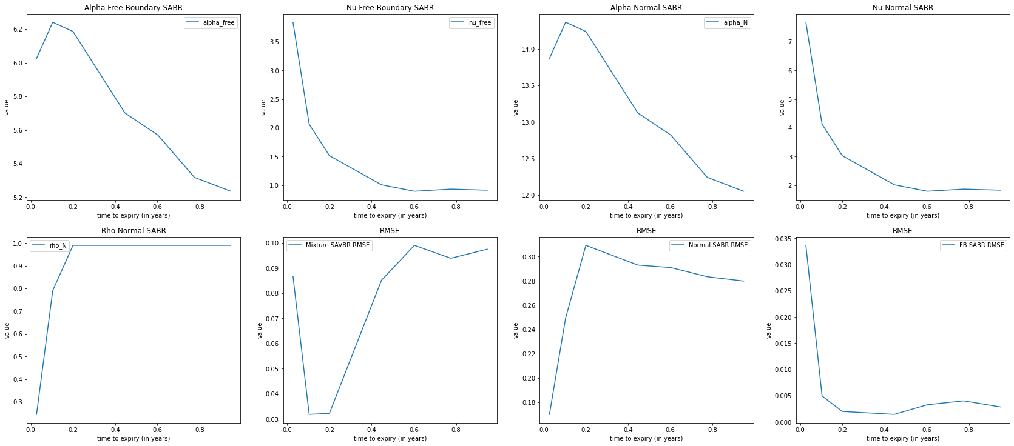

Fig. 57 – Mixture SABR calibration output on coffee

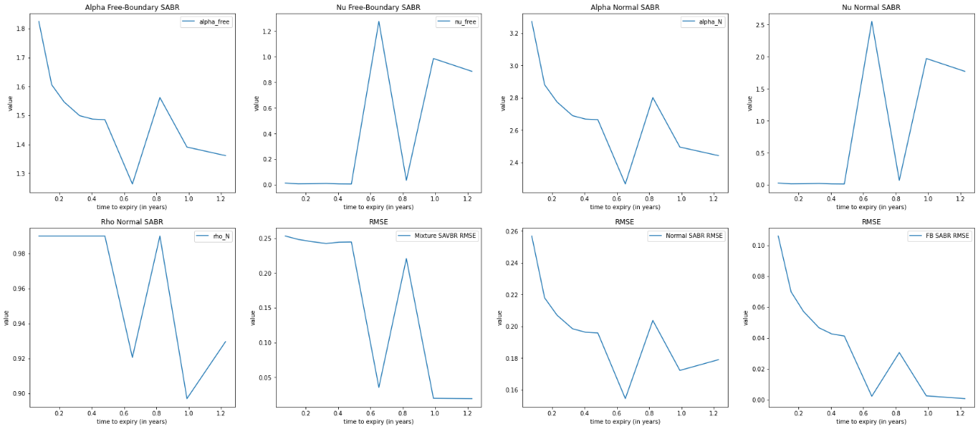

Fig. 58 – Mixture SABR calibration output on gold

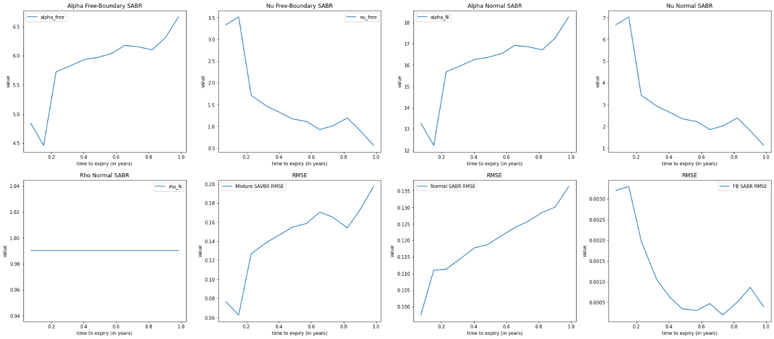

Fig. 59 – Mixture SABR calibration output on gold

The output results in overstated volatilities, with smiles always plotting on the area above market curves. The reason behind volatilities not quite fitting the smiles is most likely due to balancing good fitting non-normal Free-Boundary smiles with the poorly performing zero-correlation Normal SABR model, averaging about 0.15 RMSE on coffee, 0.002 on silver and 0.006 on gold. The Normal SABR has mostly an increasing RMSE whereas we see a decreasing RMSE for the Free Boundary model. Essentially the model turns out to increase the unbalanced error from the Normal SABR.

Mixture SABR on coffee behaves slightly better especially on mid to short maturities staying below 0.005. On silver, the resulting surface is completely unrealistic and shows steep changes over time and flat smiles. On gold, the surface is overstating volatility by a good 15-20%, from an average of 15% to 35% for the mixture SABR.

We argue that the Mixture model works best when both models calibrated together show already good results independently.

## Comparison

### Comparison of SABR, Heston and Black Volatility models

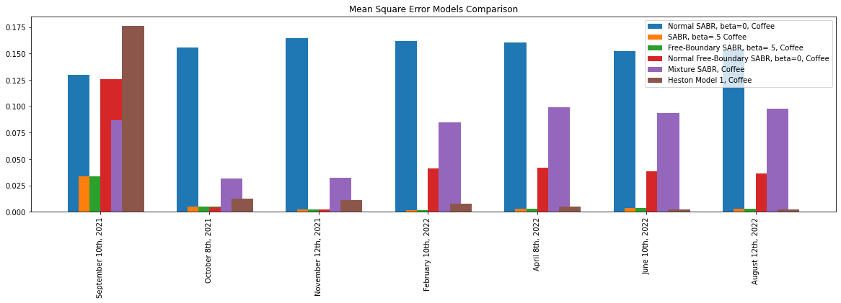

Fig. 60 – RMSE error comparison over tenors on coffee

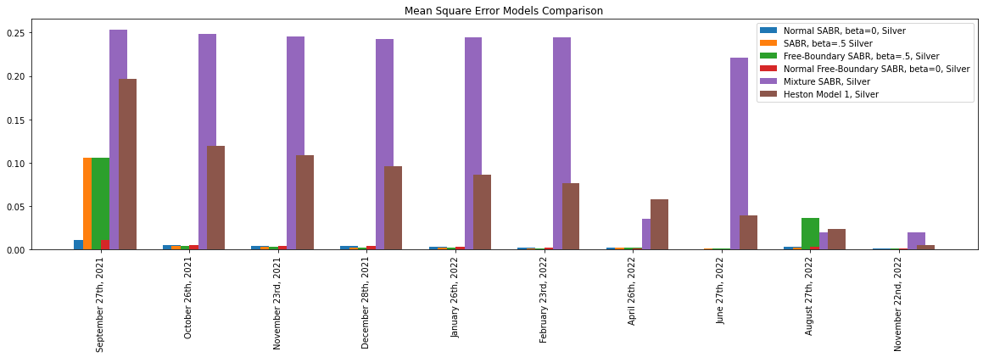

Fig. 61 - RMSE error comparison over tenors on silver

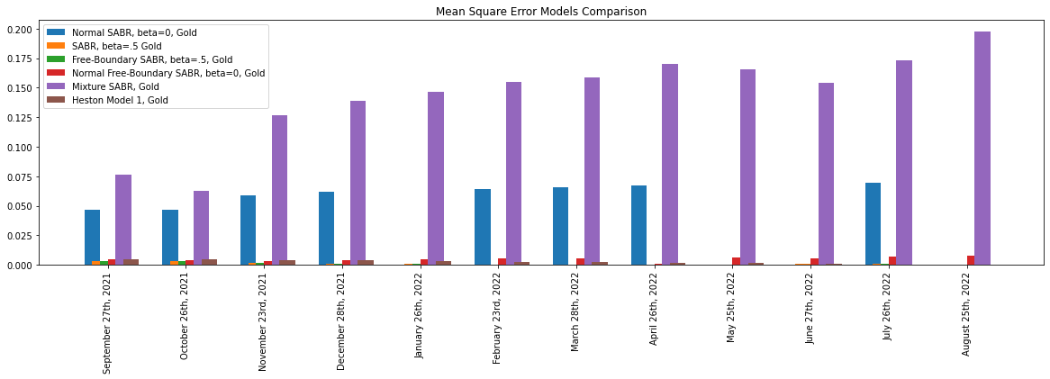

Fig. 62 - RMSE error comparison over tenors on gold

We can clearly distinguish two groups of performance. Gold and coffee, where the Normal SABR and mixture SABR are performing the worst on average, then silver, where the Mixture and the Heston model have larger RMSE on average across most tenors. The other cases, classical non-normal (roughly between 0.001 to 0.025 RMSE) and free boundary SABR models (ranging between 0.004 to 0.041 RMSE) perform generally well across all datasets except for the Normal free boundary SABR that performs poorly on coffee options data with an average of 0.04, especially for mid to long maturities.

To further assess our results, we shall present the same errors chart showing top performing models with the addition of the shifted SABR.

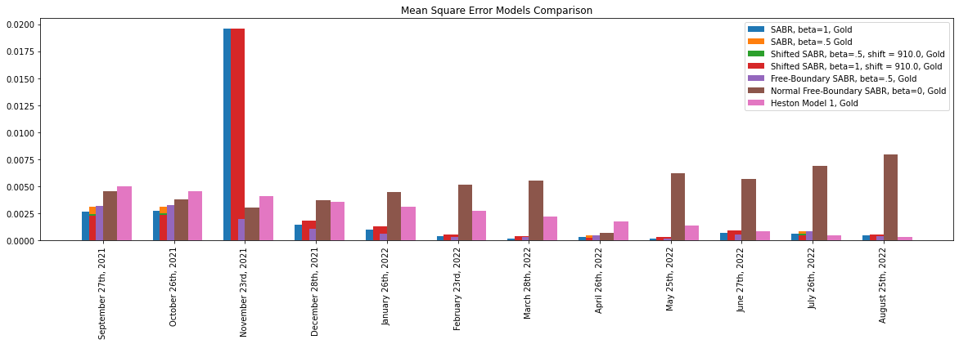

Fig. 64 - RMSE error comparison (2) over tenors on gold

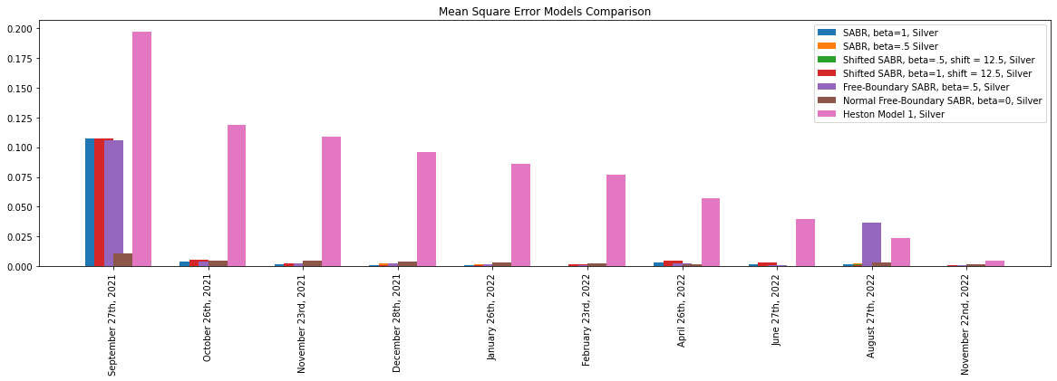

Fig. 65 - RMSE error comparison (2) over tenors on silver

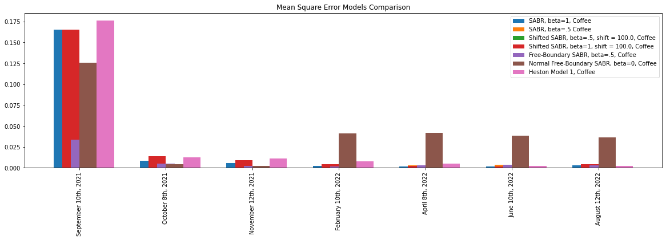

Fig. 63 - RMSE error comparison (2) over tenors on coffee

It is a common trend for models to perform best with longer maturities. There is a large difference between last ending and fist ending maturities. Moreover, it is important to note that there are outlier results in the calibration, the best example being SABR $β=1$ for gold on options maturing on 23/11/2021 (about 0.10 to 0.15 RMSE).

Overall, by looking at the average error table we can see that all SABR models result in the smallest RMSE and hence show the best fit to market data. More detailed smile charts and tables are shown in the relative Appendix section.

### Computational Complexity and Technical Implementation

The LVM was the easiest to implement by just setting interpolation of $ql.BlackVarianceSurface$ to $bicubic$ and using a local volatility handle on the Black surface. The main module $ql.LocalVolSurface$ which returns an error when IV data is “not smooth enough”. This appears to happen when the volatility surface is not arbitrage free, leading to negative LV or negative transition probabilities. Luckily the module $ql.NoExceptLocalVolSurface$ fixes this by skipping the smoothness check, at the cost of higher calculation error.

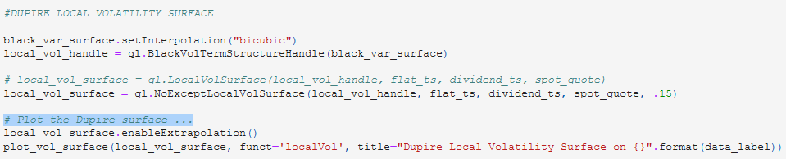

Code 1 – Local Volatility Model in Python

For the Heston model, a different set of mathematical methods can be used on $QuantLib$ (see the documentation for more details) and can be passed in $ql.HestonModel.calibrate$ which increases flexibility. There is an additional layer of complexity as the output is very sensible to initial conditions and another minimization with $scipy.optimize$ is run to find the surface with the lowest RMSE. This increases instability, inaccuracy and time.

Classic and free boundary SABR models implementation in $QuantLib$ perform well and can be coded easily by setting initial bounds on $scipy.optimize$. Nevertheless, we incurred in problems when setting $β=0$ as smiles behave poorly and have a v-shape on most tenors. The solution to this problem is still debated and needs more research. For classical and shifted SABR we use $ql.sabrVolatility$ and $ql.shiftedSabrVolatility$ respectively which are based on Hagan’s formula as shown previously. For free boundary SABR models we use $ql.flochKennedyVolatility$ which follows the process shown in chapter 3.

Mixture SABR does not have a specific module in $QuantLib$ so calibration was coded independently by following the process explained in chapter 3, with modules $ql.sabrVolatility$ setup for zero-correlation by forcing $ρ$ to be zero, then calibrating the Normal SABR model. Overall, the complexity of the minimization increases as more parameters are calibrated, possibly leading to the least desirable solution. For more details and reference please see the Appendix for a copy of python code.

### Computation time

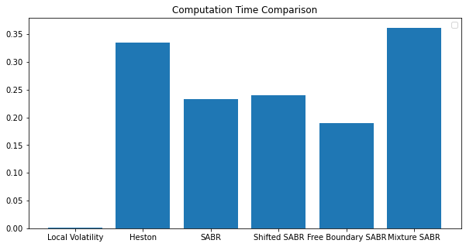

Fig. 66

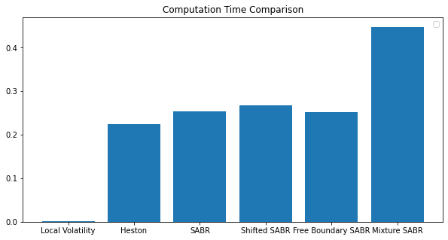

Fig. 67

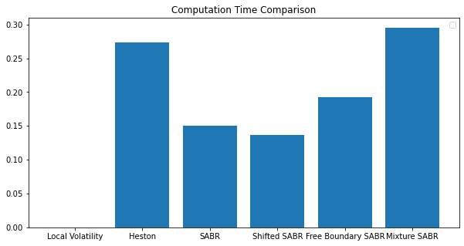

Fig. 68

The LVM stands out with an almost instant calculation, this comes from forcing the calibration using the $ql.NoExcceptLocalVolatilitySurface$. Leaving LVM aside, we clearly see that SABR models do stand out more, ranging from 0.15 to 0.25 seconds.

The mixture SABR model is taking the longest (above 0.30 seconds) to calibrate with approximately double the time of the Normal or the free boundary SABR. This is expected since it does involve calibrating the two processes together.

The Heston model scores poorly when not used for gold data, where it stands out with the fastest computation time after LVM (about 0.21 seconds). Nevertheless, this varies with respect to initial conditions and data used, which means that computation time is generally understated here.

# CONCLUSION

In this thesis we have gone through an analytical and theoretical review of models developed after Black-Scholes for pricing options. We have explained issues and motivations of new models to account for changes in volatility smiles across time. Following, we have run calibrations for each model using vanilla options data for gold, silver and coffee. We have analyzed and compared models’ performance across datasets and calibration methods. In the last section we have commented on the main sub questions posed in the introduction, goodness of fit, computational complexity, computational time and technical implementation to structure our findings.

Overall, we have seen that the analysis has given mixed results. SABR models – classical, shifted and free boundary - generally performed the best with a closest fit to market data, with outliers when using the normal model on coffee and gold data. The Heston model follows which tended to be more efficient with longer tenors, and finally the Mixture model which did not return satisfactory results. Most models were natively easy to implement using $QuantLib$. The mixture SABR model was the most challenging to code given $QuantLib$ does not support a native implementation.

On a computation time standpoint, the mixture SABR model is approximately twice as slow as the classical SABR model, whereas the Heston model have mixed results and in the general case can be the slowest due to sensibility to initial conditions. All the other SABR models have performed well with about 100 to 300 milliseconds of time calibration. The local volatility model performed the fastest although the fit is inconclusive.

SABR models, not including the mixture version, performed best overall with the lowest RMSE across datasets especially with very few outliers, especially on silver data and options maturing on 27/08/2021. Conversely, the Normal SABR model has performed poorly due to a constant v-shape across tenors, which might be related to calibration errors in $QuantLib$. In addition, free boundary models share a good level of complexity, necessarily higher than classical SABR but much lower than Heston or LVM models. SABR models can be easily calibrated using relative modules $ql.sabrVolatility$ for classical SABR, $ql.shiftedSabrVolatility$ for shifted SABR and $ql.flochKennedySABR$ for the free boundary case.

|  |  |
| --- | --- |
| **Model (gold)** | **Average RMSE** |
| SABR, beta=1 | 0.002516 |
| SABR, beta=.5 | 0.001084 |
| Shifted SABR, beta=1, shift = 910.0 | 0.002566 |
| Shifted SABR, beta=.5, shift = 910.0 | 0.001099 |
| Normal Free-Boundary SABR, beta=0 | 0.004813 |
| Free-Boundary SABR, beta=.5 | 0.001103 |
| Heston Model 1 | 0.002504 |

Table 5

|  |  |
| --- | --- |
| **Model (silver)** | **Average RMSE** |
| SABR, beta=1 | 0.012200 |
| SABR, beta=.5 | 0.012385 |
| Shifted SABR, beta=1, shift = 910. | 0.012953 |
| Shifted SABR, beta=.5, shift = 910.0 | 0.012346 |
| Normal Free-Boundary SABR, beta=0 | 0.003667 |
| Free-Boundary SABR, beta=.5 | 0.015829 |
| Heston Model 1 | 0.080827 |

Table 6

|  |  |
| --- | --- |
| **Model (coffee)** | **Average RMSE** |
| SABR, beta=1 | 0.027006 |
| SABR, beta=.5 | 0.007454 |
| Shifted SABR, beta=1, shift = 910.0 | 0.028827 |
| Shifted SABR, beta=.5, shift = 910.0 | 0.010505 |
| Normal Free-Boundary SABR, beta=0 | 0.041553 |
| Free-Boundary SABR, beta=.5 | 0.007456 |
| Heston Model 1 | 0.031102 |

Table 7

To further extent this study, research could be performed on stress test comparisons of SABR models to negative oil prices during the pandemic and compare results to general market conditions. It would also be beneficial to perform the same comparison across data gathered on multiple days to have a clearer indication of performance and lowering bias on data selection. Ultimately, research could continue around the development of the mixture SABR in explaining market volatility, which might need adjustments with respect to its calibration and balancing processes, as so far has given failing results.

Generally, Antonov’s approach to use SABR models works better than traditional models in calibrating implied volatility on commodities markets and share methods that work well under negative rates.

# APPENDIX

## LVM

### Local Volatility Model on gold

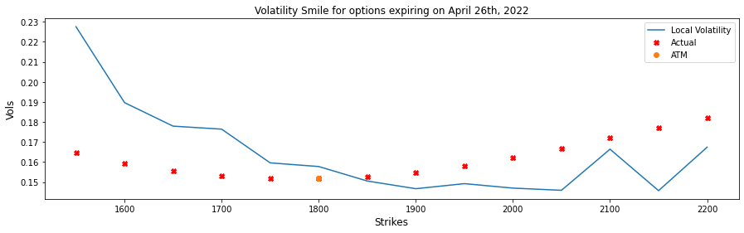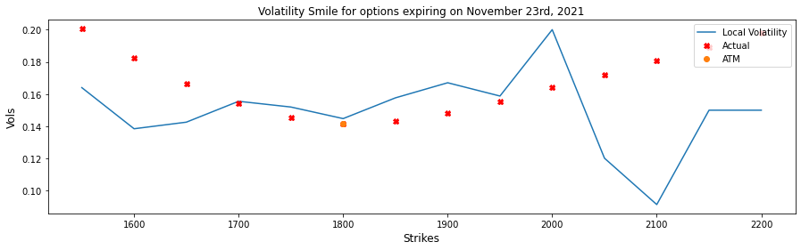

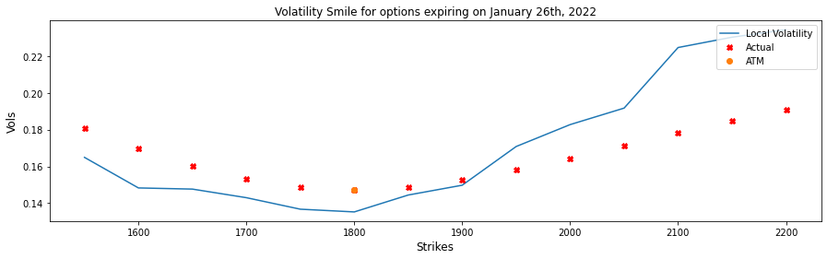

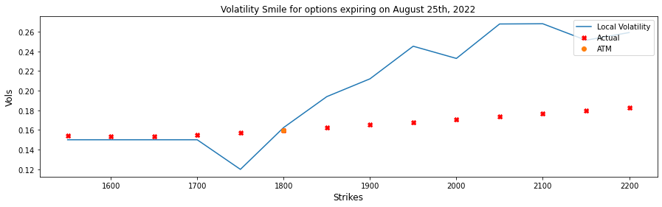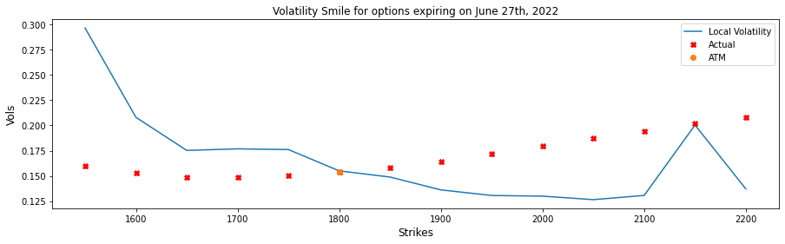

### Local Volatility Model on silver

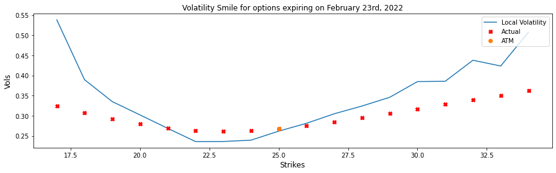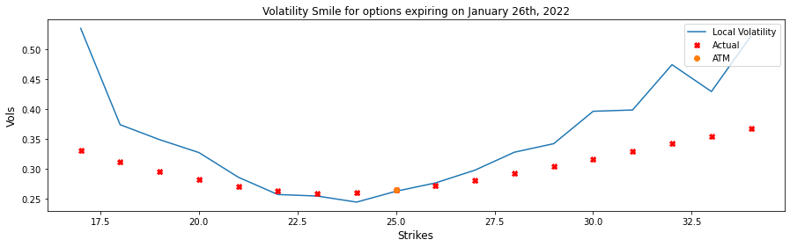

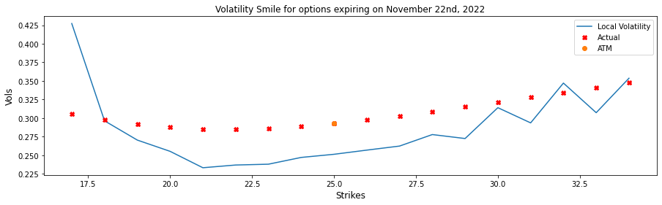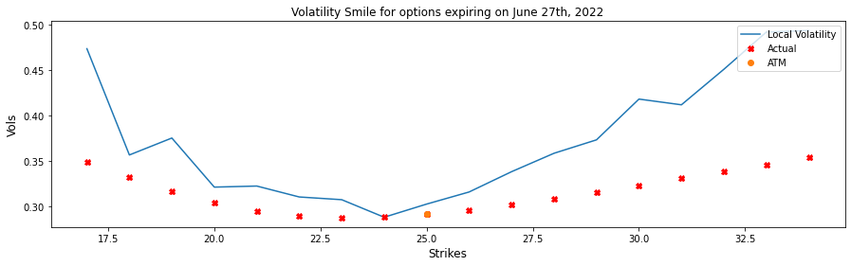

### Local Volatility Model on coffee

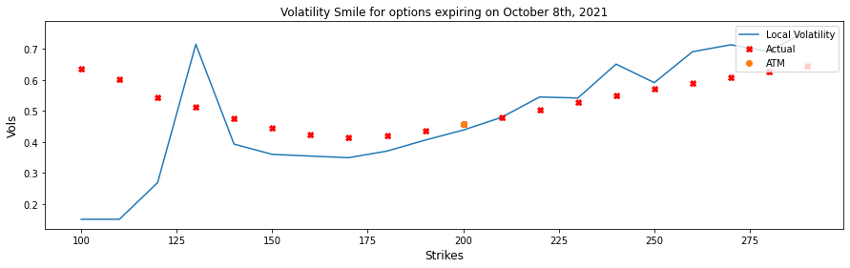

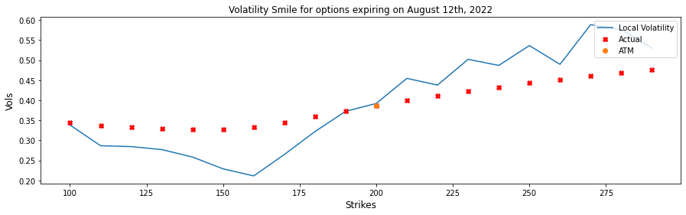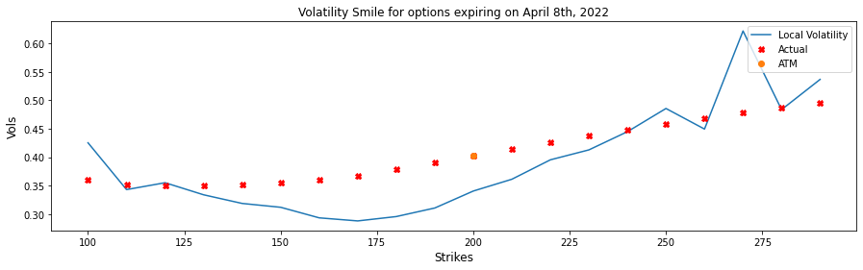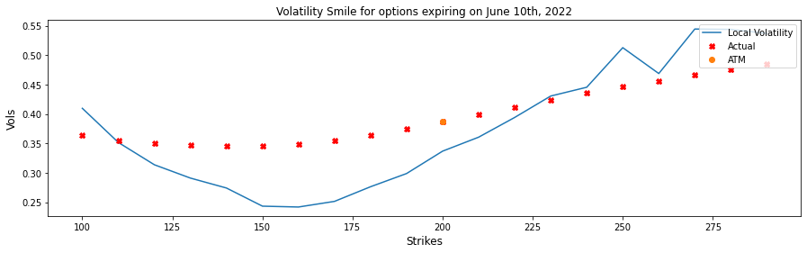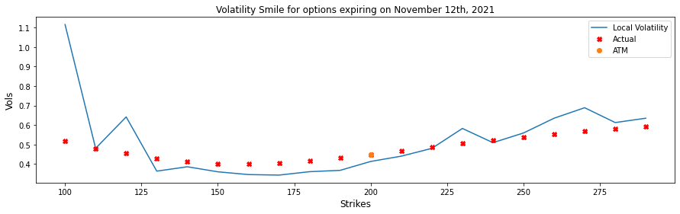

## Heston

### Heston Model on gold

| Heston Model Initial Conditions on (gold) | | | | | |
| --- | --- | --- | --- | --- | --- |
|  | **theta** | **kappa** | **sigma** | **rho** | **v0** |
| **Model1** | 0.030000 | 0.300000 | 0.500000 | 0.300000 | 0.040000 |
| **Model2** | 0.010000 | 0.500000 | 0.500000 | 0.100000 | 0.030000 |

| Heston Model 1, gold calibration results | | | | |
| --- | --- | --- | --- | --- |
|  | **Strikes** | **Market Value** | **Model Value** | **Relative Error (%)** |
| **0** | 1550.000000 | 19.492403 | 19.375897 | -0.597696 |
| **1** | 1600.000000 | 28.798716 | 28.934788 | 0.472492 |
| **2** | 1650.000000 | 41.573900 | 41.866857 | 0.704666 |
| **3** | 1700.000000 | 58.585336 | 58.672316 | 0.148467 |
| **4** | 1750.000000 | 79.768612 | 79.623471 | -0.181952 |
| **5** | 1800.000000 | 105.019940 | 104.708932 | -0.296141 |
| **6** | 1850.000000 | 103.874121 | 103.527089 | -0.334090 |
| **7** | 1900.000000 | 85.994838 | 85.715468 | -0.324869 |
| **8** | 1950.000000 | 71.103345 | 70.905193 | -0.278682 |
| **9** | 2000.000000 | 58.676208 | 58.642578 | -0.057314 |
| **10** | 2050.000000 | 48.535785 | 48.515652 | -0.041479 |
| **11** | 2100.000000 | 40.145960 | 40.164975 | 0.047363 |
| **12** | 2150.000000 | 33.216956 | 33.284023 | 0.201907 |
| **13** | 2200.000000 | 27.591312 | 27.615042 | 0.086006 |

| Heston Model 1, gold parameters output | |
| --- | --- |
|  | **Value** |
| **v0** | 0.252117 |
| **kappa** | 0.000000 |
| **theta** | 0.172547 |
| **sigma** | 0.334091 |
| **rho** | 0.027691 |
| **avgError** | 0.269509 |

| Heston Model 2, gold calibration results | | | | |
| --- | --- | --- | --- | --- |
|  | **Strikes** | **Market Value** | **Model Value** | **Relative Error (%)** |
| **0** | 1550.000000 | 19.492403 | 83.867143 | 330.255541 |
| **1** | 1600.000000 | 28.798716 | 97.568235 | 238.793698 |
| **2** | 1650.000000 | 41.573900 | 113.217348 | 172.327946 |
| **3** | 1700.000000 | 58.585336 | 131.037464 | 123.669391 |
| **4** | 1750.000000 | 79.768612 | 151.243329 | 89.602559 |
| **5** | 1800.000000 | 105.019940 | 174.019636 | 65.701519 |
| **6** | 1850.000000 | 103.874121 | 169.351989 | 63.035785 |
| **7** | 1900.000000 | 85.994838 | 147.334642 | 71.329634 |
| **8** | 1950.000000 | 71.103345 | 128.013438 | 80.038560 |
| **9** | 2000.000000 | 58.676208 | 111.246076 | 89.593158 |
| **10** | 2050.000000 | 48.535785 | 96.817246 | 99.476008 |
| **11** | 2100.000000 | 40.145960 | 84.468619 | 110.403782 |
| **12** | 2150.000000 | 33.216956 | 73.928840 | 122.563561 |
| **13** | 2200.000000 | 27.591312 | 64.936544 | 135.351417 |

| Heston Model 2, gold parameters output | |
| --- | --- |
|  | **Value** |
| **v0** | 0.461423 |
| **kappa** | 0.453074 |
| **theta** | 0.986932 |
| **sigma** | -0.282696 |
| **rho** | 0.000000 |
| **avgError** | 128.010183 |



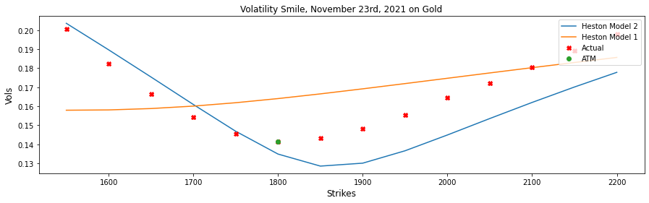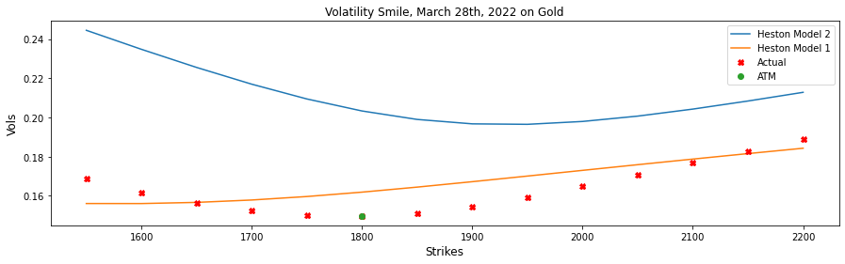

### Heston Model on silver

| Heston Model 1, silver calibration results | | | | |
| --- | --- | --- | --- | --- |
|  | **Strikes** | **Market Value** | **Model Value** | **Relative Error (%)** |
| **0** | 17.000000 | 0.441963 | 0.459567 | 3.983277 |
| **1** | 18.000000 | 0.584625 | 0.598604 | 2.391130 |
| **2** | 19.000000 | 0.772837 | 0.775236 | 0.310407 |
| **3** | 20.000000 | 1.016130 | 0.999160 | -1.670087 |
| **4** | 21.000000 | 1.320553 | 1.281587 | -2.950709 |
| **5** | 22.000000 | 1.694830 | 1.633884 | -3.595998 |
| **6** | 23.000000 | 2.140845 | 2.064862 | -3.549233 |
| **7** | 24.000000 | 2.657936 | 2.577651 | -3.020570 |
| **8** | 25.000000 | 3.241375 | 3.168390 | -2.251649 |
| **9** | 26.000000 | 2.879332 | 2.821984 | -1.991708 |
| **10** | 27.000000 | 2.570582 | 2.533089 | -1.458539 |
| **11** | 28.000000 | 2.307485 | 2.290853 | -0.720777 |
| **12** | 29.000000 | 2.082518 | 2.086032 | 0.168738 |
| **13** | 30.000000 | 1.890759 | 1.911202 | 1.081251 |
| **14** | 31.000000 | 1.724693 | 1.760562 | 2.079688 |
| **15** | 32.000000 | 1.581650 | 1.629603 | 3.031865 |
| **16** | 33.000000 | 1.456465 | 1.514822 | 4.006769 |
| **17** | 34.000000 | 1.348394 | 1.413472 | 4.826319 |

| Heston Model 1, silver parameters output | |
| --- | --- |
|  | **Value** |
| **v0** | 0.473522 |
| **kappa** | 0.468403 |
| **theta** | 1.267293 |
| **sigma** | 0.303634 |
| **rho** | 0.000000 |
| **avgError** | 2.393818 |

| Heston Model 2, silver calibration results | | | | |
| --- | --- | --- | --- | --- |
|  | **Strikes** | **Market Value** | **Model Value** | **Relative Error (%)** |
| **0** | 17.000000 | 0.441963 | 0.494731 | 11.939443 |
| **1** | 18.000000 | 0.584625 | 0.626302 | 7.128863 |
| **2** | 19.000000 | 0.772837 | 0.776131 | 0.426138 |
| **3** | 20.000000 | 1.016130 | 0.950184 | -6.489953 |
| **4** | 21.000000 | 1.320553 | 1.157844 | -12.321257 |
| **5** | 22.000000 | 1.694830 | 1.414538 | -16.538056 |
| **6** | 23.000000 | 2.140845 | 1.745868 | -18.449578 |
| **7** | 24.000000 | 2.657936 | 2.188864 | -17.647980 |
| **8** | 25.000000 | 3.241375 | 2.772408 | -14.468139 |
| **9** | 26.000000 | 2.879332 | 2.477830 | -13.944281 |
| **10** | 27.000000 | 2.570582 | 2.271424 | -11.637754 |
| **11** | 28.000000 | 2.307485 | 2.120275 | -8.113146 |
| **12** | 29.000000 | 2.082518 | 2.004393 | -3.751439 |
| **13** | 30.000000 | 1.890759 | 1.912151 | 1.131395 |
| **14** | 31.000000 | 1.724693 | 1.836541 | 6.485091 |
| **15** | 32.000000 | 1.581650 | 1.773126 | 12.106125 |
| **16** | 33.000000 | 1.456465 | 1.718957 | 18.022530 |
| **17** | 34.000000 | 1.348394 | 1.671993 | 23.998798 |

| Heston Model 2, silver parameters output | |
| --- | --- |
|  | **Value** |
| **v0** | 1.498890 |
| **kappa** | 0.000000 |
| **theta** | 26.829691 |
| **sigma** | 0.268779 |
| **rho** | 2.496803 |
| **avgError** | 11.366665 |



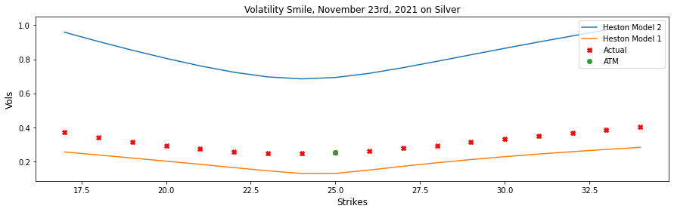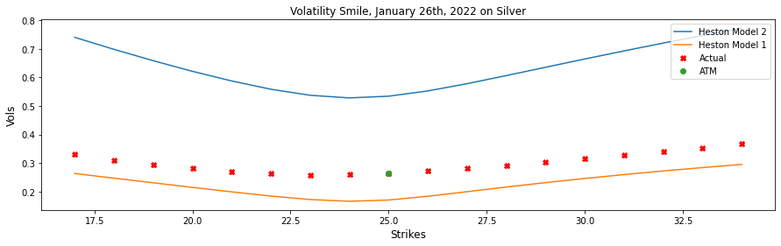

### Heston Model on coffee

|  | **theta** | **kappa** | **sigma** | **rho** | **v0** |
| --- | --- | --- | --- | --- | --- |
| **Model1** | 0.010000 | 0.100000 | 0.300000 | 0.100000 | 0.020000 |
| **Model2** | 0.200000 | 0.900000 | 0.900000 | 0.900000 | -0.190000 |

| Heston Model 1, coffee calibration results | | | | |
| --- | --- | --- | --- | --- |
|  | **Strikes** | **Market Value** | **Model Value** | **Relative Error (%)** |
| **0** | 100.000000 | 0.336740 | 0.333489 | -0.965443 |
| **1** | 110.000000 | 0.655519 | 0.659828 | 0.657296 |
| **2** | 120.000000 | 1.218025 | 1.218920 | 0.073469 |
| **3** | 130.000000 | 2.131744 | 2.125694 | -0.283803 |
| **4** | 140.000000 | 3.511885 | 3.528806 | 0.481833 |
| **5** | 150.000000 | 5.528623 | 5.607725 | 1.430781 |
| **6** | 160.000000 | 8.461670 | 8.548821 | 1.029953 |
| **7** | 170.000000 | 12.562362 | 12.483658 | -0.626503 |
| **8** | 180.000000 | 17.671092 | 17.417277 | -1.436324 |
| **9** | 190.000000 | 23.555020 | 23.228484 | -1.386272 |
| **10** | 200.000000 | 30.054349 | 29.746388 | -1.024680 |
| **11** | 210.000000 | 27.026128 | 26.770173 | -0.947064 |
| **12** | 220.000000 | 24.402363 | 24.226489 | -0.720728 |
| **13** | 230.000000 | 22.138513 | 22.028049 | -0.498968 |
| **14** | 240.000000 | 20.156662 | 20.110653 | -0.228258 |
| **15** | 250.000000 | 18.421029 | 18.425992 | 0.026945 |
| **16** | 260.000000 | 16.889495 | 16.936752 | 0.279800 |
| **17** | 270.000000 | 15.548853 | 15.613419 | 0.415246 |
| **18** | 280.000000 | 14.348527 | 14.432189 | 0.583068 |
| **19** | 290.000000 | 13.272169 | 13.373561 | 0.763947 |

| Heston Model 1, coffee parameters output | |
| --- | --- |
|  | **Value** |
| **v0** | 1.230783 |
| **kappa** | 0.000000 |
| **theta** | 0.623021 |
| **sigma** | 0.618250 |
| **rho** | 0.162907 |
| **avgError** | 0.693019 |

| Heston Model 2, coffee calibration results | | | | |
| --- | --- | --- | --- | --- |
|  | **Strikes** | **Market Value** | **Model Value** | **Relative Error (%)** |
| **0** | 100.000000 | 0.336740 | 0.333489 | -0.965550 |
| **1** | 110.000000 | 0.655519 | 0.659827 | 0.657200 |
| **2** | 120.000000 | 1.218025 | 1.218919 | 0.073379 |
| **3** | 130.000000 | 2.131744 | 2.125693 | -0.283892 |
| **4** | 140.000000 | 3.511885 | 3.528803 | 0.481740 |
| **5** | 150.000000 | 5.528623 | 5.607719 | 1.430680 |
| **6** | 160.000000 | 8.461670 | 8.548812 | 1.029845 |
| **7** | 170.000000 | 12.562362 | 12.483644 | -0.626612 |
| **8** | 180.000000 | 17.671092 | 17.417259 | -1.436429 |
| **9** | 190.000000 | 23.555020 | 23.228460 | -1.386370 |
| **10** | 200.000000 | 30.054349 | 29.746362 | -1.024769 |
| **11** | 210.000000 | 27.026128 | 26.770144 | -0.947174 |
| **12** | 220.000000 | 24.402363 | 24.226457 | -0.720858 |
| **13** | 230.000000 | 22.138513 | 22.028016 | -0.499119 |
| **14** | 240.000000 | 20.156662 | 20.110619 | -0.228430 |
| **15** | 250.000000 | 18.421029 | 18.425957 | 0.026752 |
| **16** | 260.000000 | 16.889495 | 16.936716 | 0.279587 |
| **17** | 270.000000 | 15.548853 | 15.613382 | 0.415013 |
| **18** | 280.000000 | 14.348527 | 14.432153 | 0.582815 |
| **19** | 290.000000 | 13.272169 | 13.373525 | 0.763674 |

| Heston Model 2, coffee parameters output | |
| --- | --- |
|  | **Value** |
| **v0** | 0.939937 |
| **kappa** | 0.000000 |
| **theta** | 0.623019 |
| **sigma** | 0.618249 |
| **rho** | 0.162907 |
| **avgError** | 0.692994 |

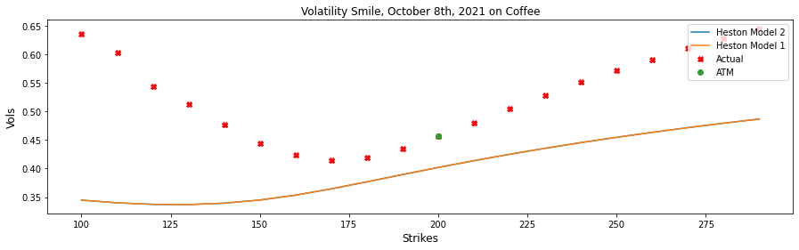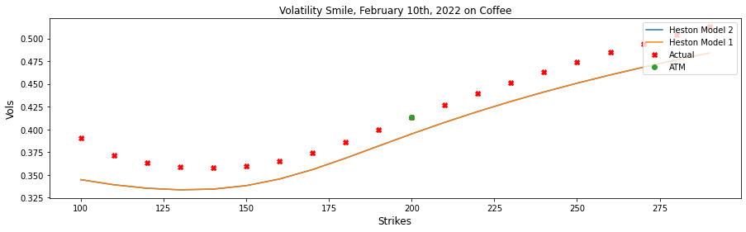

## SABR

### SABR Model on gold



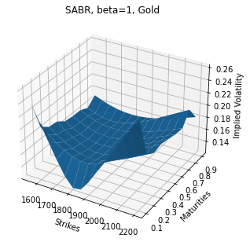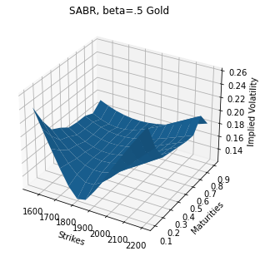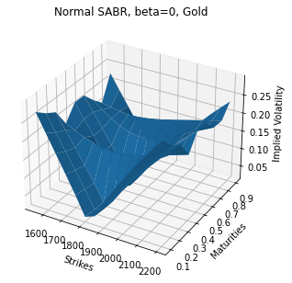

### SABR Model on silver



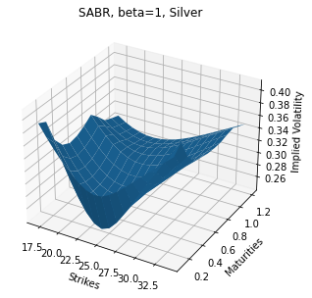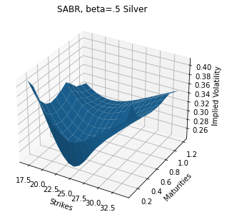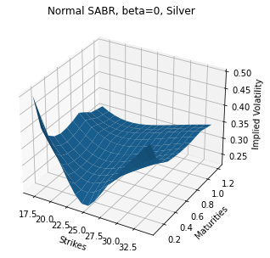

### SABR Model on coffee



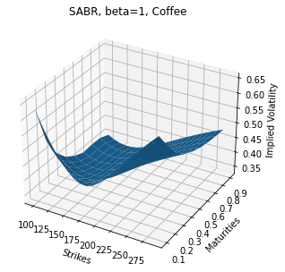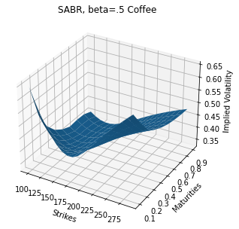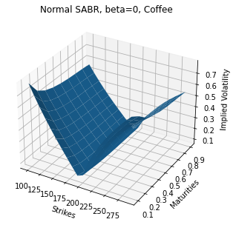

## Shifted SABR

### Shifted SABR Comparison on gold

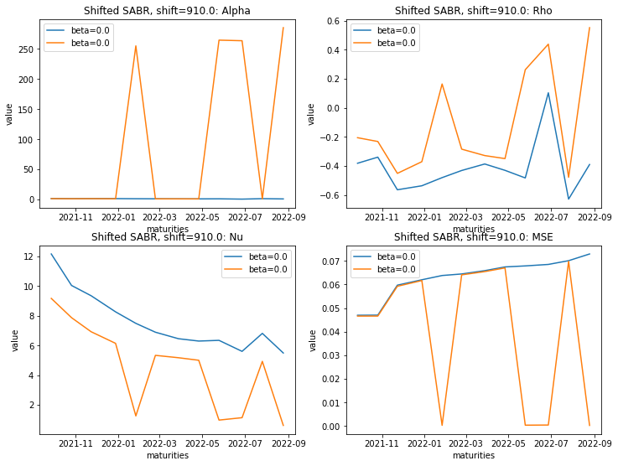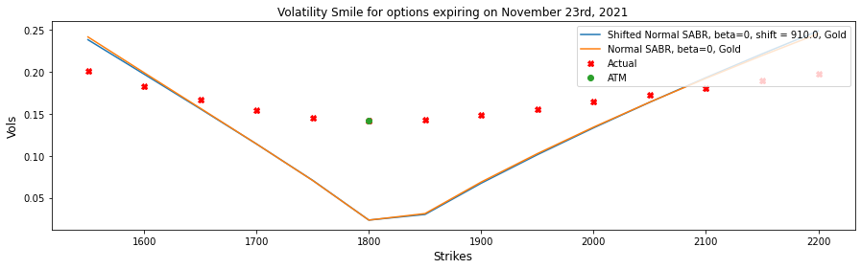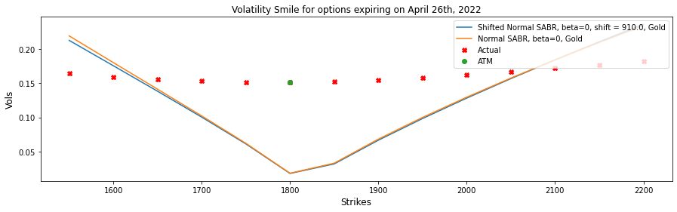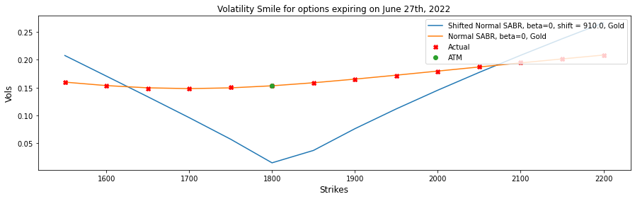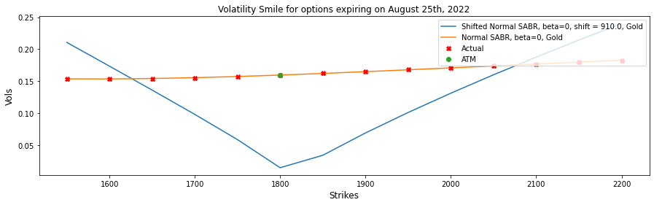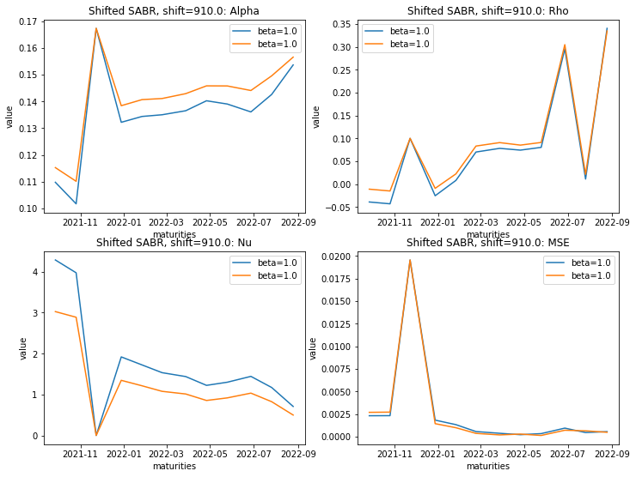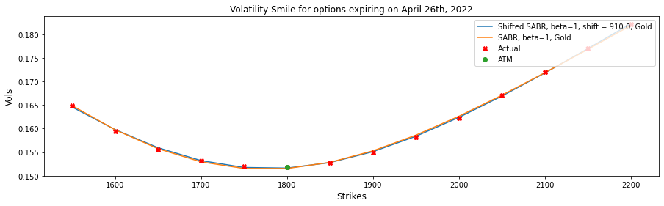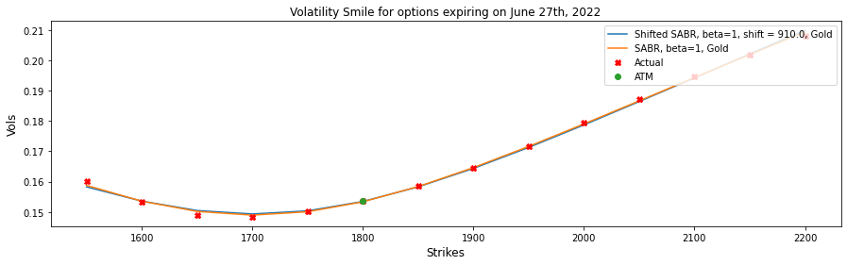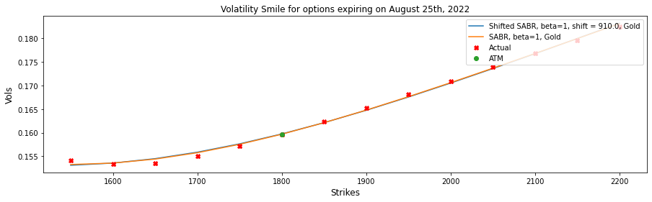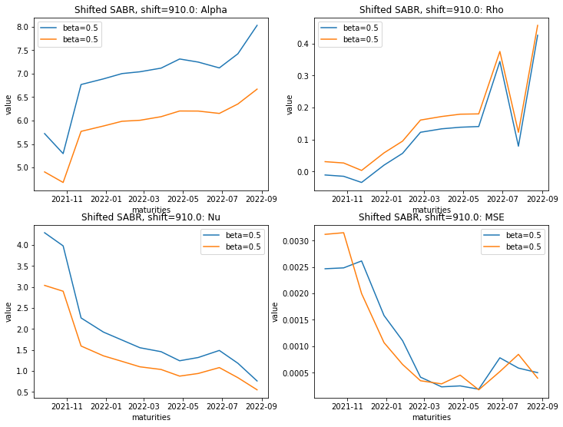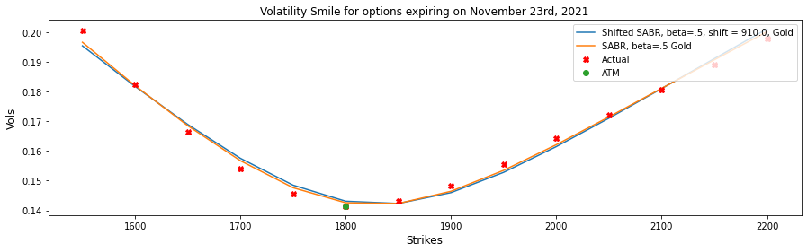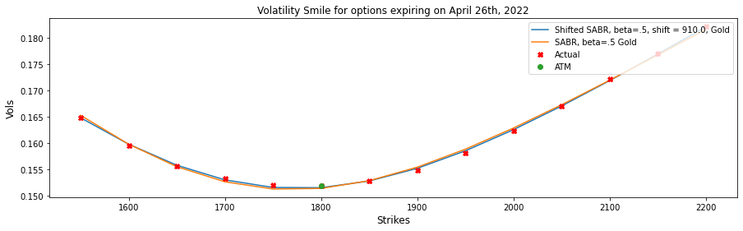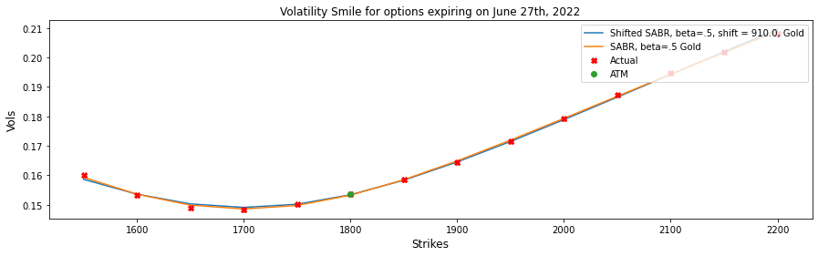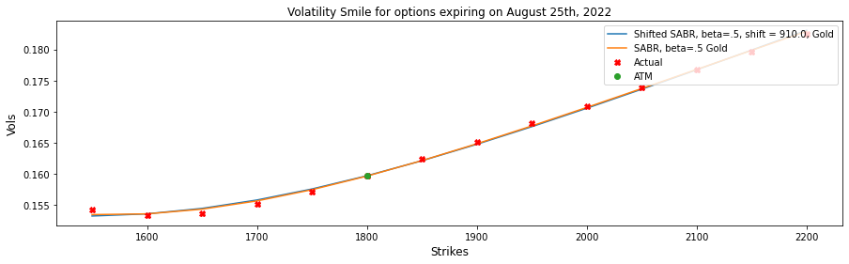

### Shifted SABR Comparison on silver

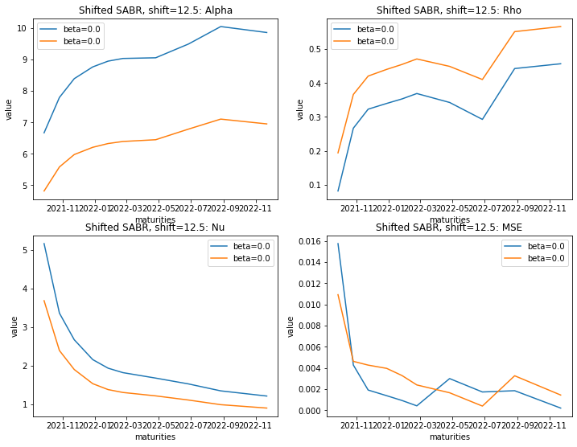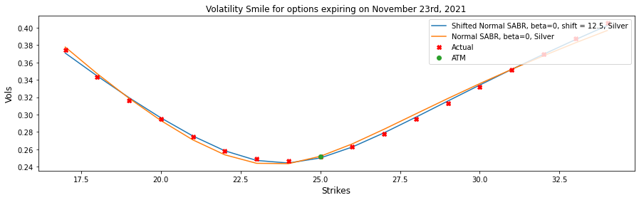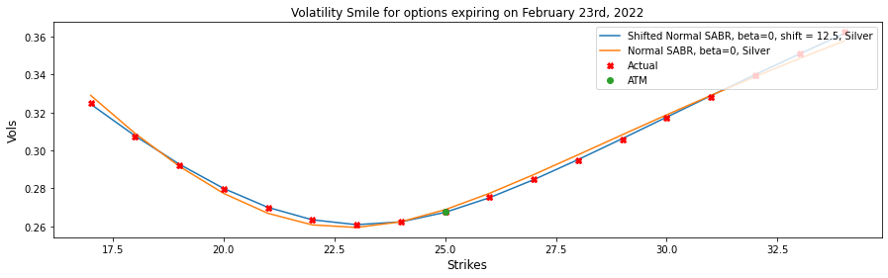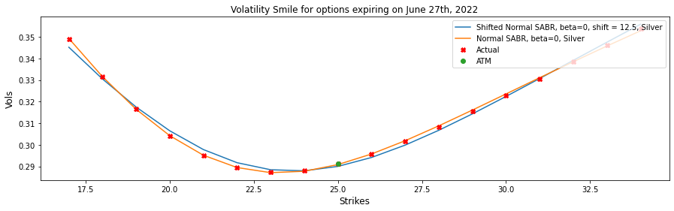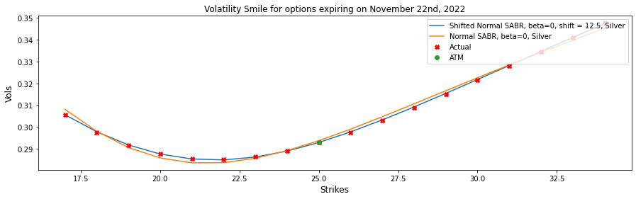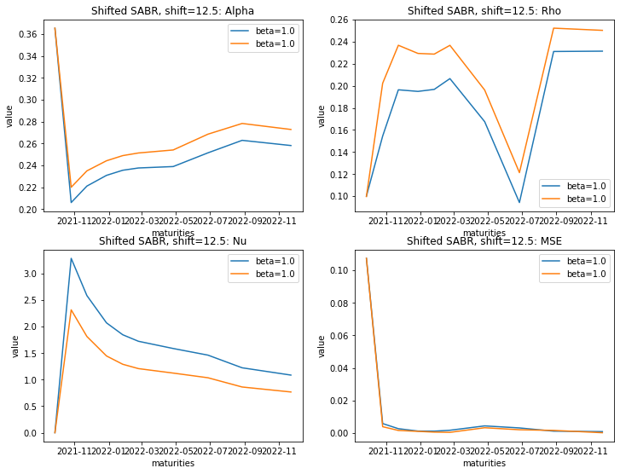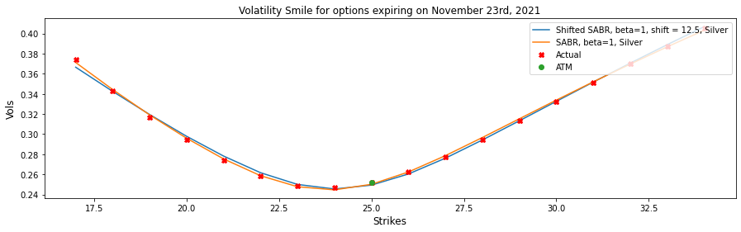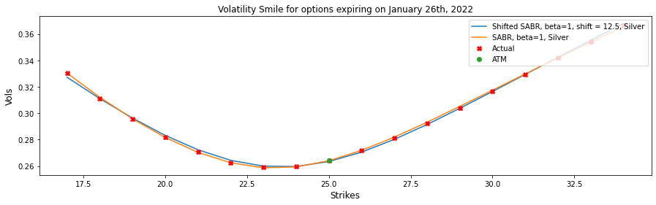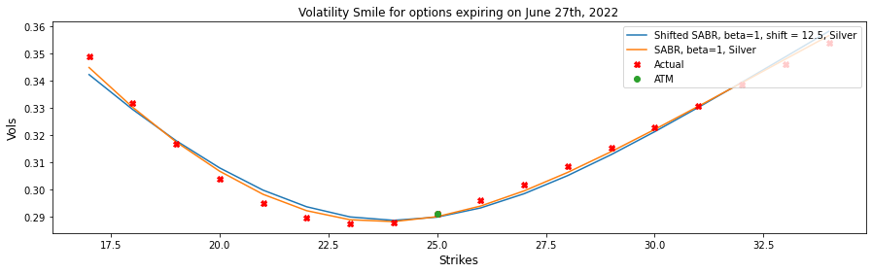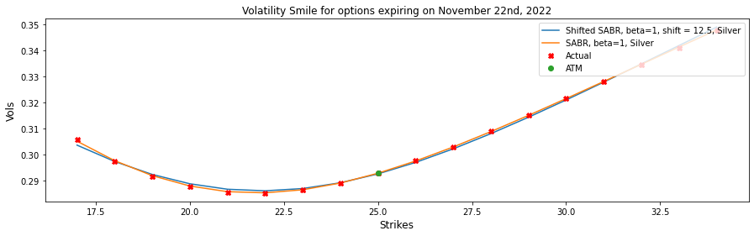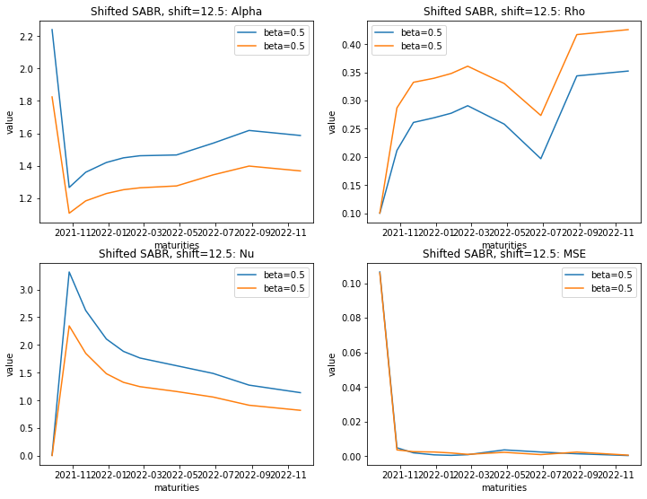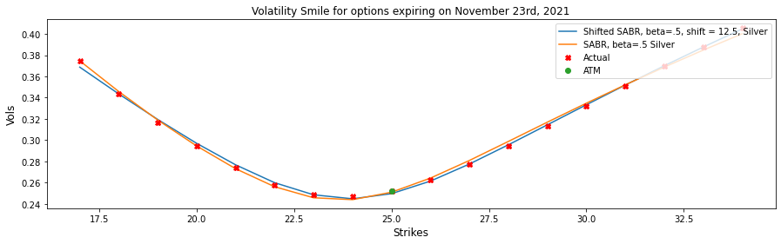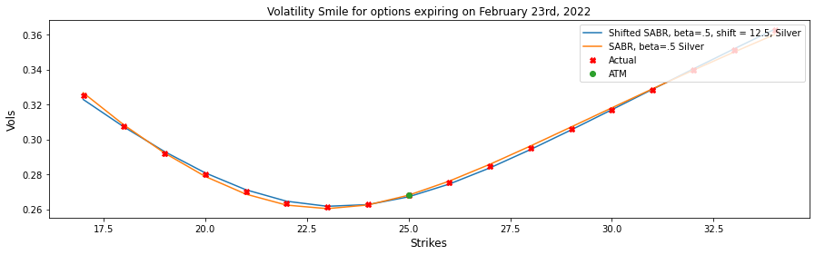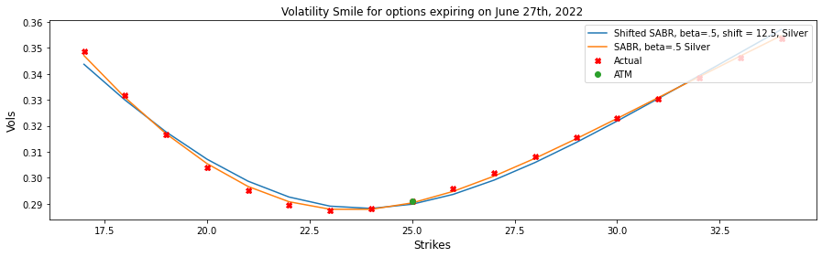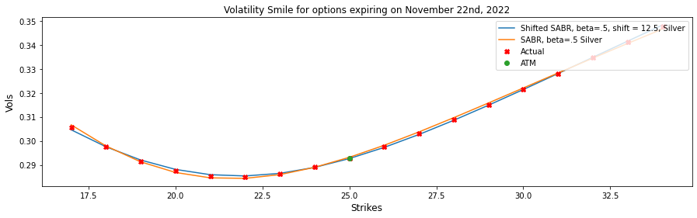

### Shifted SABR Comparison on coffee

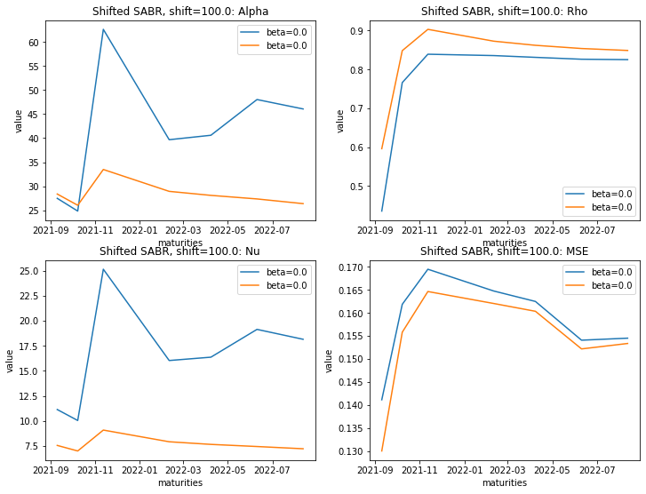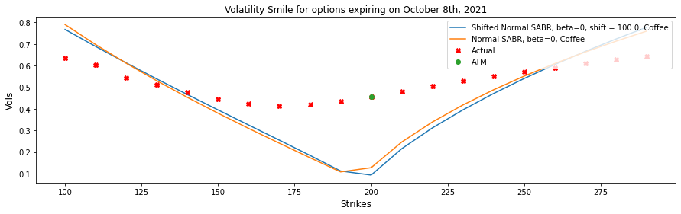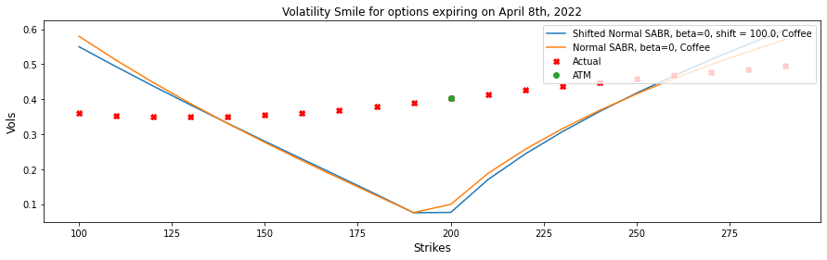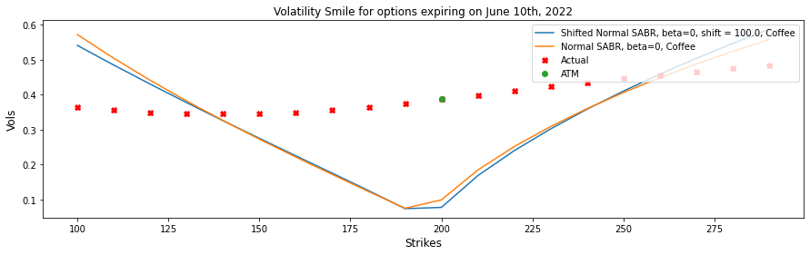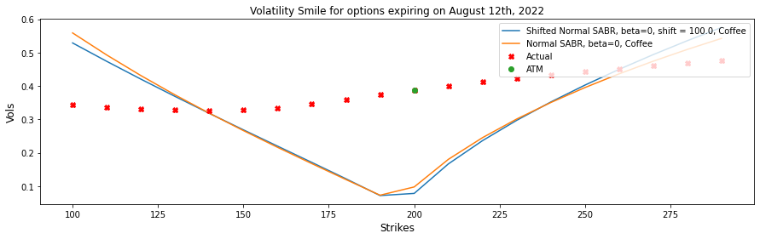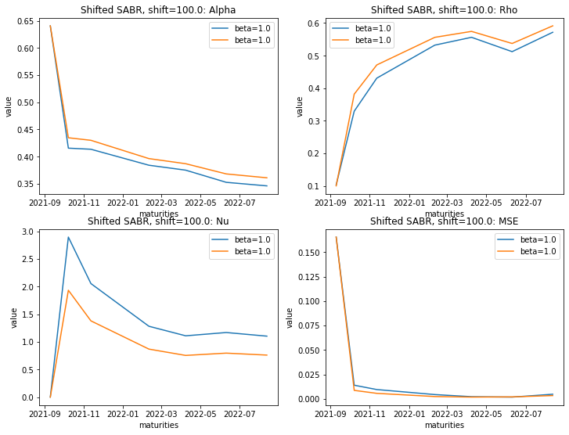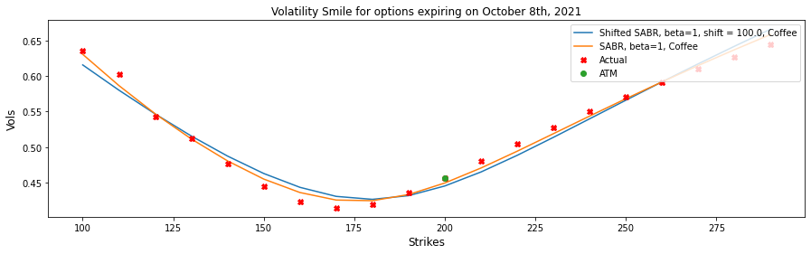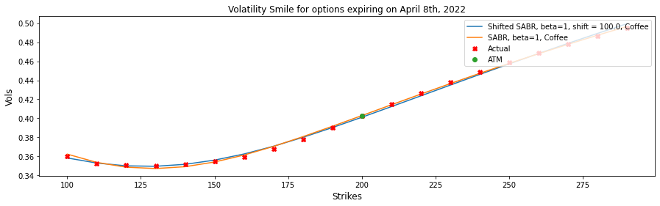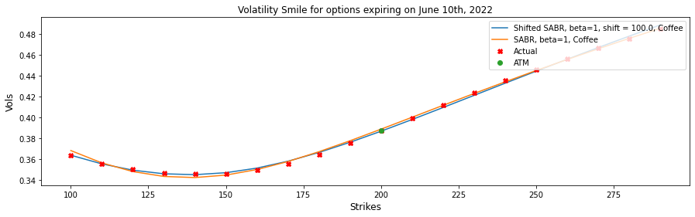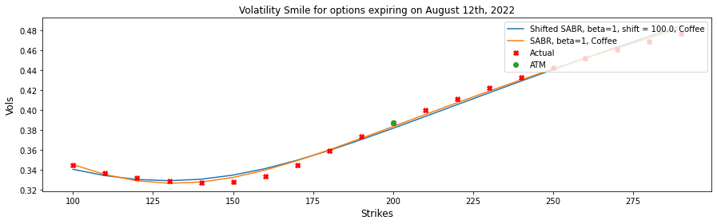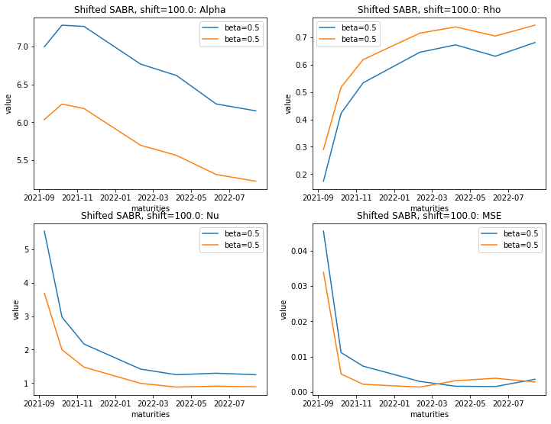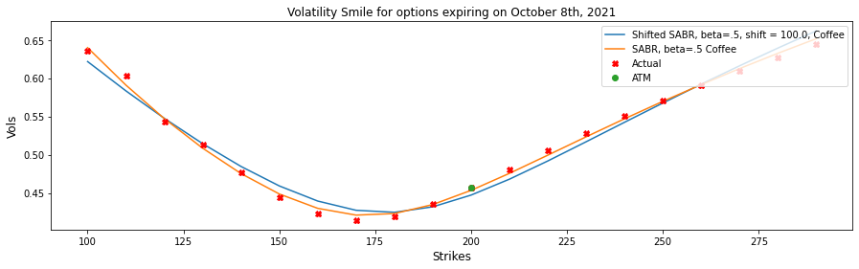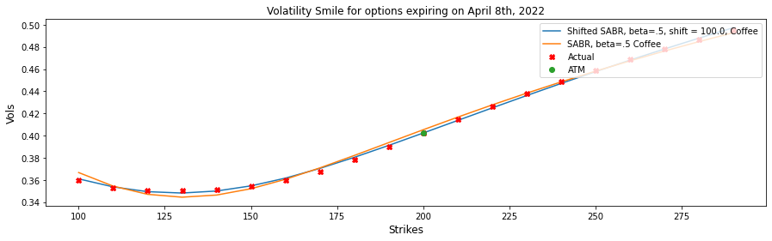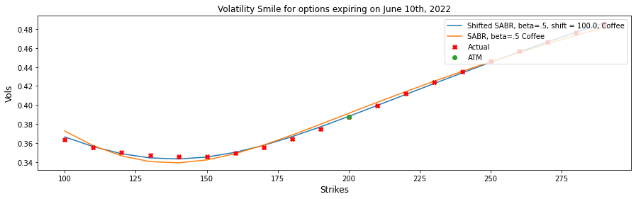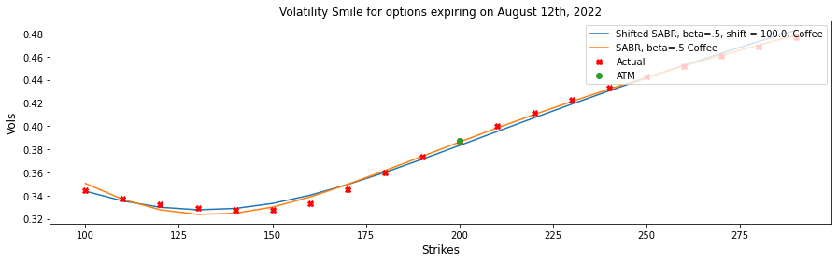

## Free Boundary SABR

### Free-Boundary SABR on gold

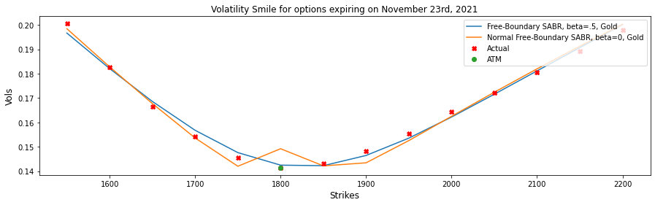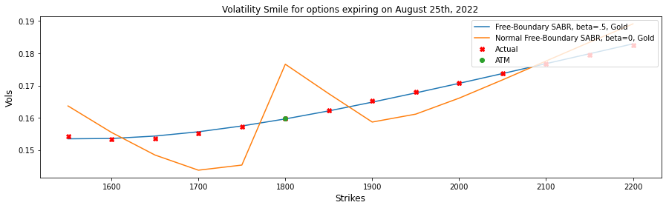

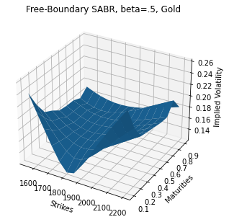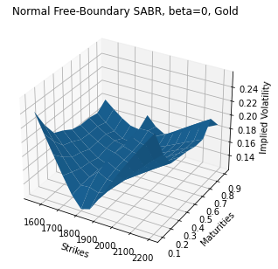

### Free-Boundary SABR on silver

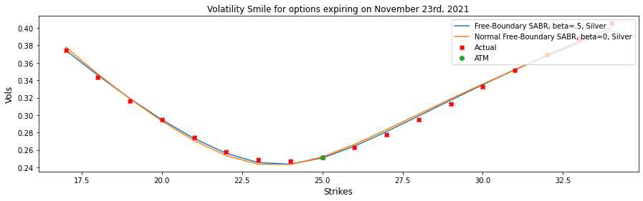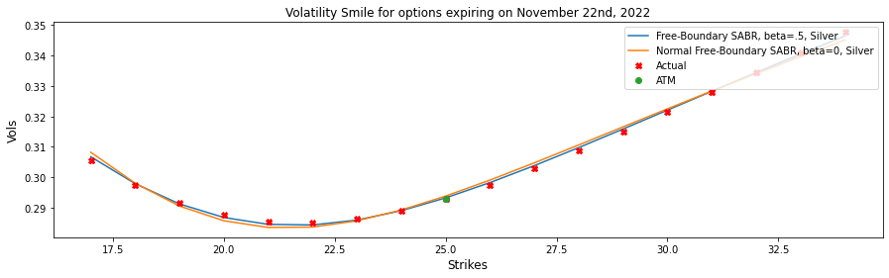

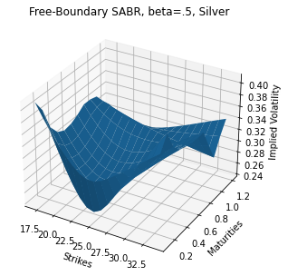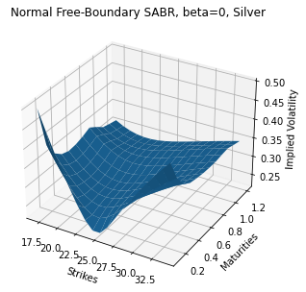

### Free-Boundary SABR on coffee

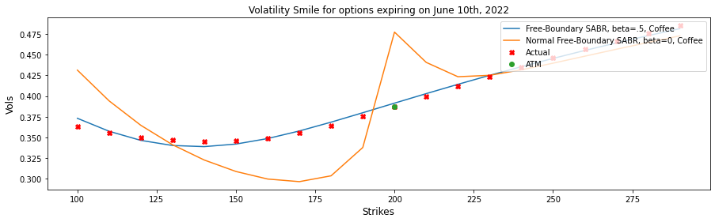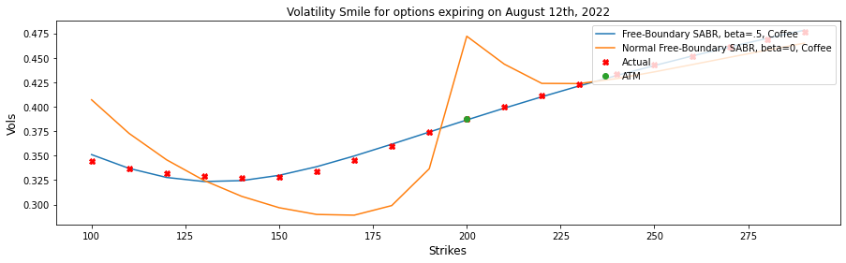

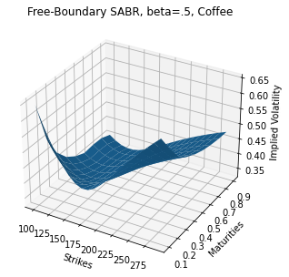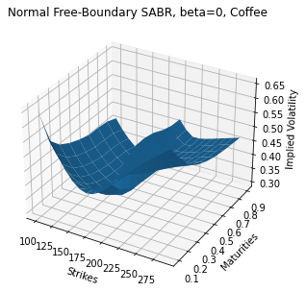

## Mixed SABR

### Mixture SABR on gold

|  | **alpha_free** | **beta_free** | **nu_free** | **rho_free** | **alpha_N** | **beta_N** | **nu_N** | **rho_N** | **Normal SABR RMSE** | **Free Boundary SABR RMSE** | **RMSE** |
| --- | --- | --- | --- | --- | --- | --- | --- | --- | --- | --- | --- |
| **September 27th, 2021** | 4.842674 | 0.5 | 3.336643 | 0.0 | 4.842674 | 0.0 | 6.673287 | 0.99 | 0.097470 | 0.003205 | 0.076402 |
| **October 26th, 2021** | 4.462455 | 0.5 | 3.515373 | 0.0 | 4.462455 | 0.0 | 7.030745 | 0.99 | 0.111039 | 0.003301 | 0.062545 |
| **November 23rd, 2021** | 5.724018 | 0.5 | 1.715591 | 0.0 | 5.724018 | 0.0 | 3.431182 | 0.99 | 0.111316 | 0.001980 | 0.126814 |
| **December 28th, 2021** | 5.837908 | 0.5 | 1.464982 | 0.0 | 5.837908 | 0.0 | 2.929965 | 0.99 | 0.114830 | 0.001044 | 0.138828 |
| **January 26th, 2022** | 5.937087 | 0.5 | 1.322429 | 0.0 | 5.937087 | 0.0 | 2.644858 | 0.99 | 0.117830 | 0.000627 | 0.146612 |
| **February 23rd, 2022** | 5.967954 | 0.5 | 1.174825 | 0.0 | 5.967954 | 0.0 | 2.349650 | 0.99 | 0.118687 | 0.000344 | 0.154522 |
| **March 28th, 2022** | 6.039150 | 0.5 | 1.110556 | 0.0 | 6.039150 | 0.0 | 2.221112 | 0.99 | 0.121492 | 0.000305 | 0.158635 |
| **April 26th, 2022** | 6.176050 | 0.5 | 0.925985 | 0.0 | 6.176050 | 0.0 | 1.851970 | 0.99 | 0.123905 | 0.000471 | 0.170492 |
| **May 25th, 2022** | 6.154438 | 0.5 | 1.011414 | 0.0 | 6.154438 | 0.0 | 2.022828 | 0.99 | 0.125732 | 0.000194 | 0.165279 |
| **June 27th, 2022** | 6.101873 | 0.5 | 1.193507 | 0.0 | 6.101873 | 0.0 | 2.387014 | 0.99 | 0.128494 | 0.000506 | 0.153949 |
| **July 26th, 2022** | 6.304776 | 0.5 | 0.901238 | 0.0 | 6.304776 | 0.0 | 1.802476 | 0.99 | 0.130098 | 0.000863 | 0.173185 |
| **August 25th, 2022** | 6.665379 | 0.5 | 0.563103 | 0.0 | 6.665379 | 0.0 | 1.126207 | 0.99 | 0.136320 | 0.000391 | 0.197323 |

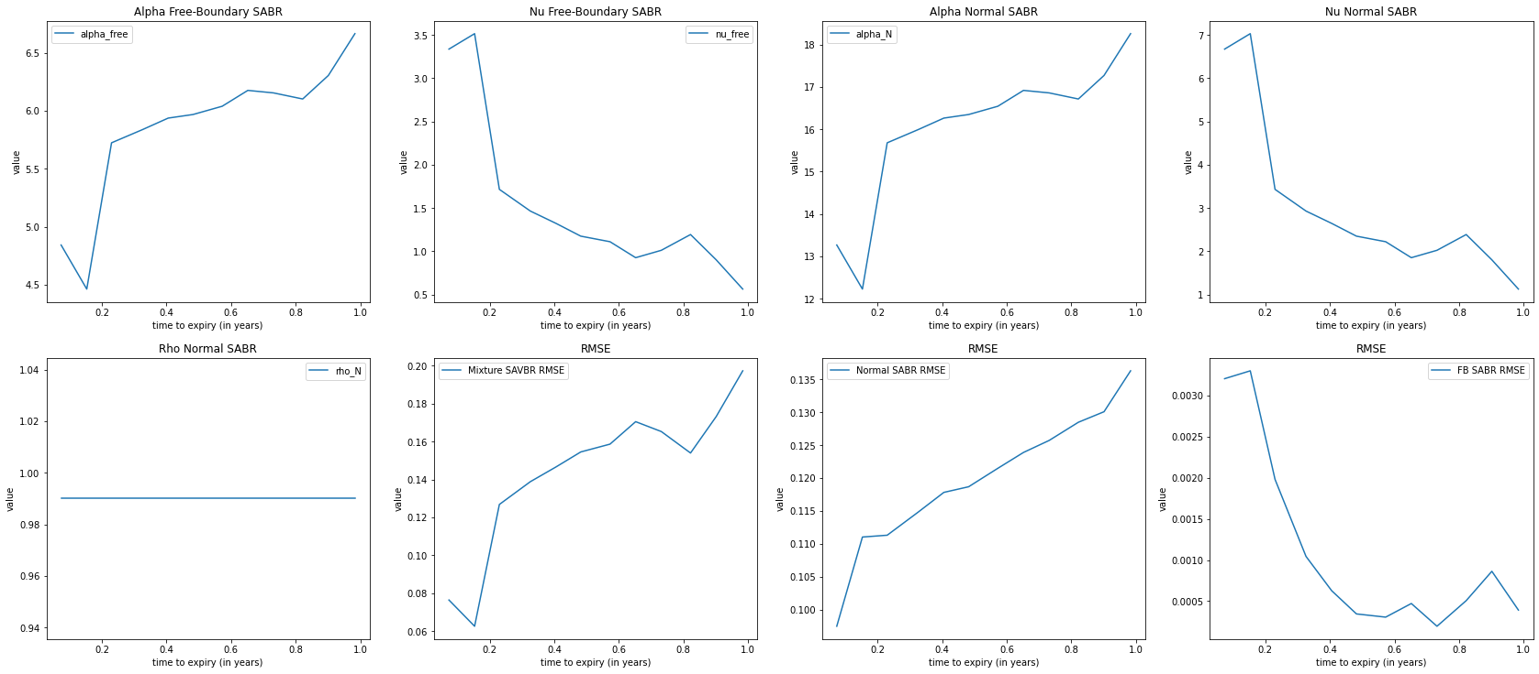

### Mixture SABR on silver

|  | **alpha_free** | **beta_free** | **nu_free** | **rho_free** | **alpha_N** | **beta_N** | **nu_N** | **rho_N** | **Normal SABR RMSE** | **Free Boundary SABR RMSE** | **RMSE** |
| --- | --- | --- | --- | --- | --- | --- | --- | --- | --- | --- | --- |
| **September 27th, 2021** | 1.824276 | 0.5 | 0.012676 | 0.0 | 1.824276 | 0.0 | 0.025352 | 0.990000 | 0.256852 | 0.105904 | 0.252996 |
| **October 26th, 2021** | 1.605741 | 0.5 | 0.007406 | 0.0 | 1.605741 | 0.0 | 0.014812 | 0.990000 | 0.217926 | 0.069793 | 0.248150 |
| **November 23rd, 2021** | 1.546282 | 0.5 | 0.008135 | 0.0 | 1.546282 | 0.0 | 0.016270 | 0.990000 | 0.207024 | 0.057091 | 0.245195 |
| **December 28th, 2021** | 1.499043 | 0.5 | 0.010128 | 0.0 | 1.499043 | 0.0 | 0.020257 | 0.990000 | 0.198470 | 0.046521 | 0.242259 |
| **January 26th, 2022** | 1.487262 | 0.5 | 0.006905 | 0.0 | 1.487262 | 0.0 | 0.013810 | 0.990000 | 0.196295 | 0.042527 | 0.244121 |
| **February 23rd, 2022** | 1.485328 | 0.5 | 0.006224 | 0.0 | 1.485328 | 0.0 | 0.012448 | 0.990000 | 0.195849 | 0.041226 | 0.244418 |
| **April 26th, 2022** | 1.263259 | 0.5 | 1.275493 | 0.0 | 1.263259 | 0.0 | 2.550987 | 0.920582 | 0.154490 | 0.002219 | 0.035507 |
| **June 27th, 2022** | 1.561563 | 0.5 | 0.034805 | 0.0 | 1.561563 | 0.0 | 0.069611 | 0.990000 | 0.203720 | 0.030528 | 0.220698 |
| **August 27th, 2022** | 1.390720 | 0.5 | 0.985957 | 0.0 | 1.390720 | 0.0 | 1.971915 | 0.897071 | 0.172235 | 0.002460 | 0.019836 |
| **November 22nd, 2022** | 1.361176 | 0.5 | 0.885531 | 0.0 | 1.361176 | 0.0 | 1.771062 | 0.929645 | 0.179004 | 0.000702 | 0.019403 |

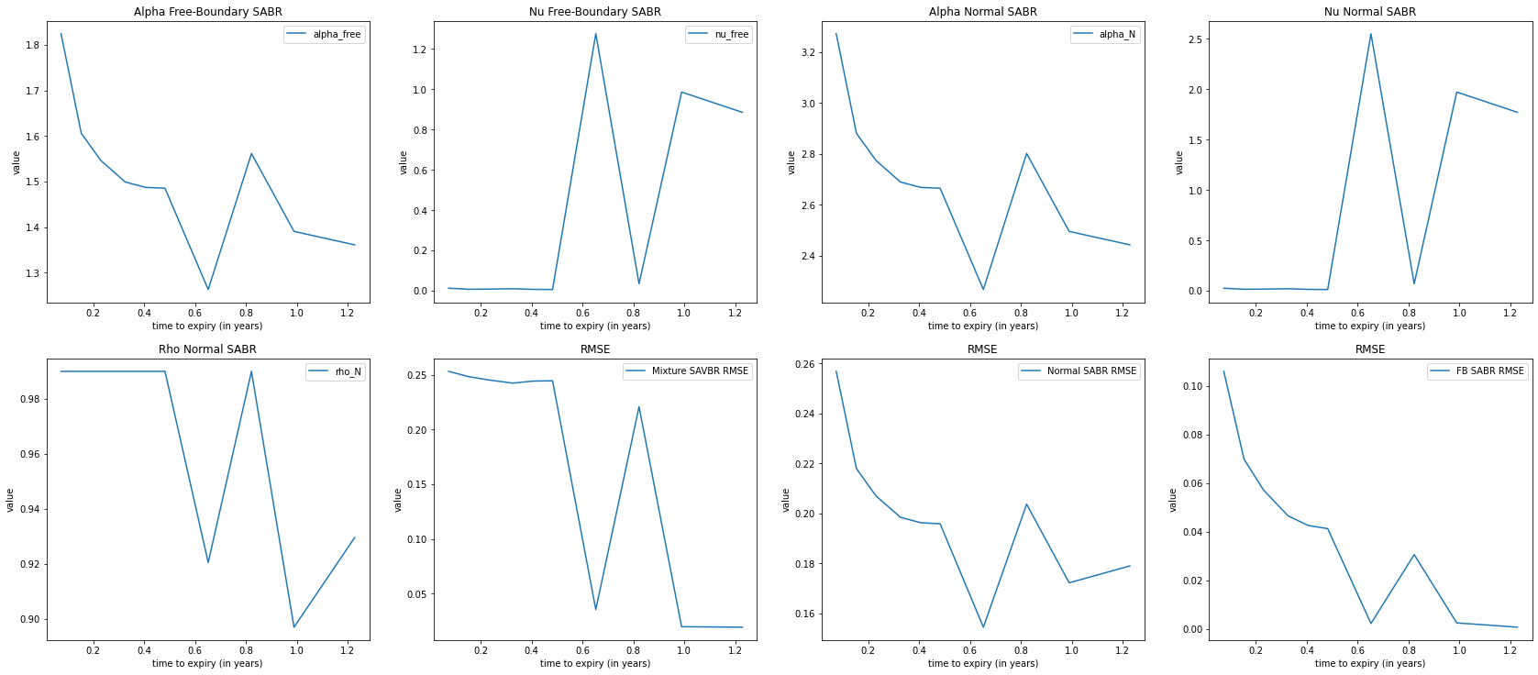

### Mixture SABR on coffee

|  | **alpha_free** | **beta_free** | **nu_free** | **rho_free** | **alpha_N** | **beta_N** | **nu_N** | **rho_N** | **Normal SABR RMSE** | **Free Boundary SABR RMSE** | **RMSE** |
| --- | --- | --- | --- | --- | --- | --- | --- | --- | --- | --- | --- |
| **September 10th, 2021** | 6.025595 | 0.5 | 3.837014 | 0.0 | 6.025595 | 0.0 | 7.674029 | 0.244223 | 0.170102 | 0.033653 | 0.086769 |
| **October 8th, 2021** | 6.240877 | 0.5 | 2.063090 | 0.0 | 6.240877 | 0.0 | 4.126181 | 0.790298 | 0.249379 | 0.004953 | 0.031825 |
| **November 12th, 2021** | 6.186047 | 0.5 | 1.515749 | 0.0 | 6.186047 | 0.0 | 3.031498 | 0.990000 | 0.309072 | 0.001994 | 0.032247 |
| **February 10th, 2022** | 5.700959 | 0.5 | 1.009065 | 0.0 | 5.700959 | 0.0 | 2.018131 | 0.990000 | 0.292859 | 0.001435 | 0.085135 |
| **April 8th, 2022** | 5.569397 | 0.5 | 0.896280 | 0.0 | 5.569397 | 0.0 | 1.792560 | 0.990000 | 0.290798 | 0.003277 | 0.099017 |
| **June 10th, 2022** | 5.318125 | 0.5 | 0.933773 | 0.0 | 5.318125 | 0.0 | 1.867547 | 0.990000 | 0.283299 | 0.004015 | 0.093896 |
| **August 12th, 2022** | 5.235279 | 0.5 | 0.914867 | 0.0 | 5.235279 | 0.0 | 1.829733 | 0.990000 | 0.279730 | 0.002866 | 0.097493 |



## Comparison Tables

|  |  |
| --- | --- |
| **Model (gold)** | **Average RMSE** |
| SABR, beta=1 | 0.002516 |
| SABR, beta=.5 | 0.001084 |
| Shifted SABR, beta=1, shift = 910.0 | 0.002566 |
| Shifted SABR, beta=.5, shift = 910.0 | 0.001099 |
| Normal Free-Boundary SABR, beta=0 | 0.004813 |
| Free-Boundary SABR, beta=.5 | 0.001103 |
| Heston Model 1 | 0.002504 |

|  |  |
| --- | --- |
| **Model (silver)** | **Average RMSE** |
| SABR, beta=1 | 0.012200 |
| SABR, beta=.5 | 0.012385 |
| Shifted SABR, beta=1, shift = 910. | 0.012953 |
| Shifted SABR, beta=.5, shift = 910.0 | 0.012346 |
| Normal Free-Boundary SABR, beta=0 | 0.003667 |
| Free-Boundary SABR, beta=.5 | 0.015829 |
| Heston Model 1 | 0.080827 |

|  |  |
| --- | --- |
| **Model (coffee)** | **Average RMSE** |
| SABR, beta=1 | 0.027006 |
| SABR, beta=.5 | 0.007454 |
| Shifted SABR, beta=1, shift = 910.0 | 0.028827 |
| Shifted SABR, beta=.5, shift = 910.0 | 0.010505 |
| Normal Free-Boundary SABR, beta=0 | 0.041553 |
| Free-Boundary SABR, beta=.5 | 0.007456 |
| Heston Model 1 | 0.031102 |

## Python Code and Full Data

The full code and data are available on the GitHub page <https://github.com/lucasomigli/SABR-volatility-models>. The $readme.md$ file provides with all the information on how to run the code and how single components and classes work.

For a copy of the main files where the calibration is coded, see below. The files are: $heston.py$, calibrates and constructs prices, from which volatility smiles are computed; $sabr.py$ which constructs volatility surfaces and smiles for classical, shifted and free boundary SABR models; $mixedSABR.py$ where the mixture SABR model is built.

*Please do acknowledge that the files will not work without the $initialize.py$ and remaining boilerplate python files which are available on the GitHub page mentioned above. Also bear in mind that files were created with the aim of being used on a python notebook (again, available on the link above).*

# sabr.py

**import** **matplotlib.pyplot** **as** **plt**

**from** **mpl_toolkits.mplot3d** **import** Axes3D

**import** **numpy** **as** **np**

**import** **pandas** **as** **pd**

**import** **time**

**import** **datetime**

**import** **math**

**import** **QuantLib** **as** **ql**

**from** **scipy.optimize** **import** minimize

**from** **initialize** **import** *

**from** **plotting** **import** *

# CALIBRATE SABR VOLATILITY SURFACE

volMatrix = ql.Matrix(len(strikes), len(dates))

**for** i **in** range(len(vols)):

**for** j **in** range(len(vols[i])):

volMatrix[j][i] = vols[i][j]

black_var_surface = ql.BlackVarianceSurface(

today, calendar, dates, strikes, volMatrix, day_count)

black_var_surface.enableExtrapolation()

**class** **SABRSmile**:

**def** **__init__**(self, date, marketVols, shift=**0**, beta=**1**, method="normal", strikes=strikes, fwd=current_price, zero_rho=False):

self.date = date

self.expiryTime = round((self.date - today)/**365**, **6**)

self.marketVols = marketVols

self.shift = shift

self.strikes = strikes

self.fwd = fwd

self.forward_price = self.fwd * \

math.exp(rate.value() * self.expiryTime)

self.zero_rho = zero_rho

self.alpha, self.beta, self.nu, self.rho = (

.**1**, beta, **0.**, **0.** **if** self.zero_rho **else** .**1**)

self.method = method

self.newVols = None

self.error = None

**def** **initialize**(self):

# alpha, beta, nu, rho

cons = (

{'type': 'ineq', 'fun': **lambda** x: x[**0**] - **0.001**},

{'type': 'eq', 'fun': **lambda** x: x[**1**] - self.beta},

{'type': 'ineq', 'fun': **lambda** x: x[**2**] - .**001**},

{'type': 'ineq', 'fun': **lambda** x: .**99** - x[**3**]\*\***2**},

)

x = self.set_init_conds()

result = minimize(self.f, x, constraints=cons, method="SLSQP", bounds=(

(**1e-8**, None), (**0**, **1**), (**1e-8**, None), (-.**999**, .**999**)))

self.error = result['fun']

[self.alpha, self.beta, self.nu, self.rho] = result['x']

self.newVols = [self.vols_by_method(

strike, self.alpha, self.beta, self.nu, self.rho) **for** strike **in** self.strikes]

**def** **set_init_conds**(self):

**return** [self.alpha, self.beta, self.nu, self.rho]

**def** **vols_by_method**(self, strike, alpha, beta, nu, rho):

**if** self.method == "floch-kennedy":

**return** ql.sabrFlochKennedyVolatility(strike, self.forward_price, self.expiryTime, alpha, beta, nu, rho)

**elif** self.shift != **0**:

**return** ql.shiftedSabrVolatility(strike, self.forward_price, self.expiryTime, alpha, beta, nu, rho, self.shift)

**else**:

**return** ql.sabrVolatility(strike, self.forward_price, self.expiryTime, alpha, beta, nu, rho)

**def** **f**(self, params):

alpha, beta, nu, rho = params

vols = np.array([self.vols_by_method(

strike, alpha, beta, nu, rho) **for** strike **in** self.strikes])

self.error = ((vols - np.array(self.marketVols))\*\***2**).mean() ** .**5**

**return** self.error

**class** **SABRVolatilitySurface**:

**def** **__init__**(self, strks=strikes, method="normal", beta=**1**, shift=**0**, fwd=current_price, label="", zero_rho=False):

self.method = method

self._beta = beta

self.shift = shift

self.strikes = strks

self.fwd = fwd

self.label = label

self.zero_rho = zero_rho

self.initialize()

**def** **initialize**(self):

self.vol_surface_vector, self.errors, self.smiles, self.alpha, self.beta, self.nu, self.rho = [

], [], [], [], [], [], []

self.SABRVolMatrix, self.SABRVolDiffMatrix = (

ql.Matrix(len(self.strikes), len(dates)), ql.Matrix(len(self.strikes), len(dates)))

**for** i, d **in** enumerate(dates):

v = []

**for** j **in** range(len(self.strikes)):

**if** self.strikes[i] **in** strikes:

v.append(vols[i][j])

volSABR = SABRSmile(date=d, beta=self._beta, strikes=self.strikes, marketVols=v, shift=self.shift,

method=self.method, fwd=self.fwd, zero_rho=self.zero_rho)

volSABR.initialize()

self.alpha.append(volSABR.alpha)

self.beta.append(volSABR.beta)

self.nu.append(volSABR.nu)

self.rho.append(volSABR.rho)

self.errors.append(volSABR.error)

smile = volSABR.newVols

self.vol_surface_vector.extend(smile)

self.smiles.append(volSABR)

# constructing the SABRVolatilityMatrix

**for** j **in** range(len(smile)):

self.SABRVolMatrix[j][i] = smile[j]

self.SABRVolDiffMatrix[j][i] = (

smile[j] - v[j]) / v[j]

self.vol_surface = ql.BlackVarianceSurface(

today, calendar, dates, self.strikes, self.SABRVolMatrix, day_count)

self.vol_surface.enableExtrapolation()

**def** **to_data**(self):

d = {'alpha': self.alpha, 'beta': self.beta,

'nu': self.nu, 'rho': self.rho}

**return** pd.DataFrame(data=d, index=dates)

# Backbone modelling for SABR

**def** **SABR_backbone_plot**(beta=**1**, bounds=None, shift=**0**, strikes=strikes, fixes=(.**95**, **1**, **1.14**, **1.24**), tenor=dates[**2**]):

l = []

**for** i **in** fixes:

vol_surface = SABRVolatilitySurface(

method="normal", shift=current_price*shift, beta=beta, fwd=current_price * i)

SABR_vol_surface = ql.BlackVarianceSurface(

today, calendar, dates, strikes, vol_surface.SABRVolMatrix, day_count)

SABR_vol_surface.enableExtrapolation()

l.append(([SABR_vol_surface.blackVol(tenor, s)

**for** s **in** strikes], "fwd = {}".format(current_price * i)))

plot_smile(tenor, l, bounds=bounds, market=False,

title="backbone, beta = {}, {}".format(vol_surface.beta[**0**], tenor))

**def** **SABRComparison**(methods, title="", display=False):

fig, axs = plt.subplots(**2**, **2**, figsize=plot_size)

plt.subplots_adjust(left=None, bottom=None, right=None,

top=**1.5**, wspace=None, hspace=None)

**for** method **in** methods:

lbl = "beta={}".format(method.beta[**1**])

axs[**0**, **0**].plot(maturities, method.alpha, label=lbl)

axs[**0**, **0**].set_title('{}: Alpha'.format(title))

axs[**0**, **0**].set(xlabel='maturities', ylabel='value')

axs[**0**, **0**].legend()

axs[**1**, **0**].plot(maturities, method.nu, label=lbl)

axs[**1**, **0**].set_title('{}: Nu'.format(title))

axs[**1**, **0**].set(xlabel='maturities', ylabel='value')

axs[**1**, **0**].legend()

axs[**0**, **1**].plot(maturities, method.rho, label=lbl)

axs[**0**, **1**].set_title('{}: Rho'.format(title))

axs[**0**, **1**].set(xlabel='maturities', ylabel='value')

axs[**0**, **1**].legend()

axs[**1**, **1**].plot(maturities, method.errors, label=lbl)

axs[**1**, **1**].set_title('{}: MSE'.format(title))

axs[**1**, **1**].set(xlabel='maturities', ylabel='value')

axs[**1**, **1**].legend()

**if** display:

method_df = method.to_data()

display(method_df.style.set_caption("SABR, {}".format(lbl)))

plot_vol_surface(method.vol_surface, title="{}".format(method.label))

smiles_comparison(methods)

# mixedSabr.py

**from** **initialize** **import** *

**from** **SABR** **import** *

**from** **plotting** **import** *

**class** **MixtureSABRSmile**:

**def** **__init__**(self, date, fwd=current_price, s=**0**):

self.date = date

self.expiryTime = round((self.date - today)/**365**, **6**)

self.marketVols = vols[dates.index(self.date)]

self.fwd = fwd

self.s = s

self.alpha_N = .**1**

self.beta_N = **0.**

self.nu_N = .**1**

self.rho_N = .**1**

self.alpha_free = .**1**

self.beta_free = .**5**

self.nu_free = .**1**

self.rho_free = **0.**

self.errors_N, self.errors_free = ([], [])

self.initialize()

**def** **initialize**(self):

# # calibrate the Free Zero-Correlation SABR first

self.freeSABR = SABRSmile(

date=self.date, beta=.**5**, marketVols=self.marketVols, method="floch-kennedy", fwd=self.fwd, zero_rho=True)

self.freeSABR.initialize()

self.alpha_free = self.freeSABR.alpha

self.beta_free = self.freeSABR.beta

self.nu_free = self.freeSABR.nu

self.error_free = self.freeSABR.error

self.normVols, self.error_N = ([], None)

# alpha, beta, nu, rho (Normal, free)

cons = (

{'type': 'eq', 'fun': **lambda** x: x[**0**] - self.alpha_free *

math.log(current_price)**self.beta_free},

{'type': 'eq', 'fun': **lambda** x: x[**4**] - self.alpha_free},

{'type': 'eq', 'fun': **lambda** x: x[**1**]},

{'type': 'eq', 'fun': **lambda** x: x[**5**] - self.beta_free},

{'type': 'eq', 'fun': **lambda** x: x[**2**] -

self.nu_free / (**1** - self.beta_free)},

{'type': 'eq', 'fun': **lambda** x: x[**6**] - self.nu_free},

{'type': 'ineq', 'fun': **lambda** x: x[**3**]},

{'type': 'ineq', 'fun': **lambda** x: .**99** - x[**3**]},

{'type': 'eq', 'fun': **lambda** x: x[**7**]},

)

# Set initial conditions

x = [self.alpha_N, self.beta_N, self.nu_N, self.rho_N,

self.alpha_free, self.beta_free, self.nu_free, self.rho_free]

result = minimize(self.f, x, constraints=cons, method="SLSQP")

self.error = result['fun']

params = [self.alpha_N, self.beta_N, self.nu_N, self.rho_N, self.alpha_free,

self.beta_free, self.nu_free, self.rho_free] = result['x']

self.normVols = []

self.newVols = [self.calibrate_volatilities(

strike, params) **for** strike **in** strikes]

self.error_N = (

(self.normVols - np.array(self.marketVols))\*\***2**).mean() ** .**5**

**def** **calibrate_volatilities**(self, strike, params):

p = (params[**0**] * params[**5**] * math.exp(self.s)) / \

((params[**0**] * params[**5**] * math.exp(self.s)) +

abs(params[**2**] * params[**3**]))

normalSABR = ql.sabrVolatility(

strike, self.fwd, self.expiryTime, *params[:**4**])

self.normVols.append(normalSABR)

**return** math.sqrt((p\*\***2**) * self.freeSABR.newVols[int(np.where(strikes == strike)[**0**])] + ((**1**-p)\*\***2**) * normalSABR)

**def** **f**(self, params):

mixture_vols = np.array([self.calibrate_volatilities(

strike, params) **for** strike **in** strikes])

self.error = ((mixture_vols - np.array(self.marketVols))

** **2**).mean() ** .**5**

**return** self.error

**class** **MixtureSABRVolatilitySurface**:

**def** **__init__**(self, fwd=current_price, label="Mixture SABR, {}".format(data_label), dates=dates):

self.fwd = fwd

self.label = label

self.dates = dates

self.vol_surface_vector, self.errors = [], []

self.alpha_N, self.beta_N, self.nu_N, self.rho_N = [], [], [], []

self.alpha_free, self.beta_free, self.nu_free, self.rho_free = [], [], [], []

self.errors_free, self.errors_N = ([], [])

self.initialize()

**def** **initialize**(self):

self.SABRVolMatrix, self.SABRVolDiffMatrix = (

ql.Matrix(len(strikes), len(self.dates)),

ql.Matrix(len(strikes), len(self.dates))

)

**for** i, d **in** enumerate(self.dates):

volMixedSABR = MixtureSABRSmile(date=d, fwd=self.fwd)

self.alpha_N.append(volMixedSABR.alpha_N)

self.alpha_free.append(volMixedSABR.alpha_free)

self.beta_N.append(volMixedSABR.beta_N)

self.beta_free.append(volMixedSABR.beta_free)

self.nu_N.append(volMixedSABR.nu_N)

self.nu_free.append(volMixedSABR.nu_free)

self.rho_N.append(volMixedSABR.rho_N)

self.rho_free.append(volMixedSABR.rho_free)

self.errors_N.append(volMixedSABR.error_N)

self.errors_free.append(volMixedSABR.error_free)

self.errors.append(volMixedSABR.error)

smile = volMixedSABR.newVols

self.vol_surface_vector.extend(smile)

# constructing the SABRVolatilityMatrix

**for** j **in** range(len(smile)):

self.SABRVolMatrix[j][i] = smile[j]

self.SABRVolDiffMatrix[j][i] = (

smile[j] - vols[i][j]) / vols[i][j]

self.vol_surface = ql.BlackVarianceSurface(

today, calendar, self.dates, strikes, self.SABRVolMatrix, day_count)

self.vol_surface.enableExtrapolation()

**def** **to_data**(self):

d = {'alpha_free': self.alpha_free, 'beta_free': self.beta_free, 'nu_free': self.nu_free, 'rho_free': self.rho_free,

'alpha_N': self.alpha_free, 'beta_N': self.beta_N, 'nu_N': self.nu_N, 'rho_N': self.rho_N,

'Normal SABR RMSE': self.errors_N, 'Free Boundary SABR RMSE': self.errors_free,

'RMSE': self.errors,

}

**return** pd.DataFrame(data=d, index=self.dates)

**def** **plot**(self):

fig, axs = plt.subplots(**2**, **4**, figsize=plot_size)

plt.subplots_adjust(right=**2**, top=**2**)

x_values = [(x-today)/**365.** **for** x **in** self.dates]

axs[**0**, **0**].plot(x_values, self.alpha_free, label="alpha_free")

axs[**0**, **0**].set_title('Alpha Free-Boundary SABR')

axs[**0**, **0**].set(xlabel='time to expiry (in years)', ylabel='value')

axs[**0**, **0**].legend()

axs[**0**, **1**].plot(x_values, self.nu_free, label="nu_free")

axs[**0**, **1**].set_title('Nu Free-Boundary SABR')

axs[**0**, **1**].set(xlabel='time to expiry (in years)', ylabel='value')

axs[**0**, **1**].legend()

axs[**0**, **2**].plot(x_values, self.alpha_N, label="alpha_N")

axs[**0**, **2**].set_title('Alpha Normal SABR')

axs[**0**, **2**].set(xlabel='time to expiry (in years)', ylabel='value')

axs[**0**, **2**].legend()

axs[**0**, **3**].plot(x_values, self.nu_N, label="nu_N")

axs[**0**, **3**].set_title('Nu Normal SABR')

axs[**0**, **3**].set(xlabel='time to expiry (in years)', ylabel='value')

axs[**1**, **3**].legend()

axs[**1**, **0**].plot(x_values, self.rho_N, label="rho_N")

axs[**1**, **0**].set_title('Rho Normal SABR')

axs[**1**, **0**].set(xlabel='time to expiry (in years)', ylabel='value')

axs[**1**, **0**].legend()

axs[**1**, **1**].plot(x_values, self.errors, label="Mixture SAVBR RMSE")

axs[**1**, **1**].set_title('RMSE')

axs[**1**, **1**].set(xlabel='time to expiry (in years)', ylabel='value')

axs[**1**, **1**].legend()

axs[**1**, **2**].plot(x_values, self.errors_N, label="Normal SABR RMSE")

axs[**1**, **2**].set_title('RMSE')

axs[**1**, **2**].set(xlabel='time to expiry (in years)', ylabel='value')

axs[**1**, **2**].legend()

axs[**1**, **3**].plot(x_values, self.errors_free, label="FB SABR RMSE")

axs[**1**, **3**].set_title('RMSE')

axs[**1**, **3**].set(xlabel='time to expiry (in years)', ylabel='value')

axs[**1**, **3**].legend()

# Heston.py

**from** **initialize** **import** *

**from** **SABR** **import** *

**from** **plotting** **import** *

**class** **hestonModelSurface**:

**def** **__init__**(self, params, label=""):

(self.v0, self.kappa, self.theta, self.sigma, self.rho) = params

self.label = label

self.strks, self.marketValue, self.modelValue, self.relativeError = ([], [], [

], [])

self.initialize()

**def** **initialize**(self):

process = ql.HestonProcess(flat_ts, dividend_ts,

ql.QuoteHandle(

ql.SimpleQuote(current_price)),

self.v0, self.kappa, self.theta, self.sigma, self.rho)

self.hestonModel = ql.HestonModel(process)

self.engine = ql.AnalyticHestonEngine(self.hestonModel)

self.errors = []

self.heston_helpers = []

black_var_surface.setInterpolation("bicubic")

one_year_idx = -**1**

date = dates[one_year_idx]

**for** j, s **in** enumerate(strikes):

t = (date - today)

p = ql.Period(t, ql.Days)

sigma = vols[one_year_idx][j]

helper = ql.HestonModelHelper(p, calendar, current_price, s,

ql.QuoteHandle(

ql.SimpleQuote(sigma)),

flat_ts,

dividend_ts)

helper.setPricingEngine(self.engine)

self.heston_helpers.append(helper)

lm = ql.LevenbergMarquardt(**1e-8**, **1e-8**, **1e-8**)

self.hestonModel.calibrate(self.heston_helpers, lm,

ql.EndCriteria(**500**, **300**, **1.0e-8**, **1.0e-8**, **1.0e-8**))

self.v0, self.kappa, self.theta, self.sigma, self.rho = self.hestonModel.params()

self.set_surface()

self.compute_errors()

**def** **set_surface**(self):

# Boilerplate to get to the Vol Surface object

heston_handle = ql.HestonModelHandle(self.hestonModel)

self.heston_vol_surface = ql.HestonBlackVolSurface(heston_handle)

self.heston_vol_surface.enableExtrapolation()

# compute errors

**for** j **in** range(len(dates)):

heston_vols = [self.heston_vol_surface.blackVol(

dates[j], s) **for** s **in** strikes]

error = ((heston_vols - np.array(vols[i]))\*\***2**).mean() ** .**5**

self.errors.append(error)

**def** **compute_errors**(self):

# Statistical analysis on the Heston model and plotting

self.avgError = **0**

**for** i, opt **in** enumerate(self.heston_helpers):

err = (opt.modelValue()/opt.marketValue() - **1.0**)

self.strks.append(strikes[i])

self.marketValue.append(opt.marketValue())

self.modelValue.append(opt.modelValue())

self.relativeError.append(

**100.0**\*(opt.modelValue()/opt.marketValue() - **1.0**))

self.avgError += abs(err)

self.avgError = self.avgError\***100.0**/len(self.heston_helpers)

self.to_data()

**def** **to_data**(self):

self.errors_data = pd.DataFrame({"Strikes": self.strks, "Market Value": self.marketValue,

"Model Value": self.modelValue, "Relative Error (%)": self.relativeError})

self.var_data = pd.DataFrame(data=[self.v0, self.kappa, self.theta, self.sigma, self.rho, self.avgError], index=[

"v0", "kappa", "theta", "sigma", "rho", "avgError"], columns=["Value"])

ACKNOWLEDGEMENT

Firstly, I would like to thank my supervisor, for giving me the opportunity to be part of his students and work towards the achievement of this paper. Secondly, I would like to thank my family, especially my brother Marco who has been supportive and encouraging. Finally, I want to give myself a pat on the back, by being perseverant and never giving up on goals and aspirations, even when things seemed to be difficult.

REFERENCES

1. A. Antonov, M. Konikov, M. Spector, *Mixing SABR models for negative rates* in *SSRN paper*, 2015.
2. A. Antonov, M. Konikov, M. Spector, *The free boundary SABR: natural extension to negative rates* in *SSRN paper*, 2015.
3. A. Antonov, M. Konikov, M. Spector, *SABR spreads its wings* in *SSRN paper*, 2013.
4. A. Lindsay, D. Brecher, *Results on the CEV process, past and present* in *Past and Present (March 9, 2010)*, 2010.
5. B. Dupire, *Pricing and hedging with smiles* in *Risk Magazine*, 1993.
6. B. Dupire, *Pricing with a smile* in *Risk Magazine*, 1994
7. C Bin, *Calibration of the heston model with application in derivative pricing and hedging* in *Mathematical department of  
   Technical University of Delft*, 2007.
8. E. Derman and I. Kani, *Riding on the smile* in *Risk, vol. 7, pp. 32-39*, 1994.
9. E. Derman and I. Kani, *The Volatility Smile and Its Implied Tree* in *goldman Sachs Quantitative Strategies Research Notes*, 1994.
10. F. Black and M. Scholes, *The pricing of options and corporate liabilities* in *J. Pol, Econ*, 1973.
11. F. Le Floch, G. Kennedy, *Finite Difference Techniques for Arbitrage-Free SABR* in *Working paper*, 2015.
12. G. Vlaming, *Pricing options with the SABR Model* in *University of Utrecht*, 2011.
13. J. C. Cox and S. Ross, *The Valuation of Options for Alternative Stochastic Process* in *Journal of Financial Economics*, 1976
14. J. C. Cox, Ingersoll, Jonathan E, and S. Ross, *A Theory of the Term Structure of Interest Rates*  in *Econometrica*, 1985.
15. J. C. Cox, Ingersoll, M. Rubinstein, *Option pricing: a simplified approach*  in *Journal of Financial Economics*, 1979.
16. J. C. Cox, *Note on Option Pricing: Constant Elasticity of Variance Diffusions* in *Mimeo, Stanford University*, 1975.
17. J. Ivarsson, *The SABR model in a negativer omterest rate framework*  in *Copenaghen Business School*, 2020.
18. J. Obłój, *Fine-tune your smile: Correction to Hagan et al* in *arXiv preprint arXiv*, 2007.
19. J.D. Lawson, D.A. Swayne, *A simple efficient algorithm for the solution of heat conduction problems* in *Sixth Manitoba Conference on Numerical Math*, 1976.
20. L. Paulot, *Asymptotic implied volatility at the second order with application to the SABR model* in *SSRN paper*, 2009.
21. L. Wu, F. Zhang, *Fast swaption pricing under the market model with a square-root volatility process* in *Quantitative Finance*, 2008.
22. Louis L. Bachelier, *Theory of Speculation* in *The Random Character of Stock Market Prices of Ann. Sci. Ecole Norm. Sup.*, 2002.
23. M. Mrázek, J. Pospíšil, *Calibration and simulation of Heston model* in *Open Mathematics*, 2017.
24. M. Mrázek, J. Pospíšil, T. Sobotk, *On calibration of stochastic and fractional stochastic volatility models* in *Eur. J. Oper. Res*, 2016.
25. MacBeth, J. and L. Merville, *An empirical examination of the Black-Scholes call option pricing model,* in *Journal of   
    Finance*, 1979.
26. P. S. Hagan, D. Kumar, A. S. Lesniewski and D. E. Woodward, *Managing Smile Risk* in *Willmott Magazine*, 2002.
27. R. C. Blatterberg and N. J. Gonedes, *A comparison of the Stable and Student T distributions as statistical models for stock prices* in *Journal of Business*, 1974.
28. S. Ramsus, *Derivative Pricing*  in *Avd. Matematisk Statistik, Lund*, 2008.
29. Steven L. Heston, *A Closed-Form Solution for Options with Stochastic Volatility with Applications to Bond and Currency Options* in *The Review of Financial Studies*, 1993.
30. V. Peterbarg, *Implied volatility smile asymptotics when all moments are finite* in *Working paper*, 2004.
31. V. Peterbarg, *Mixture of Models: A Simple Recipe for a... Hangover?* in *SSRN paper*, 2003.
32. W. Feller, *The Asymptotic Distribution of the Range of Sums of Independent Random Variables* in *Ann. Math. Statist. 22 (3) 427 - 432*, 1951.
33. Y Cui, S del Bano Rollin, G Germano, *Full and fast calibration of the Heston stochastic volatility model* in *European Journal of Operational Research*, 2017.